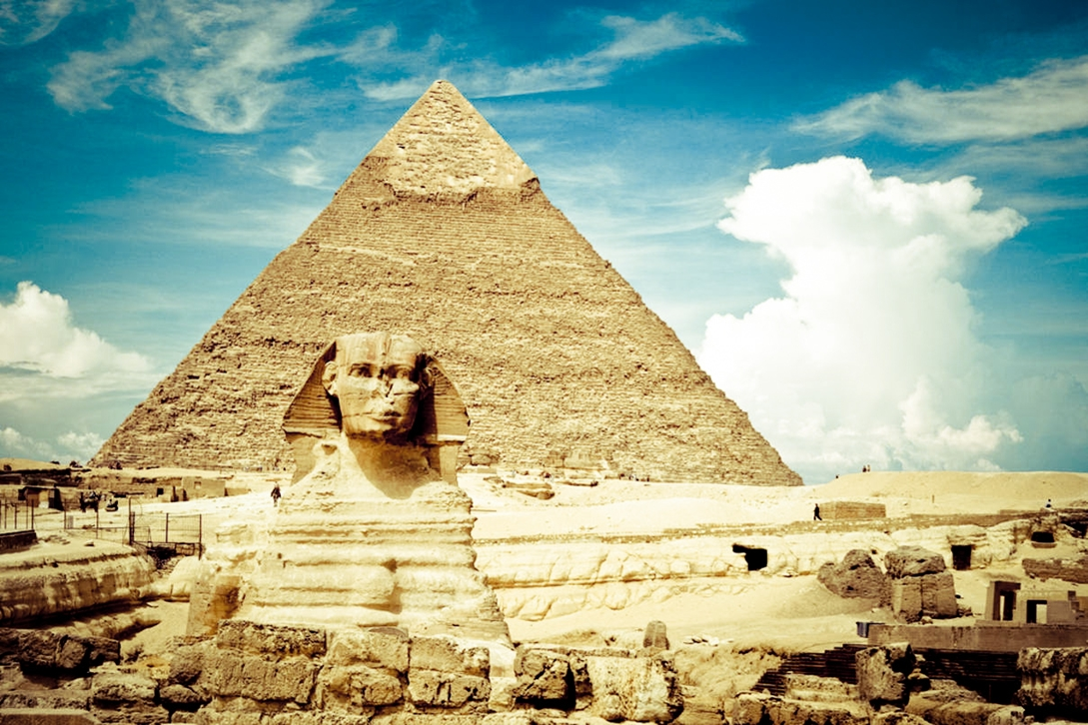
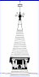

Tomb Raiders!
Sapphire Class
Spring 2
Pupil comments in red
English
During Sping 2 we will be focusing on the story of ‘Daft Jack’. a similar story to ‘Jack and the beanstalk’ with a twist in the tale!
We will also be writing to persuade and thinking about the language that we could use to convince someone to come to our event or believe our viewpoint.
How could we convince the reader to feel sorry for our character?
What language could we use to persuade?
Geography/History
The Stone Age
This half-term we will be learning about the Egyptians. Here are a few things we would love to learn:
What did the ancient Egyptians eat and how did they make it? Did the pyramids of Egypt have temples within them and what were they used for? Why did the Egyptians mummify people? How did the Egyptians live?
Science – Materials
Ourselves and other animals – the children had all sorts of ideas of what to learn in this topic. Here are a few things they would live to know:
Did monkeys evolve in to humans and how? How do animals move at different speeds e.g. cheetahs and sloths? How do animals differ from their parents?
4. Why do we need to blink?
P.E
Our focus will be batting and fielding and we will be focusing on Cricket in particular. The children are excited to learn new skills and be involved in a mini competition.
How do you accurately hit the ball? How do you accurately catch when fielding?
R.E

We are continuing to learn about the creation story and will be covering the Easter story too.
What does the Easter story represent?
Computing
The children are excited about computing and thought about the following questions:
How can we use PPT to be informative? How can we create a game using Scratch?
Outdoor Learning
We will be incorporating outdoor learning in to our topic this half-term through learning how the Egyptians built their homes and how they hunted and scavenged.
DT/Music
DT – We will be building Egyptians structures using a range of materials.
Music – we are continuing to learn all about reggae music and we will begin to compose our own music in a reggae style.
Global Learning
We have lots of exciting topics that we will be learning about. During the first week we have an exciting day for World Book Day where the children get to dress up! ☺
French
By the end of the term we will have looked at the names for different foods, how foods differ in France and creating our own French menus.
Which foods do the French eat that we don’t find in our country or are not common?
Mathematics
We will be covering Length, perimeter and area. Through these topics, we will be covering a whole range of topics and will be asking the children to apply their understanding to the wider world e.g. shopping.
How can we measure with a broken ruler?
What happens when a shape is not a regular shape? Can you still work out the area?

