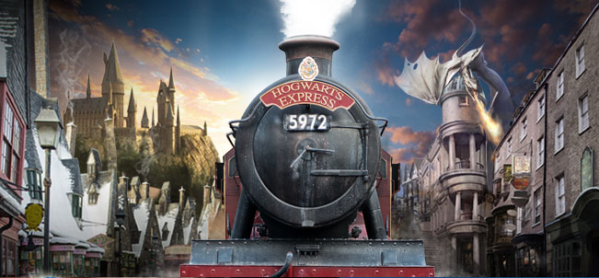

**PHSE and Global Learning**

Homelessness – railway charity

Trust

Going for Goals

**DT**

**Cooking:** Healthy and varied diet

Year 3 and 4

Spring Term 2019

**Geography/History**

**Key Focus: Development of the Railways**

Chronology of transport

Invention of the steam train

George and Robert Stephenson

Local study- Crewe

Effect on local area and development of railways

Main events and changes caused by train travel

**All Aboard!!**

**Music**

Young Voices – rehearsal for concert

Stop!

Lean on me – gospel-based music

**RE**

**Christianity** - What can people learn about Easter from the creative arts?

**Christianity** - How does a church community live out their lives as disciples?

**PE**

Gymnastics and dance

Striking and fielding – cricket

Tennis

**English**

The children will develop their skills in ‘Talk for Writing’ through a range of genre including:

**Beat the Monster -** Harry Potter “The Troll”

**Persuasive Writing –** Advert for spell books

**Fantasy setting** - The Magician’s shop

**Newspaper report –** Invention of the train

**French**

Epiphany celebrations

Animals around us

Carnival and playground games

Easter celebrations

**Art**

* Create printing blocks using a relief or impressed method.
* Create repeating patterns.

Print with two colour overlays.

**Science**

**Living things and their habitats:**

Recognise that living things can be grouped in a variety of ways.

Explore and use classification keys to help group, identify and name a variety of living things in their local and wider environment.

Recognise that environments can change and that this can sometimes pose dangers to living things.

**Maths**

**Number** – Multiplication and division

**Number –** Fractions

**Measurement-** Money

**Measurement –** Length and perimeter

**ICT**

Using a search engine to find out facts about the past.

Writing and improving algorithms