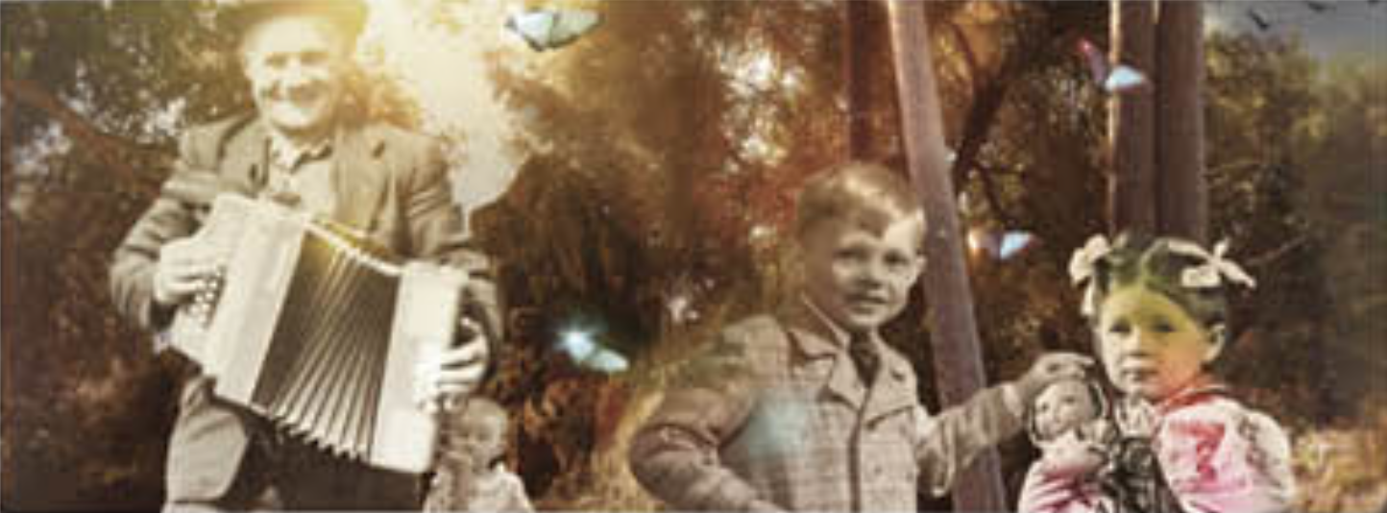

**Then and Now**

**Autumn 1**

We will be looking back at our lives so far to find out more about how we change and grow. We will be looking at memorable moments in our life. If you have anything to share please bring it into school.

**Music**

Hey you!  
Our learning will be based around the one song called Hey You! This song is written in an old school hip hope style for children to learn about the difference between pulse, rhythm and pitch.

**Art**

* Use a variety of tools and techniques including different brush sizes and types.
* Experiment with tools and techniques e.g. layering, mixing media, scrapping through.
* Name different types of paint and their properties.
* Identify primary and secondary colours by name.
* Mix primary shades and tones.
* Mix secondary colours.

**PE**

This half term our focus is in invasion games. We will develop ball, footwork and marking skills in order to play netball.

Golden Mile

**RE -**

We will be learning about churches and their common features.

We will learn about what a church is, who it is special for and what goes on there.

**Geography/History**

* We will compare the similarities and differences of our lives compared to periods in the past by looking at how toys, schools and children’s crazes have changed.
* Order events from our lives in order of when they happened.
* Learn about how our local area has changed.
* Talk about and share our family life.
* Compare our own life and interests, now and then.

**ICT**

E-Safety – understand what the internet is, why it is used and how to use the internet safely.

**Maths**

Count to ten, forwards and backwards, beginning with 0 or 1, or from any given number.

Count, read and write numbers to 10 in numerals and words.

Given a number, identify one more or one less.

Identify and represent numbers using objects and pictorial representations including the number line, and use the language of: equal to, more than, less than (fewer), most, least.

**Science – Animals including humans**

* Explore our senses and discuss basic body parts
* Draw and label basic body parts.
* Identify and name a variety of common animals that are carnivores, herbivores and omnivores
* Talk about physical and developmental changes from baby to adult.
* Identify and name a variety of common animals including fish, birds and mammals.

**Literacy**

* SPaG: sentence construction, capital letters, full stops, exclamation marks and question marks.
* Daily phonics using following letters and sounds Phase 3/5.
* Use the story, ‘The Gingerbread Man’ to write our own stories and character descriptions.
* We will be writing instructions for gingerbread men.