
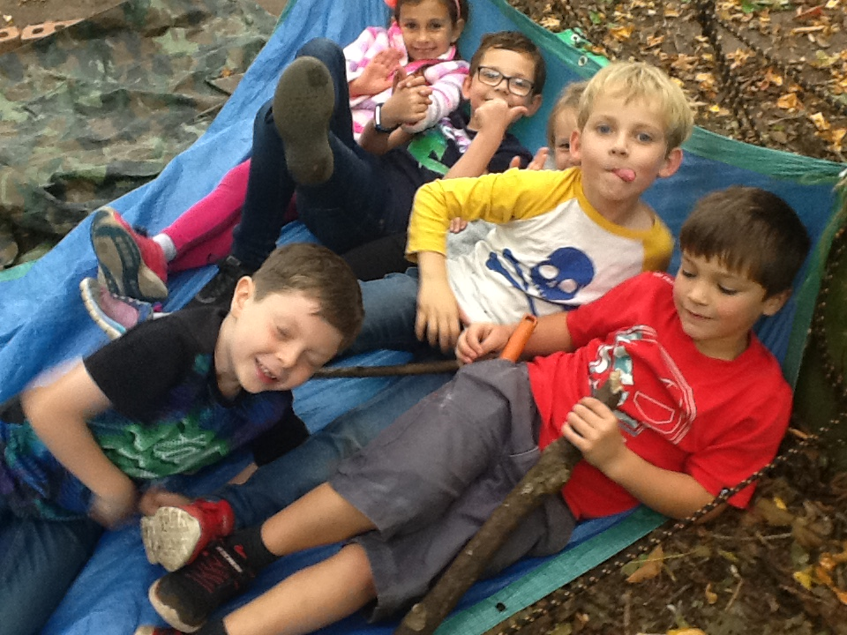
Ruby Class learning letter
08.10.18 -12.10.18

What have we been learning this week?
Literacy
In literacy this week we have begun learning how to write a great set of instructions! We are learning all about bossy verbs, time words and headings. We even began learning an exciting set of instructions on how to trap a dragon. I’m sure the children would love to show you what we have learned so far!

Forest School
We had a wonderful time as always at forest school this week creating African drums, weaving and making African animals, exploring the mud kitchen, learning how to build dens and learning how to have fun outdoors safely. We love exploring our beautiful environment!

Maths
We have been learning to use the column method for tricky addition and subtraction sums this week and we are loving it! Please see the attached document for further information on how we are teaching this maths strategy in class☺. Thank you so much to the parents who are already practising this at home

As always if there is any issue, no matter how small, that you wish to discuss with us please feel free to make an appointment with our wonderful Mrs Cotterell or Mrs Newton at the desk! We hope you have a wonderful weekend!
Miss Poppleton, Mrs Tomlinson and Miss Williams Day
Our Sound Superstars!
 |  |  | 
Teamwork Resilience Independence Curiosity Caring

Homework
From Autumn 2 onwards we will be changing our homework style. Each week children will be asked to complete a literacy or mathematical task at home. This will be in addition to weekly spelling or grammar and reading practise. I would like to take this opportunity to thank you all for all the reading that is happening at home. The children are so excited to gain stickers for reading each night and the impact this is having on their reading is incredible! Please can I ask that if you are writing in the homework books that all writing is completed in pencil please. I have provided each child with a pencil in their book-bags. ☺
Fun fact of the week!

A snail can sleep for 3 years.

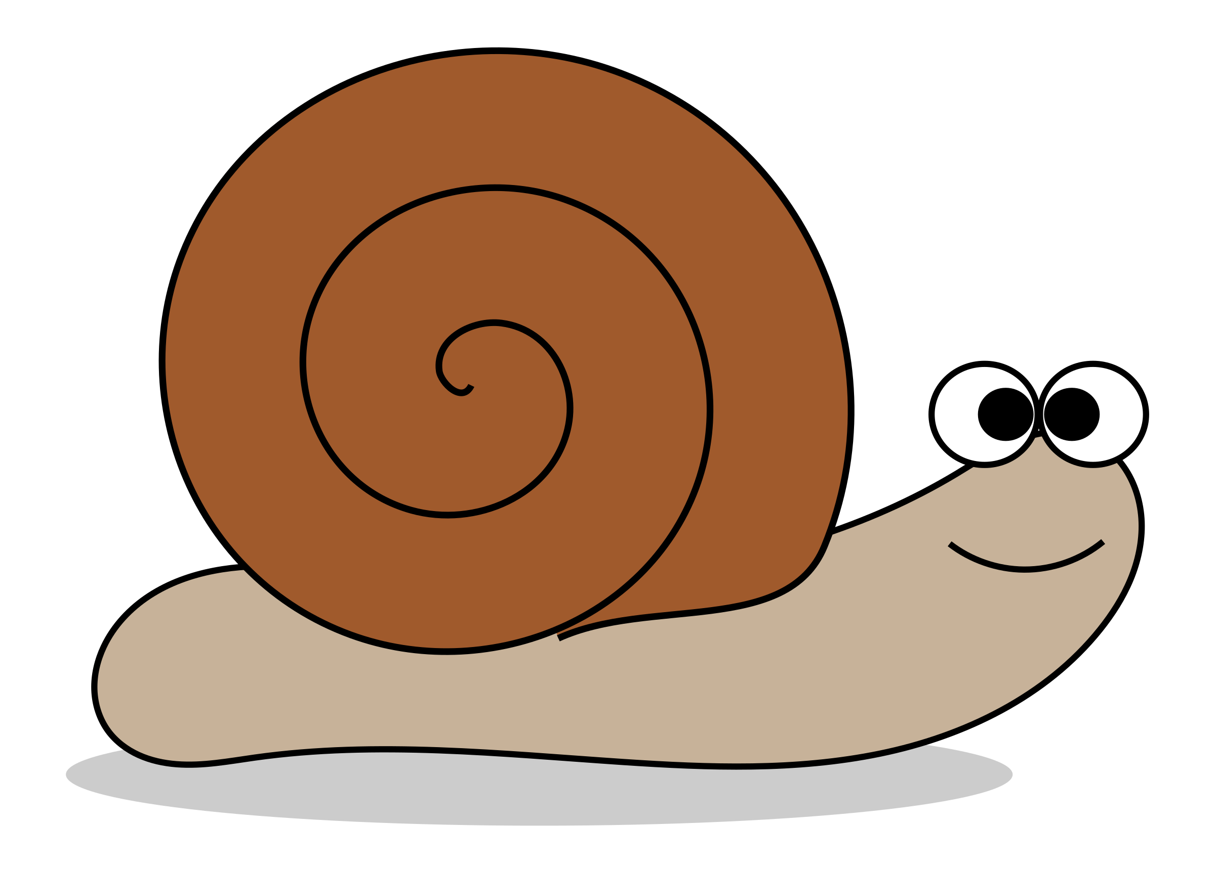

Special moment from the week

Goes to George Vorwerg for being our wonderful class photographer and handy helper!

