
Ruby Class learning letter
22.10.18 -26.10.18

What have we been learning this week?

Literacy
Wow! What a week we have had! ☺ We worked so hard to complete our final set of instructions this week and we did amazingly well (which I’m sure you will agree with having seen the children’s literacy books this week!). We are really impressed with our ability to use bullet points, headings, bossy verbs and time words! Keep up the amazing work year 2!

Forest School
We just love forest school! We really enjoyed having some of our parents come and join in the fun too this week! Ps- We do still have one final forest school session on Wednesday 7th November (this is to make up the session we missed a few weeks ago. I will send a reminder text out the first week back).

Team Day
This half term team day was based around Remembrance Day. We absolutely loved visiting different teachers in our teams! We did history, science, art and DT work. We particularly enjoyed the teacher challenge at the end of the day, this always makes us laugh!!

Maths
This week we completed an addition and subtraction assessment and we absolutely cracked it! We put to use all of the strategies we have been working hard to learn. I am so proud of the progress the children are making in maths. Next half term we will begin learning all about money including adding coins in a number of ways, giving change and solving money word problems!

Halloween Disco!
Wowee! Didn’t the children all look fabulous in their Halloween costumes? It was lovely to see their great big smiles, happy faces and groovy dance moves!

First week back
Reminder-Forest School- Wednesday 7th November
Remembrance exhibition- Friday 9th November (after school)

We hope you all have a wonderful break!
Miss Poppleton, Mrs Tomlinson and Miss Williams Day
Our Sound Superstars!
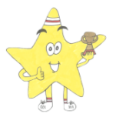 | 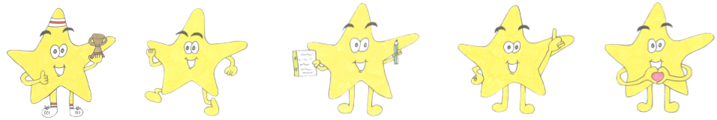 |  | 
Teamwork Resilience Independence Curiosity Caring

Homework
-Poppy homework please!
-Reading each night (we will backtrack sticker charts on the first week back!)
But most importantly have the best holiday ever! Everyone has worked incredibly hard this half term and I am so proud of you all! Time for a much needed rest to recharge the batteries!
Fun fact of the week!

A shark is the only known fish that can blink with both eyes!

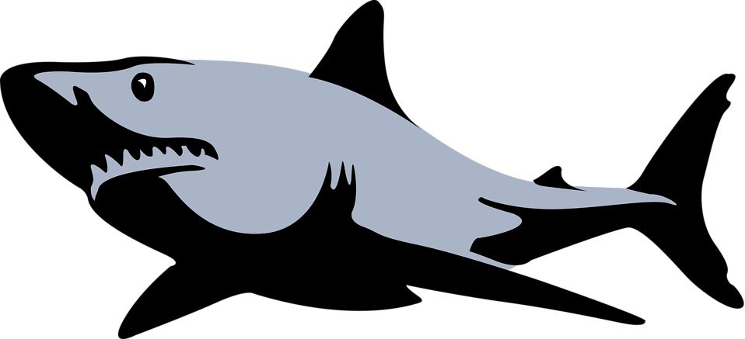
Special moment from the week
Wow! Our special award goes to Elsie for being so caring during team day this week. I love how you wanted to help the Reception children! Keep being amazing!


