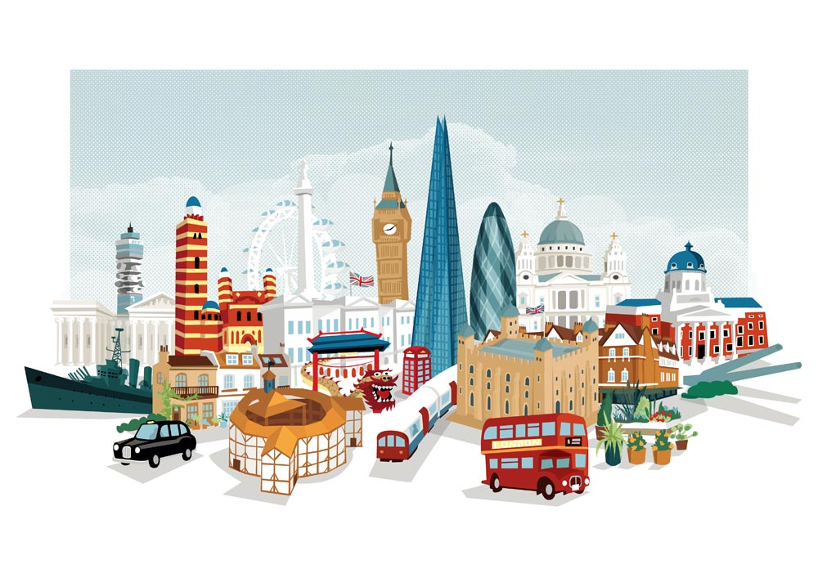

**Maths**

Length and Height

-Compare lengths and heights

- Measure different lengths to the nearest CM

Volume and Weight

- Introduction to weight and mass

- Measure mass

- Compare mass

- Introduction to capacity and volume

- Measure capacity

- Compare capacity

**Literacy**

* SPaG: sentence construction, capital letters, full stops, exclamation marks and question marks.
* We will continue to prepare for the Year 1 Phonics screening check.
* Daily phonics using following letters and sounds Phase 3/5.
* This term the children will be learning to write a story where their character overcomes a magical disaster!
* We will also use our learning from science to write an explanation text about how sunflowers grow.

**Geography/History**

- We will learn about events beyond living memory that are significant nationally or globally e.g. ‘The Great Fire of London’.

- Name and locate the four countries of the United Kingdom on a map or globe.

- Use simple locational language including in front, behind, next to, far away and near to, to describe the location of geographical features on a map and in fieldwork.

- Recognise simple human and physical features on an aerial photograph or simple map showing an awareness that objects look different from above.

- Identify the similarities and differences between the local environment and one other place.

- Explore google maps and identify key landmarks

**Science – Plants**

We will be learning about the structure of plants and trees and what they need to grow well. We will:

•Identify and name a variety of common wild and garden plants, including deciduous and evergreen trees.

•Identify and describe the basic structure of a variety of common flowering plants, including trees.

•Find out and describe how plants need water, light and a suitable temperature to grow and stay healthy.

•Observe and describe how seeds and bulbs grow into mature plants.

We are going to plant sunflower seeds and watch how they grow.

**ICT**

This half term we will be using the iPads to learn more about London! We will continue to learn about the importance of keeping safe online.

**Music**

This term we will be focusing on a piece of music called ‘round and round’.

**PE**

This half term we will be learning how to play tennis!

We will also be practising for sports day.

Golden Mile

**Art/DT**

We will be looking at the artist ‘Andy Warhol’ and in particular his portraits of the Queen.

We will be looking at different techniques to achieve our own versions of the painting.

We will be designing a new sandwich for Paddington Bear to enjoy!

**Bright Lights, Big City!**

**Summer 1**

**RE -**

This term we will be exploring different symbols that are important to the Christian faith.