Forest School
Nursery
Prospectus
Contact Rachel from The Outdoor-Fun Team
Telephone 07554432043
Email rachashley1977@gmail
www.outdoor-fun.org Ofsted Registration No 2534832
Sound and District Primary School
Whitchurch Road
Sound
Nantwich CW5 8AE
Outdoor-fun was created by me (Rachel Ashley) because I felt it was time to offer something unique and different! To help schools and nurseries develop outdoor learning within their own sites. Having managed the company for past 3 years and gained much experience, I felt it was time to provide a truly outdoor experience. Current and historic research tells us that children simply do not spend enough time outside and there are huge consequences of this. Being immersed in nature promotes many of the characteristics and traits we now know are essential for success in later life.
Experiences in the outdoors provides children with more opportunities to develop self-awareness, self-esteem and resilience (to name but a few); attributes we know are essential for learning later in life. Recent studies (EPPSE) have also highlighted how vital good quality early years experiences are in ensuring children achieve well and are happy during their entire lives. Outdoor-Fun forest School Nursery was established to give children the chance to grow up with a sense of awe and freedom as part of their everyday lives, after all wisdom begins in wonder. We have created a world where children are inspired by nature to live a simple and naturally healthy lifestyle, breaking away from the modern childhood of sedentary screen based or prescriptive plastic toy playtime to play the natural way we played as children. We strive for constant innovation to ensure we are committed to offering the best-known practice in educating children and are passionate to the point of obsession with an outdoors, child-led, play-based, happy and healthy environment. We see ourselves as inspirational educators offering an incredibly fun and rich experience for children - the fact that we also offer childcare is almost incidental.
We treat all our children as individuals and we respect their needs and wishes, as well as those of the parents and carers involved. We believe in equality of opportunity for all and each child is encouraged to participate and achieve to their own potential. Individual care and attention are facilitated by a high ratio of staff to children and by appointing a key person for each child. We celebrate each child’s uniqueness and encourage respect and social interaction. We work in partnership with parents to help children learn and develop; we offer children and their parents a service that supports children through their learning journey and prepares them for the transition to school or their next setting.
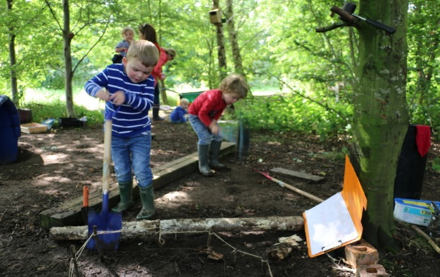
Our Setting Aims to:
- To help children make the transition from home to Outdoor-Fun forest school nursery and then from us to school smoothly and confidently.
- To provide parents/carers access to information about their progress and assess their development on a regular basis.
- Promote an environment that is FUN, HEALTHY, SAFE, SECURE, and WELCOMING
- Provide high quality care and education for children between 2 and 5 years.
- To promote understanding and kindness towards others.
- Nurture self-confidence, self-esteem and encourage independence.
- Work in Partnership with Parents; building strong and supportive relationships.
- To have happy, enthusiastic and motivated staff, through encouragement, empowerment and appraisal.
- Allow children to enjoy being part of a group in which each individual is valued, through encouragement and praise.
- Offer children and their parents or carers a service that promotes equality and values diversity and inclusivity.
- Helps all our children reach their own potential in all areas of development and learning, through the fostering of positive relationships and opportunity.
- Encourage children to learn through play whilst having fun and engaging with nature.

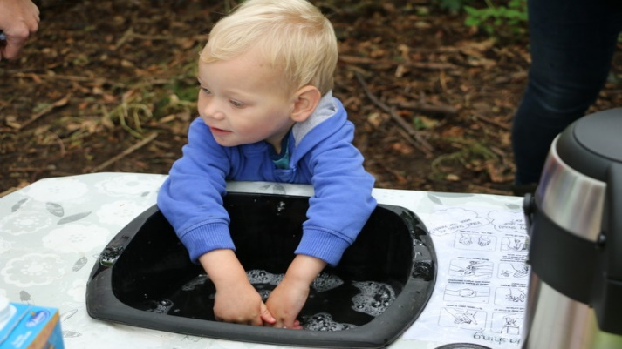
Outdoor-Fun’s Ethos is
- Reuse
- Protect
- Nurture

EVERY CHILD MATTERS
Unique Child. Each child in your care is unique and capable of constant learning, resilience and confidence.
Our Approach to Learning, development & Assessment

Learning through play
Play helps young children to learn and develop through doing and talking, which research has shown to be the means by which young children learn to think. Outdoor-Fun uses the ‘Development Matters’ in the Early Years Foundation Stage guidance to plan and provide a range of play activities which help children to make progress in each of the areas of learning. In many of these activities, children decide how they will use the resources, whilst in some an adult takes the lead in modelling and scaffolding the children to taking part. Children are not rushed in any way and given ‘time to be’ which in turn promotes thinking skills.

Assessment
We assess how young children are learning and developing by observing them frequently. We use information that we gain from observations to document their progress and where this may be leading them. This then recorded to an online system, which you can view at any point. We use this information to plan individually for each child in our setting. We believe that parents know their child best and we ask them to contribute to assessment by sharing information about what their child likes to do at home and how they, as parents, are supporting development. We make periodic assessment summaries of children’s digital learning journeys based on our ongoing development records. We undertake these assessment summaries at regular intervals, as well as times of transition, such as when a child moves to a different setting, school or nursery. We make use of a software application to assist us in recording these precious moments, which in turn enables us to confidentially share them with you on a regular basis.

GDPR All your data is handled with the upmost security and will never be shared with anyone without your knowledge in accordance ICO (Information Commissioner’s Office) Outdoor-Fun Limited reference number ZA530670

How parents and carers take part
Parents and carers are regarded as members of our setting who have full participatory rights.
These include a right to be:
- valued and respected;
- kept informed;
- consulted;
- involved;
- included at all levels.
- Outdoor-Fun Forest School Nursery recognises parents/carers as the first and most important educators of their children. There are many ways in which parents/carers take part in making Forest School Nursery a welcoming and stimulating place for children and parents/carers, such as:
- exchanging knowledge about their children's needs, activities, interests and progress with the staff;
- sharing their own special interests with the children;
- taking part in events and informal discussions about the activities and curriculum provided;
- joining in community activities in which Outdoor-Fun takes part.

You are very welcome to visit at any time, as we have an open door policy. Younger siblings are made very welcome but due to insurance reasons they must remain your responsibility at all times/this also includes our Forest Tot sessions. We find this provides an ideal way for younger ones to become used to us before they start themselves and to join in and have fun. Each half-term we produce a newsletter to keep you up to date with any news and our website is updated regularly.

Key Person Outdoor-Fun Forest school Nursery has a key person system. This means that each member of staff has a group of children for whom she/he is specifically responsible. Your child's key person will be assigned before your child starts and is primarily the person who works with you to make sure that what we provide is right for your child's particular needs and interests. When your child first starts at Outdoor-Fun Forest School nursery, she/he will help your child to settle, offer a home visit and throughout your child's time with us she/he will help your child to benefit from the activities on offer.

Routines We believe that care and education are equally important in the experience which we offer children. The routines and activities that make up the day are provided in ways that:
• help each child to feel that she/he is a valued member of the setting;
• ensure the safety of each child;
- help children to gain from the social experience of being part of a group
- provide children with opportunities to learn and help them to value learning.
- Ensure that your child has a heathy outlook on food, by each child helping to prepare food for each other throughout the day.

The First days We want your child to feel happy and safe with us. To make sure that this is the case, the staff will work with you to decide on how to help your child to settle into Nursery and forest school setting. We encourage parents to decide when or how they would like to settle their child and have no expectations or rules about this. We will always be guided by and support you with this. Staff will always be ready and willing to listen to your views and ideas and to answer any questions.

Term Dates We are open during school term times for funded places, although extra hours are available at addition costs. Our term dates are set to follow Sound and District Primary School, for 2019/20 are attached to the enrolment pack. Outdoor-Fun Holiday Club is available at other times and children will be separated into age appropriate groups.

Hours We are open Monday to Friday from 7.30 until 6pm, funded places are based on either 9am until 3pm term time only or the hours can be divided to cover yearly. We ask that children attend for a minimum of 2 days.

Fees Fees are payable half-termly in advance and must be paid before your child attends on the first day of each half term. Fees must still be paid if children are absent for a short period of time including holiday and illness. If your child must be absent for a long period of time, please talk to our Manager or a member of the Outdoor-Fun Team. For your child to keep her/his place, you must pay the fees. We are in receipt of nursery education funding for two-year olds and three/ four-year olds. There is a full explanation of fees on enrolment pack and your invoice.

The Sessions We organise our sessions so that the children can choose from, and work at, a range of activities and in doing so build up their ability to select and work through a chosen task. Our focus is on providing an environment which allows children the space and time to develop the ‘characteristics of effective learning’. Children are encouraged to take part in activities that they freely choose, whilst offering adult supported sessions (where appropriate) which introduces them to new experiences and helps them to gain new skills.
We encourage and foster collaborative relationships that enable children to learn to work with others. We encourage children to flow freely in the outdoor space (whilst being supervised); which allows them the opportunity to investigate and experiment as well as contributing to their health, wellbeing and knowledge of the world around them. Children have the opportunity, and are encouraged to, take part in child-initiated and adult-led activities; we provide an abundance of ‘open-ended’ natural resources that enable children to draw on their own experiences and gain new skills through play and exploration.

Clothing We provide a set of Didriksons waterproofs, water bottle and backpack as part of the registration fee in which children must come to Forest School Nursery each day. We encourage all children to gain the skills that help them to be independent and look after themselves. These include all aspects of selfcare including putting on clothes. Clothing that is easy for them to manage will help them to do this.
"There is no such thing as bad weather, only inappropriate clothing." -- Sir Rannulph Fiennes
Policies & Procedures Copies of our Policies and Procedures are available for you to see on request. Our Policies help us to make sure that the service provided by Outdoor-Fun Forest School Nursery is a high quality one and that being a member of the setting is an enjoyable and beneficial experience for each child and her/his parents. The staff and children of Outdoor-Fun Forest School Nursery work together to adopt the Policies and have the opportunity to take part in the annual review. This review helps us to make sure that the Policies are enabling us to provide a quality service for its members and the local community.
If you feel you need to make a complaint about the setting, please talk to a member of the Outdoor-fun team who will be please to help you with your situation, if not, they can help you to follow the complaint procedure, which is set out in Outdoor-fun Forest school nursery policies

Safeguarding Children Outdoor-fun has a duty, under the law, to help safeguard children against suspected or actual ‘significant harm’. Our employment practices protect children against the likelihood of abuse in our setting. We also have a procedure for managing complaints or allegations against members of staff. Our way of working with children and their parents ensures we are aware of any problems that may emerge and can offer support, including referral to appropriate agencies when necessary, to help families in difficulty.

Special Educational Needs & Disability (SEND Reforms 2014) We provide an environment in which all children with additional needs are supported to reach their full potential. We have regard and a legal duty for the SEND code of practice (2014). We ensure our provision is inclusive to all children with additional needs and provide support for parents. This law marks a significant change in the approach to special educational needs: the focus now is very much on ‘outcomes’, in other words, identifying what the child/young person, parents and professionals want the child/young person to achieve in the long, medium and short-term.

Staff Outdoor-Fun Forest School Nursery is owned by Rachel Ashley qualified teaching assistant with forest school level 3 and working toward level 3 in early years, managed by Erica Taylor/Safeguarding lead, who is Level 3 NVQ in Childcare and Education with outdoor learning practitioner, and Deputy manager Kathryn Davies/Senco lead B.Ed 2:1 Hons Early Years main subject Science.
All our staff qualified first aider and Enhanced DBS checked staff are dedicated, caring and committed to continuing professional development. Together they possess a wealth of early years’ experience. Our established team complement each other well and are therefore able to provide a quality early years provision for all children.

Admissions We currently offer places for children aged from 2 to 5 years and provided we have vacancies, can admit children at any time during the academic year. We have a limited number of funded places, please contact us for more details and see our enrolment pack for further information.

