Year 2 (Key Stage One)
 | Autumn One  (7 weeks) | Autumn Two  (8 weeks) | Spring One  (6 weeks) | Spring Two  (5 weeks) | Summer One  (6 weeks) | Summer Two  (8 weeks)
Topic Title / Information: | Jurassic Forest  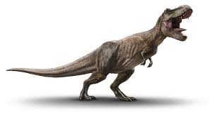  We step back in time to the Jurassic period and learn all about the amazing dinosaurs that lived before us! | 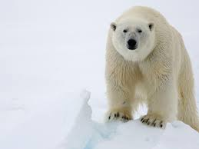  Polar Regions and Ice Explorers  Where we will learn about everything polar including the animals and the people who first explored there! | Amazing Africa  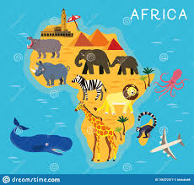  Off we go! We travel to Africa to learn all about African Culture including, food, lifestyle, sports, music and much more! | Minibeasts  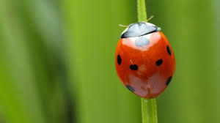  Wellies at the ready as we explore what’s wriggling and crawling in our school grounds! | Royal Family  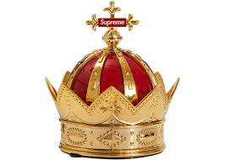  Crowns are sparkling as we learn about the Royal family as well as our own family trees! | Water, Seas and the Galapagos Islands  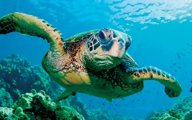  What lies beneath? We find out exactly what does lie beneath as we learn all about our beautiful Oceans!
Geography | Locational Knowledge  We will learn to name and locate the world’s 7 continents and 5 oceans- capital cities of United Kingdom.  Geographical skills and fieldwork  We will learn to use simple compass directions (north, south, east and west) and locational and directional language [For example, near and far, left and right], to describe the location of features and routes on a map. | Human and physical geography  We will learn to identify seasonal and daily weather patterns in the United Kingdom and the location of hot and cold areas of the world in relation to the Equator and the North and South Poles | Place Knowledge  We will learn to understand geographical similarities and differences through studying the human and physical geography of the United Kingdom and South Africa.  Geographical sills and fieldwork  We will learn to use world, maps, atlases and globes to identify the United Kingdom and its countries, as well as the countries, continents and oceans of our world. | Geographical sills and fieldwork  We will use simple fieldwork and observational skills to study the geography of our school grounds and the key human and physical features of our surrounding environment.  We will compare minibeasts that live and grow in this country to minibeasts that live and grow in other countries. | Geographical sills and fieldwork  We will use aerial photographs and plan perspectives to recognise landmarks and basic human physical features; devise a simple map; and use and construct basic symbols in a key. | Human and physical geography  We will learn to use basic geographical vocabulary to refer to:  →Key physical features, including: beach, cliff, coast, forest, hill, mountain, sea, ocean, river, soil, valley, vegetation, season and weather.  →Key human features, including: city, town, village, factory, farm house, office, port, harbour and shop.  Locational Knowledge  We will learn to locate the world’s 7 continents and 5 oceans and capital cities of the United Kingdom.
History | Significant People  We will learn about the lives of significant historical events, people and places in their own locality.  E.g. Mary Anning | Significant People  We will learn about the lives of significant historical events, people and places in their own locality.  E.g. Ernest Shakleton, Robert Falcon Scott | Significant People  We will be learning about the lives of significant individuals in the past who have contributed to national and international achievements, some should be used to compare aspects of life in different periods- E.g. Nelson Mandela |  | Significant People  We will learn of the lives of significant individuals in the past who have contributed to national and international achievements, some should be used to compare aspects of life in different periods E.g. Elizabeth I and Queen Victoria}  Significant Events  We will also learn about the events beyond living memory that are significant nationally or globally E.g. Royal Weddings, Coronations etc. | Significant Events  We will learn about significant historical events, people and places in their own locality- e.g. the sinking of the Titanic.
Science | Animals including humans  Working scientifically | Materials  Working scientifically | Plants  Working scientifically |  | Living things and their habitats  Working scientifically
Art | 3D Sculpture  - Manipulate malleable materials in a variety of ways including rolling and kneading.  - Explore sculpture with a range of malleable media.  - Manipulate malleable materials for a purpose, e.g. pot, tile.  - Understand the safety and basic care of materials and tools.  Form  - Experiment with constructing and joining recycled, natural and manmade materials.  - Use simple 2-D shapes to create a 3-D form.  Texture  Change the surface of a malleable material e.g. build a textured tile. |  | Textiles  - Match and sort fabrics and threads for colour, texture, length, size and shape.  - Change and modify threads and fabrics, knotting, fraying, fringing, pulling threads, twisting, plaiting.  - Cut and shape fabric using scissors/snips.  - Apply shapes with glue or by stitching.  - Apply decoration using beads, buttons, feathers etc.  - Create cords and plaits for decoration.  Colour  - Apply colour with printing, dipping, fabric crayons.  - Create and use dyes i.e. onion skins, tea, coffee.  Texture  Create fabrics by weaving materials i.e. grass through twigs. |  | Paint  - Print with a range of hard and soft materials e.g. corks, pen barrels, sponge.  - Make simple marks on rollers and printing palettes.  - Take simple prints i.e. mono –printing.  - Roll printing ink over found objects to create patterns e.g. plastic mesh, stencils.  - Build repeating patterns and recognise pattern in the environment.  - Create simple printing blocks with press print.  - Design more repetitive patterns.  Colour  - Experiment with overprinting motifs and colour.  Texture  Make rubbings to collect textures and patterns.
 | Drawing  3D sculpture |  | Drawing  Textiles |  | Drawing  Painting
D.T. | Mechanisms  Wheels and axles |  | Food  Preparing fruit and vegetables  (including cooking and nutrition requirements for KS1) |  | Textiles  Templates and joining techniques
Music | Hands, Feet, Heart | Ho, Ho, Ho | I want to play in a band | Zoo time | Friendship Song | Reflect, Rewind and Replay
P.E. | Invasion Games  Netball | Kicking Skills/ Passing  Volleyball | Dance | Gymnastics  & Tennis | Athletics &  Swimming | Athletics & Swimming
RE | Christianity | Christianity | Christianity | Christianity | Christianity | Judaism
PSHE/SMSC themes | Being Me | Celebrating difference | Dreams and Goals | Healthy Me | Relationships | Changing Me
Computing | E- Safety |  | Computer Science/ Programming |  | Digital Knowledge & Skills/ Word Processing

