MUSIC - Charanga Scheme of Work
2019-2020
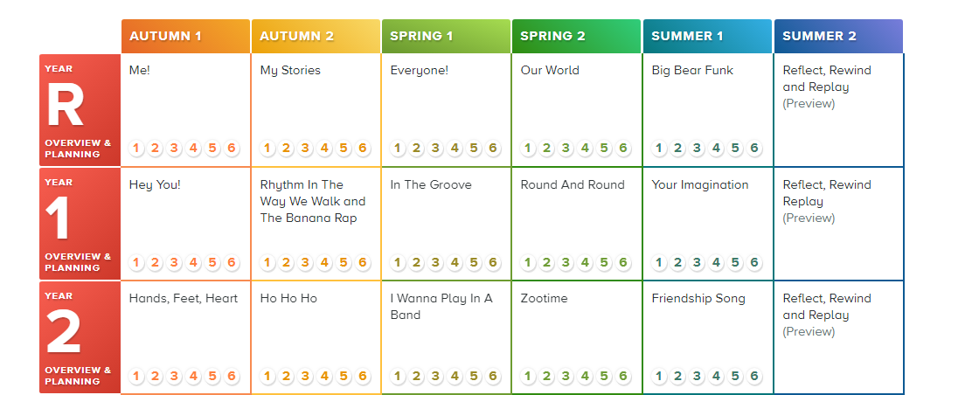
Reception and KS1: please follow the lesson plans, guidance and activities for your corresponding year group.

KS2:
- Year 3 please follow the Year 3 overview and planning
- Year 4 and 5 please follow the Year 3 overview and planning to ensure full coverage of learning objectives and topics.
- Year 6 please follow the Year 5 overview and planning
