Top Ten Ideas to Get Ahead in Primary School French
1. It doesn't matter if you don't speak French! There are many sites online which will enable you and your little one to practise your pronunciation. Have a look at this wonderful alphabet mat to really set you on your way!
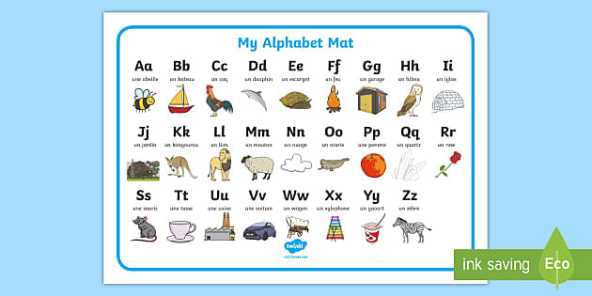

Download Now! Alphabet A-Z French Word Mat
2. Play games! Charades is great for acting out actions such as hobbies or household activities. You could also play French vocabulary games (which build up memory and concentrations skills), for example, I have a banana, an apple, an orange, adding an extra item in turns each time.
3. Buy your child a mini-whiteboard and a board marker pen (available from large stationery stores) so your child can start to practise their French spellings. These are great for drawing games too! Draw a picture and ask your child to guess the word in French. Set time limits - how many can they guess in a minute?
4. Watch French cartoons! Children understand so much more language than they can actually produce. Singing in French is also a great way to help your child learn and embed new French words. Why not try this engaging nursery rhyme:
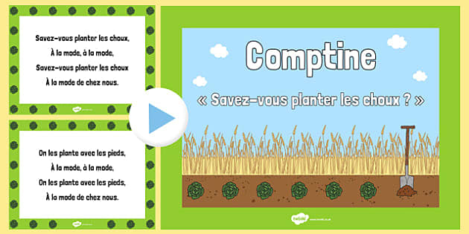

Download Now! Savez-vous planter des choux? Nursery Rhyme PowerPoint
5. Encourage your little one to speak as much French as possible - children learn a language by constant imitation and repetition. You could ask them to say something to you every day in French, even if it's just 'Bonjour!' or 'Au revoir!'
6. Try this great game to practise French hobbies vocabulary!
7. We have lots of fantastic activities to practise French colours, including this colouring sheet featuring a much-loved elephant.
8. Practise French numbers - play bingo or use this super number puzzle sheet.
9. Has your child met the French words for food? They can practise their writing and reading of French foods. Or by using this fantastic matching words activity. Why not encourage your child to name items in French during the big food shop or whilst putting the shopping away?
10. Help your child say which foods they like and dislike with this activity sheet:
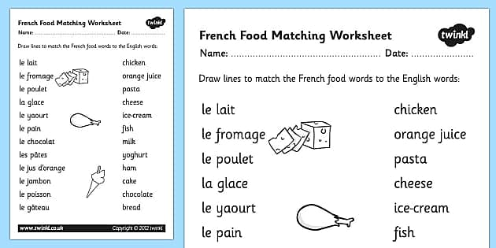

Download Now! French Food Matching Words Activity Sheet
And most of all, have fun!
Bonne chance!

