Year One – Creative Curriculum for 2019/2020

 | Autumn 1 (8 weeks) | Autumn 2 (7 weeks) | Spring 1 (6 weeks) | Spring 2 (6 weeks) | Summer 1 (5 weeks) | Summer 2 (7 weeks)
Year 1 topic overview | Memory Box  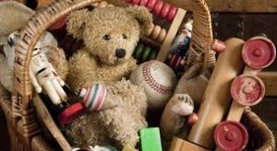 | Festivals (Bonfire Night and Remembrance)  Local Area study – around our school | Space | Great Fire of Nantwich | UK/London  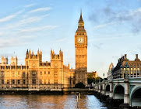 | Where in the world?  Hot and cold counties  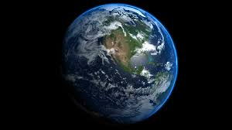
Geography and History | - Changes within living memory | - Fieldwork and map work | - World maps, atlases and globes  - Learn about the lives of significant individuals in the past who have contributed to national and international achievements.  - Name and locate the world’s seven continents and five oceans | - Learn about events beyond living memory that are significant nationally or globally  - Learn significant historical events, people and places in their own locality | - 4 countries of UK and capital cities  - Use world maps, atlases and globes to identify the United Kingdom and its countries,as well as the countries, continents and oceans studied at this key stage | - Locate the world’s seven continents and five oceans
Global Learning focus  British Value focus | Mutual respect/Tolerance | Rule of law | Mutual respect/Tolerance | Democracy | Individual Liberty | Democracy
Enhancements  Forest School  Plays  Trips | Forest Schools | Christmas Play | Residential to Standon Bowers | Nantwich Museum | - | Sports Week – Activitivies tbc
Science | Animals including humans | Seasonal changes | Everyday Materials | Seasonal changes | Plants | Scientific Inventors
PE | Netball  &  Ball  Skills/Throwing/Catching | Gymnastics | Swimming  &  Dance | Cricket  &  Swimming | Athletics  &  Tennis | Rounders
Art/DT | Food  Preparing fruit and vegetables  (including cooking and nutrition requirements for KS1) | Lines and Marks  Painting | Structures  Freestanding structures | Forma and Shape  Tone  Printing | Mechanisms  Sliders and levers | Texture  Collage
RE (inc. Chapel visits) | What does the Bible say God is like?  Why did Jesus tell the ‘lost’ parables? | Harvest focus:  How do Christians show they are thankful for what they have?  Christmas focus:  How & why do Christians celebrate Christmas? | What do Jews believe about God? What do Jews believe about creation? | How & why do Christians celebrate Easter? | What can we find out about Christianity by visiting the local church? How do Christians show they belong? | Who do Christians follow? Why is Jesus important to Christians?
Music | Hey you! | Rhythm In The Way We Walk and The Banana Rap | In the Groove | Round and Round | Your Imagination | Reflect, Rewind and Replay
Computing | E-Safety | E-Safety | Computer Science/Programming | Computer Science/Programming | Digital Knowledge and Skills  Word Processing | Digital Knowledge and Skills  Word Processing
PSHE | New Beginnings | Getting on and falling out | Going for Goals | Good to be Me | Relationships | Changes

