 |  | Autumn 1 |  | Autumn 2 |  | Spring 1 |  | Spring 2 |  | Summer 1 |  | Summer 2
 |  | Fiction | Non-Fiction | Fiction | Non-Fiction | Fiction | Non-Fiction | Fiction | Non-Fiction | Fiction | Non-Fiction | Fiction | Non-Fiction
Year 1 | GENRE | Instructions | Finding Tale | Traditional Tales/ Fairy  Tales | Information text | A Journey Story | Instructions | Tale of Defeating the Monster | Recount | Tale of Overcoming a Magical Disaster | Explanation | Finding Tale | Letter
 | TEXT | How to get ready for School | The Storm Whale | Little Red Riding Hood | Animals | Gingerbread Man | How to Bake Gingerbread | Rapunzel | School Residential | Magic Porridge Pot | How do sunflowers grow? | The Story of Pirate Tom | A letter to Head Teacher
 |  |  | 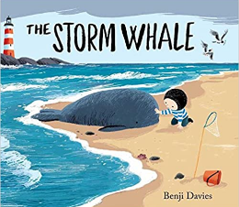 | 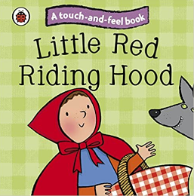 |  | 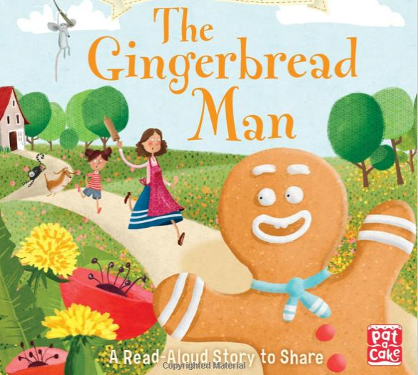 |  | 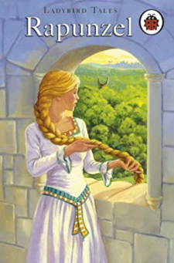 |  | 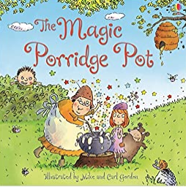
 | FOCUS | Finger spaces  Full stops  Capital letters  Say a sentence, write and  read it back to check it  makes sense. | Simple Connectives  Finger spaces  Full stops  Capital letters | Run sentences  Simple Connectives  Finger spaces  Full stops  Capital letters | Heading  Introduction  Middle section(s)  Ending | Embellished simple sentences using adjectives  Compound sentences  Run sentences  Simple Connectives | Bullet points  Simple Connectives  Heading  Introduction  Middle section(s)  Ending | Alliteration  Embellished simple sentences using adjectives  Compound sentences  Run sentences  Simple Connectives | Bullet points  Simple Connectives  Heading  Introduction  Middle section(s)  Ending | Similes using as….as…  Alliteration Embellished simple sentences using adjectives  Compound sentences  Run sentences  Simple Connectives | Bullet points  Simple Connectives  Heading  Introduction  Middle section(s)  Ending | Alliteration  Embellished simple sentences using adjectives  Compound sentences  Run sentences  Simple Connectives | Bullet points  Simple Connectives  Heading  Introduction  Middle section(s)  Ending
 | Topic | Memory Box |  | Festivals (Bonfire Night, Remembrance and Christmas around the world) |  | Space |  | UK/London |  | Great Fire of Nantwich |  | Where in the world?  Hot and Cold countries

