 |  | Autumn 1 |  | Autumn 2 |  |  | Spring 1 |  |  | Spring 2 |  |  | Summer 1 |  | Summer 2
 |  | Fiction | Non-Fiction | Fiction |  | Non-Fiction | Fiction | Non-Fiction |  | Fiction | Non-Fiction |  | Fiction | Non-Fiction | Fiction | Non-Fiction
Year 2 | GENRE | Quest  Story | Instruction | Rags to riches | Non-Chronological  Report |  | Journey Story |  | Discussion | Explanation |  | Tale of fear | Short units of writing covering a range of genres to collect evidence for end of Ks1 assessments.  Consolidate skills covered so far. |  | Persuasion |  | Tale of defeating the monster
 | TEXT | Little Red Riding Hood | How to trap a dinosaur | Cinderella | Polar Bears |  | Meerkat Mail |  | Should we have zoos? | How butterflies grow? |  | The Papaya that spoke |  |  | Save our oceans |  | The paper bag princess
 |  | 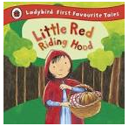 |  | 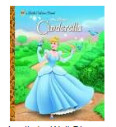 |  |  | 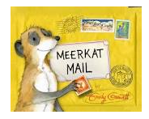 |  |  |  |  | 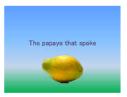 |  |  |  |  | 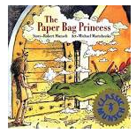
 | FOCUS | Consolidate Yr 1- Full stop, capital letter  Sentence  Structure  Embellished simple sentences using: adjectives e.g. The boys peeped inside the dark cave. adverbs e.g. Tom ran quickly down the hill  Tenses  Simple conjunctions for more embellished sentences  -and  -because | Titles  Sequential connectives  Imperative language  Tenses | Descriptive sentences- Expanded noun phrases  Conjunctions  Run sentences | Headings  Hook to engage reader  Factual statement / definition  Opening question  Varied openers  Generalisers |  | Setting  Adverbs for description  List of three for description  Dialogue |  | Powerful adjectives  Persuasive language  Range of sentences-long/short | Range of punctuation- sentence types- long and short sentences, exclamatory sentences.  Casual conjunctions (this causes, therefore, thus, consequently) |  | Additional subordinating conjunctions: what/while/when/where/ because/ then/so that/ if/to/until  Character actions  Dialogue  Commas  (commas after ly) |  |  | Powerful adjectives  Persuasive language  Range of sentences-long/short  Paragraphing  Consolidation |  | Consolidation on all of this.
 | Topic | Jurassic Park |  | Polar Regions and Ice explorers! |  |  | Amazing Africa |  |  | Minibeasts |  |  | The Royal Family |  | Water and Seas- the Galapagos Islands

