 |  | Autumn 1 |  | Autumn 2 |  | Spring 1 |  | Spring 2 |  | Summer 1 |  | Summer 2
 |  | Non-Fiction | Non-Fiction | Fiction | Non-Fiction | Fiction | Fiction | Fiction | Non-Fiction | Fiction | Non-Fiction | Fiction | Non-Fiction
Year 3 | GENRE | Recount in the form of a diary | instructions | Persuasive letter | Newspaper  Report | Explanation | Fantasy setting | Warning tale | discussion | Tale of a quest | Defeating a monster | Fables, myths and legends | Finding tale
 | TEXT | Flotsam  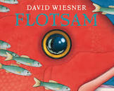 | How to make a sandwich  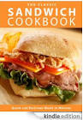 | The day the crayons quit  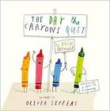 | Excitable Edgar  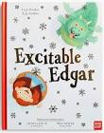 | How a giant spider traps its prey?  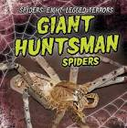 | Granddad’s island  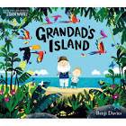 | Hamelin  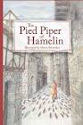 | Should animals be kept in a zoo? | Kuang – Li and the Dragon | 3 Billy Goats Gruff  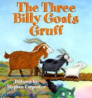 | Why Spider has a small waist.  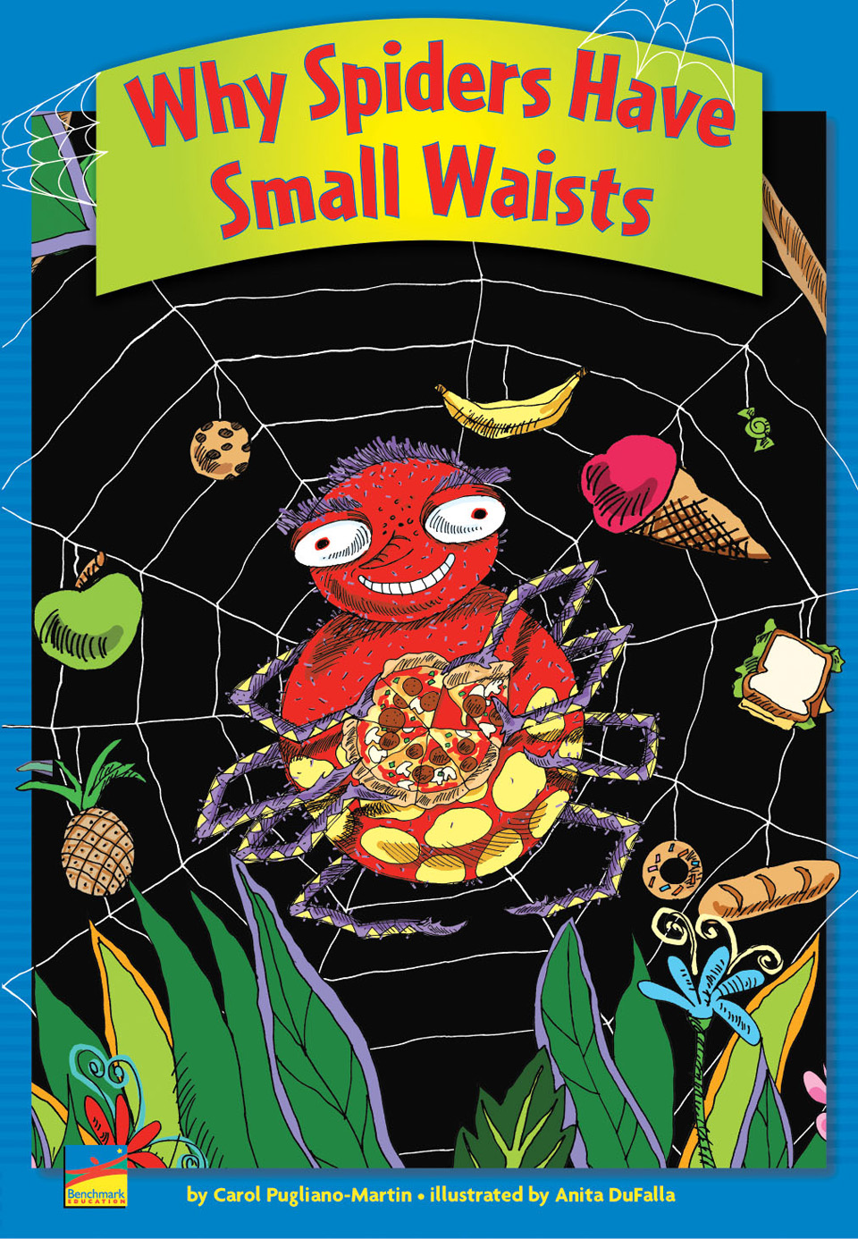 | The Flower  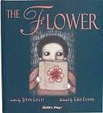
 | FOCUS | Using 1st person to write a recount. | Vary sentence order, length and openings to interest and hook the reader | To become more familiar with persuasive texts allowing us to magpie a range of persuasive devices. | Create a knowledge and understanding of past tense verbs | 3-part text structure and technical language | Use figurative language such as alliteration, onomatopoeia, similes, metaphors and personification | Characterisation and dialogue | To use a range of clauses to combine information, create emphasis and make the text more interesting for the reader. | paragraphs | Using adjectives and adverbs to add description | Character and dialogue | Settings and prepositions to describe settings

