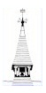

Sound and District Primary School

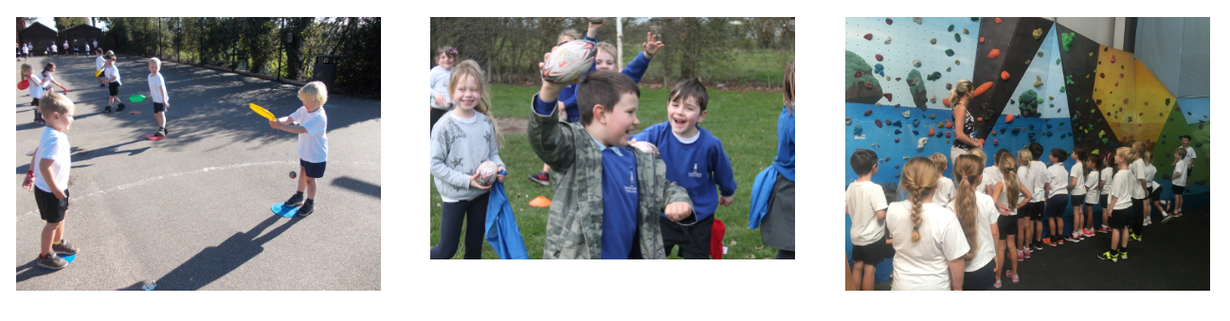

PE CURRICULUM DOCUMENT
2020-2021

Sound and District Primary School -Vision for PE

Here at Sound and District Primary School we believe that Physical Education not only improves health, reduces stress and improves concentration, but also promotes correct physical growth and development. Exercise has a positive influence on academic achievement, emotional stability and interaction with others. We aim for both teachers and children to be aware of its importance. We strive to provide a broad and balanced program for Physical Education that is linked to wider health, physical activity and sporting opportunities. We believe every child should have access to these opportunities and activities that are designed to be enjoyable, vigorous, purposeful and regular. Through providing positive experiences, a lifelong interest in physical activity is encouraged. Our aim is to increase participation in physical activity outside of the two hours offered as part of the PE curriculum and in line with government recommendations of pupils being active for an hour a day.
PE National Curriculum - Purpose of study: A high-quality physical education curriculum inspires all pupils to succeed and excel in competitive sport and other physically-demanding activities. It should provide opportunities for pupils to become physically confident in a way which supports their health and fitness. Opportunities to compete in sport and other activities build character and help to embed values such as fairness and respect.
Aims: The national curriculum for physical education aims to ensure that all pupils: develop competence to excel in a broad range of physical activities
are physically active for sustained periods of time
engage in competitive sports and activities lead healthy, active lives.
This curriculum document has been designed to give you an overview of how PE is taught at (School name).

The PE curriculum overview document shows the range of activities that pupils will be taught throughout each group. It is up to the teacher in the year group as to how long they will spend on each activity area and this should be based on the physical the needs and interests of the pupils in that year group..

The subject and generic concept tables give details to some of the main areas of focus we are hoping to develop through the PE curriculum. The coverage tables detail which of the subject and generic concepts will be highlighted and focussed on during which unit throughout the year groups. The times examined column – shows how many times each concept will be focused on throughout the planned PE curriculum.

The progression of skills table gives a breakdown of the EYFS and National Curriculum objectives that pupils will be working on in each year group. Although teacher will use and adjust this as fits the needs and abilities of pupils in their class.

The subject specific vocabulary and resource pages in this document act as a reminder to staff of the resources available to help the planning and delivery of individual sessions. All of these resources can be found on the staff shared area.

For further help or support with PE. (named person) is the subject lead and is happy to help and support with any questions you may have.

PE Curriculum Overview
 | Autumn 1 | Autumn 2 | Spring 1 | Spring 2 | Summer 1 | National Sports Week – taster sessions for ‘new’ sports/activities | Summer 2
R | Gymnastics  &  Body Management | Gymnastics  &  Christmas Play | Dance  &  Swimming | Co-operation & Solve problems  &  Swimming | Speed, Agility & Travel  &  Athletics |  | Manipulation and co-ordination  &  Rounders
Y 1 | Attack, Defend and Shoot  (Netball) | Gymnastics  &  Christmas Play | Dance  &  Swimming | Hit, Catch and Run  &  Swimming | Run, Jump and throw  &  Athletics |  | Send and Return  &  Rounders
Y2 | Attack, Defend and Shoot  (Netball) | Gymnastics  &  Christmas Play | Dance  &  Swimming | Hit, Catch and Run | Swimming  &  Run, Jump and throw |  | Swimming  &  Send and Return  (Rounders)
Y 3 | Tag Rugby  &  Netball | Lacrosse  &  Handball | Dance  &  Football | Tennis  &  Gymnastics | Athletics  &  Cricket |  | OAA  &  Rounders
Y4 | Tag Rugby  &  Hockey | Handball  &  Netball | Football  &  Dance | Gymnastics  &  Tennis | Athletics  &  Cricket |  | OAA  &  Rounders
Y 5/6 | Tag Rugby  &  Netball | Hockey  &  Handball | Dance  &  Gymnastics | Football  &  Tennis | Athletics  &  Cricket |  | OAA  &  Rounders
Intra-competition | Netball competition – final week of ½ term  all classes to play competition – all pupils involved.  KS1 & KS2 tournament.  (R to generate small competition e.g. team relays etc with ball skills) | KS2 Handball Competition – ball skills – final week of ½ term  R and KS1  Gymnastics performance – final week of ½ term | Whole school to generate dances for display for school (whole class or groups) | KS2 Tennis competition –  final week of ½ term  R & KS1 to generate small competition involving passing, catching & some hitting | R, KS1 & KS2  Sports Day |  | Whole school rounder’s competition  (including staff v children)  Y6 v staff!
Teams/inter competition | Netball & Football team training begins.  Inter-school competitions  Football  Netball  Tag Rugby | Netball, Football & Sports hall Athletics training commences/continues.  Inter-school competitions  Football  Netball | Inter-school competition  Golden Mile club commences & Indoor Athletics continues. | Cricket trails & team training begins.  Inter-school competitions  Cricket | Athletics teams chosen & training begins.  Interschool competition  Athletics |  | Netball & Football trials and teams chosen ready for September.  Inter-school competition  Rounders

Other Key Dates:
Mental Health awareness day | Sports Relief | School Sports Week | Olympics

It is an expectation that 2 sessions of PE are taught each week
Notes: You do not have to teach each area at a certain time but must cover all areas over the year. Each year group has 2 half terms of dance and gymnastics which should provide a minimum of 12 hours for each area. Some year groups have a choice of game activities within their curriculum. They may choose to teach through a variety of different activities or through one activity they’d like to specialise in.

Subject Concepts
Subject concept |  | Definition
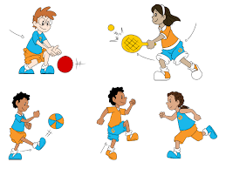 | Movement | Fundamental movement skills are the various gross motor skills such as running, jumping, balancing, throwing, catching, kicking etc. These skills are the basis for all physical activity that we do in sports, dance, gymnastics and other physical activities. It is important that these skills are learnt so that children feel confident in accessing all forms of sport and exercise.
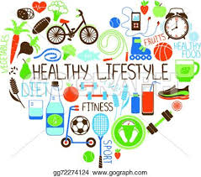 | Fitness & Health | Health means a person has good physical health, no injuries, diseases or issues, and good mental health and well being. ... Fitness is a state or condition of being physically active. Fitness is a result of general nutrition and proper conditioning, and fitness is a state of general physical and mental well-being.
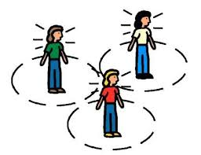 | Body & Spatial Awareness | Body awareness is the ability to understand where our bodies are in space and how our bodies move. Spatial awareness is the ability to be aware of oneself in space. It is an organised knowledge of objects in relation to oneself in that given space. Spatial awareness also involves understanding the relationship of these objects when there is a change of position.
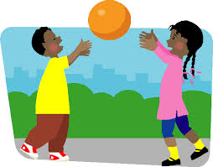 | Control | Object control skills can be defined as those abilities that an athlete displays that move or receive an item with accuracy and control. Manipulative skills are related and can be defined as the ability to move an object with the feet, hands, or even the body. The two terms are often referred to synonymously.
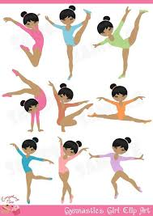 | Sequencing | The combination of fundamental movement skills and movement elements to enable the body and/or objects to move in response to a stimulus.  Being able to sequence in a multi-step task or activity performance to achieve a well-defined result
 | Health & Safety | Health and safety refers to guidelines and procedures that protect the safety, welfare and health of any person engaged in work or employment. Pupils should understand and be actively involved in the health and safety procedures for PE. Ensuring these are followed correctly so they can help to prevent accidents and reduce the risk of injury and illness.
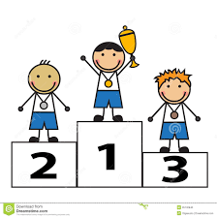 | Competition, performance  & pathways | Pupils should have the opportunity to take part in a variety of events and competitions which allow them to understand and follow rules, experience the concept of winning and losing, being part of a team and trying their best. They should also have the opportunity to perform to an audience. They should also understand the pathways to further their performance and interest through clubs and other outside agencies.

Generic Concepts
Generic concept |  | Definition
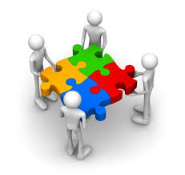 | Teamwork | Teamwork is the combined action and efforts of a group to make them effective and efficient. Pupils should experience being part of a team and playing their part in working towards a variety of goals and achievements.
 | Communication | Communication is the imparting or exchanging of information by speaking, writing, or using some other medium. Pupils should be able to understand the importance of good communication to achieve desired outcomes.
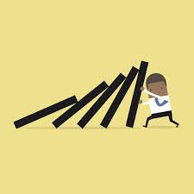 | Resilience | Resilience is the capacity to recover quickly from difficulties. Pupils should learn to persevere when problem solving, when trying to achieve a difficult goal or when faced with adversity.
 | Organisation | Organisation means to arrange systematically, to order, to make arrangements or preparations for (an event or activity). Pupils should learn to be able to organise themselves for the events and activities they are going to take part in. They should also have knowledge of organising equipment and materials necessary to undertake the activities.
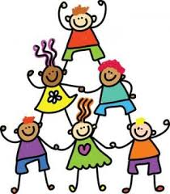 | Co-operation | Co-operation is the action or process of working together to the same end. Pupils should be able to co-operate in various ways on different tasks and activities.
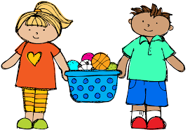 | Fairness | Fairness is the ability to be impartial and just in the treatment or behaviour towards others without favouritism or discrimination. Pupils should learn to involve everyone in activities, to encourage each other and to keep to any rules of games.
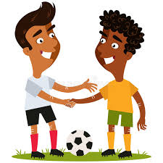 | Respect | Respect is showing due regard for the feelings, wishes, or rights of others. Pupils should show respect for themselves, each other and adults and demonstrate this in the activities they are part of.

Coverage of Subject & Generic Concepts

Reception
Dance
movement | fitness& health | awareness | control | sequencing | health& safety | comp/ perform
teamwork | communication | resilience | organisation | Cooperation | fairness | respect
Gymnastics
movement | fitness& health | awareness | control | sequencing | health& safety | comp/ perform
teamwork | communication | resilience | organisation | Cooperation | fairness | respect
Health & Fitness
movement | fitness& health | awareness | control | sequencing | health& safety | comp/ perform
teamwork | communication | resilience | organisation | Cooperation | fairness | respect
Fundamental Movement Skills
movement | fitness& health | awareness | control | sequencing | health& safety | comp/ perform
teamwork | communication | resilience | organisation | Cooperation | fairness | respect
Water Confidence Sessions
movement | fitness& health | awareness | control | sequencing | health& safety | comp/ perform
teamwork | communication | resilience | organisation | Cooperation | fairness | respect
Forest School Activities
movement | fitness& health | awareness | control | sequencing | health& safety | comp/ perform
teamwork | communication | resilience | organisation | Cooperation | fairness | respect

Year 1
Dance
movement | fitness& health | awareness | control | sequencing | health& safety | comp/ perform
teamwork | communication | resilience | organisation | Cooperation | fairness | respect
Gymnastics
movement | fitness& health | awareness | control | sequencing | health& safety | comp/ perform
teamwork | communication | resilience | organisation | Cooperation | fairness | respect
Health & Fitness
movement | fitness& health | awareness | control | sequencing | health& safety | comp/ perform
teamwork | communication | resilience | organisation | Cooperation | fairness | respect
Fundamental Movement Skills/ Games/ Athletics
movement | fitness& health | awareness | control | sequencing | health& safety | comp/ perform
teamwork | communication | resilience | organisation | Cooperation | fairness | respect
Yoga/ Stretching
movement | fitness& health | awareness | control | sequencing | health& safety | comp/ perform
teamwork | communication | resilience | organisation | Cooperation | fairness | respect
Forest School Activities
movement | fitness& health | awareness | control | sequencing | health& safety | comp/ perform
teamwork | communication | resilience | organisation | Cooperation | fairness | respect

Year 2
Dance
movement | fitness& health | awareness | control | sequencing | health& safety | comp/ perform
teamwork | communication | resilience | organisation | Cooperation | fairness | respect
Gymnastics
movement | fitness& health | awareness | control | sequencing | health& safety | comp/ perform
teamwork | communication | resilience | organisation | Cooperation | fairness | respect
Health & Fitness
movement | fitness& health | awareness | control | sequencing | health& safety | comp/ perform
teamwork | communication | resilience | organisation | Cooperation | fairness | respect
Fundamental Movement Skills/ Games/ Athletics
movement | fitness& health | awareness | control | sequencing | health& safety | comp/ perform
teamwork | communication | resilience | organisation | Cooperation | fairness | respect
Yoga/ Stretching
movement | fitness& health | awareness | control | sequencing | health& safety | comp/ perform
teamwork | communication | resilience | organisation | Cooperation | fairness | respect
Outdoor and Adventurous/ Forest School Activities
movement | fitness& health | awareness | control | sequencing | health& safety | comp/ perform
teamwork | communication | resilience | organisation | Cooperation | fairness | respect

Year 3
Dance
movement | fitness& health | awareness | control | sequencing | health& safety | comp/ perform
teamwork | communication | resilience | organisation | Cooperation | fairness | respect
Gymnastics
movement | fitness& health | awareness | control | sequencing | health& safety | comp/ perform
teamwork | communication | resilience | organisation | Cooperation | fairness | respect
Health & Fitness
movement | fitness& health | awareness | control | sequencing | health& safety | comp/ perform
teamwork | communication | resilience | organisation | Cooperation | fairness | respect
Athletics
movement | fitness& health | awareness | control | sequencing | health& safety | comp/ perform
teamwork | communication | resilience | organisation | Cooperation | fairness | respect
Invasion/ Net & Wall/ Striking & Fielding Games
movement | fitness& health | awareness | control | sequencing | health& safety | comp/ perform
teamwork | communication | resilience | organisation | Cooperation | fairness | respect
Swimming
movement | fitness& health | awareness | control | sequencing | health& safety | comp/ perform
teamwork | communication | resilience | organisation | Cooperation | fairness | respect
Outdoor and Adventurous/ Forest School Activities
movement | fitness& health | awareness | control | sequencing | health& safety | comp/ perform
teamwork | communication | resilience | organisation | Cooperation | fairness | respect

Year 4
Dance
movement | fitness& health | awareness | control | sequencing | health& safety | comp/ perform
teamwork | communication | resilience | organisation | Cooperation | fairness | respect
Gymnastics
movement | fitness& health | awareness | control | sequencing | health& safety | comp/ perform
teamwork | communication | resilience | organisation | Cooperation | fairness | respect
Health & Fitness
movement | fitness& health | awareness | control | sequencing | health& safety | comp/ perform
teamwork | communication | resilience | organisation | Cooperation | fairness | respect
Athletics
movement | fitness& health | awareness | control | sequencing | health& safety | comp/ perform
teamwork | communication | resilience | organisation | Cooperation | fairness | respect

Year 4
Invasion/ Net & Wall/ Striking & Fielding Games
movement | fitness& health | awareness | control | sequencing | health& safety | comp/ perform
teamwork | communication | resilience | organisation | Cooperation | fairness | respect
Swimming
movement | fitness& health | awareness | control | sequencing | health& safety | comp/ perform
teamwork | communication | resilience | organisation | Cooperation | fairness | respect
Outdoor and Adventurous/ Forest School Activities
movement | fitness& health | awareness | control | sequencing | health& safety | comp/ perform
teamwork | communication | resilience | organisation | Cooperation | fairness | respect

Year 5
Dance
movement | fitness& health | awareness | control | sequencing | health& safety | comp/ perform
teamwork | communication | resilience | organisation | Cooperation | fairness | respect
Gymnastics
movement | fitness& health | awareness | control | sequencing | health& safety | comp/ perform
teamwork | communication | resilience | organisation | Cooperation | fairness | respect
Health & Fitness
movement | fitness& health | awareness | control | sequencing | health& safety | comp/ perform
teamwork | communication | resilience | organisation | Cooperation | fairness | respect
Athletics
movement | fitness& health | awareness | control | sequencing | health& safety | comp/ perform
teamwork | communication | resilience | organisation | Cooperation | fairness | respect
Invasion/ Net & Wall/ Striking & Fielding Games
movement | fitness& health | awareness | control | sequencing | health& safety | comp/ perform
teamwork | communication | resilience | organisation | Cooperation | fairness | respect
Top up Swimming
movement | fitness& health | awareness | control | sequencing | health& safety | comp/ perform
teamwork | communication | resilience | organisation | Cooperation | fairness | respect
Leadership
movement | fitness& health | awareness | control | sequencing | health& safety | comp/ perform
teamwork | communication | resilience | organisation | Cooperation | fairness | respect

Year 6
Dance
movement | fitness& health | awareness | control | sequencing | health& safety | comp/ perform
teamwork | communication | resilience | organisation | Cooperation | fairness | respect
Gymnastics
movement | fitness& health | awareness | control | sequencing | health& safety | comp/ perform
teamwork | communication | resilience | organisation | Cooperation | fairness | respect
Health & Fitness
movement | fitness& health | awareness | control | sequencing | health& safety | comp/ perform
teamwork | communication | resilience | organisation | Cooperation | fairness | respect
Athletics
movement | fitness& health | awareness | control | sequencing | health& safety | comp/ perform
teamwork | communication | resilience | organisation | Cooperation | fairness | respect
Invasion/ Net & Wall/ Striking & Fielding Games
movement | fitness& health | awareness | control | sequencing | health& safety | comp/ perform
teamwork | communication | resilience | organisation | Cooperation | fairness | respect
Yoga/ Stretching
movement | fitness& health | awareness | control | sequencing | health& safety | comp/ perform
teamwork | communication | resilience | organisation | Cooperation | fairness | respect
Outdoor and Adventurous/ Forest School Activities
movement | fitness& health | awareness | control | sequencing | health& safety | comp/ perform
teamwork | communication | resilience | organisation | Cooperation | fairness | respect

Progression of Sport Specific Skills

Progression of learning objectives in Tag Rugby

Year 4 will be learning:
- To consistently perform basic tag rugby skills
- To implement rules and develop tactics in competitive situations
- To increase speed and develop endurance during game play

Year 5 will be learning:
- To combine basic tag rugby skills such as catching and quickly passing one movement
- To be able to select and implement appropriate skills in a game situation
- To begin to play effectively when attacking and defending
- To increase the power of passes so the ball can be moved quickly over greater distance

Year 6 will be learning:
- To choose and implement a range of strategies and tactics to attack and defend.
- To combine and perform more complex skills at speed
- To observe, analyse and recognise good individual and team performances

Progression of learning objectives in Hockey
Year 4 will be learning:
- To be able to consistently perform basic hockey skills such as dribbling and push pass
- To implement basic rules of hockey
- To develop tactics and apply them to basic competitive situations
- To increase speed and endurance during game play
Year 5 will be learning:
- To be able to combine basic hockey skills such as dribbling and push pass
- To be able to confidently select and apply skills in a game situation
- To begin to play effectively in different positions on the pitch including defence
- To increase power and strength of passes, moving the ball over longer distances
Year 6 will be learning:
- To choose and implement a range of strategies and tactics to attach and defend
- To combine and perform more complex skills ar great speed
- To recognise and describe good individual and team performances
- To suggest, plan and lead a warm up as a small group.

Progression of learning objectives in Rounders

Year 3 will be learning:
- To be able to play simple rounders games
- To apply some rules to the game
- To develop and use simple rounders skills

Year 4 will be learning:
- To develop the range of rounders skills that can apply in a competitive context
- To choose and use a range of simple tactics in isolations and in a game context
- To identify different positions in rounders and the role of this positions

Year 5 will be learning:
- To link together a range of skills and use in combination
- To collaborate as a team to choose, use and adapt rules in games
- To recognise how some aspects of fitness apply to rounders e.g. power, flexibility and cardiovascular endurance

Year 6 will be learning:
- To apply consistently rounders in conditioned games
- To play small sided games using standard rounders pitch layout
- To use a range of tactics for attacking and defending in role of bowler, batter and fielder

Progression of learning objectives in Athletics

Year 3 will be learning:
- To control movements and body actions in response to specific instructions.
- To demonstrate agility and speed
- To jump for height and distance with control and balance
- To throw with speed and power and apply force.
Year 4 will be learning:
- To use running, jumping and throwing work stations children investigate in small groups different ways of performing these activities
- To use a variety of equipment, ways of measuring and timing, comparing the effectiveness of different styles of runs, jumps and throws
Year 5 will be learning
- To sustain pace over short and longer distances such as running 100m and running for 2 minutes
- To be able to run as part of a relay team working at their maximum speed
- To perform a range of jumps and throws demonstrating increasing power and accuracy.
Year 6 will be learning:
- To become confident and expert in a range of techniques and recognise their own success
- To apply strength and flexibility to a borad range of throwing, running and jumping activities
- To work in collaboration and demonstrate improvement when working with self and others
- To accurately and confidently judge across a range of activities

Progression of learning objectives in Outdoor Adventurous Activities

Year 3 will be learning:
- To work with other to solve problems
- To describe their work and use different strategies to solve problems
- To lead other and be led
- To differentiate between when a task is competitive and when it is collaborative
Year 4 will be learning:
- To work well in a team group within defined and understood roles
- To plan and refine strategies to solve problems
- To identify the relevance pf and use maps, compass and symbols
- To identify what they do well and suggest what they could do to improve
Year 5 will be learning:

Year 6 will be learning:
- To use information given by others to complete tasks and work collaboratively
- To undertake more complex tasks
- To take responsibility for a role in a task
- To use knowledge of PE and physical activities to suggest design ideas & amendments to games

Progression of learning objectives in Football

Year 3 will be learning:
- To be able to show basic control skills including sending and receiving the ball
- To send the ball with some accuracy to maintain possession and build attacking play
- To implement the basic rules of football
Year 4 will be learning:
- To introduce some defensive skills
- To dribble in different directions using different parts of their feet
- To pass for distance
- To evaluate skills to aid improvement
Year 5 will be learning:
- To play effectively in a variety of positions and formations on the pitch
- To relate a greater number of attacking and defensive tactics to game play
- To become more skilful when performing movements at speed
Year 6 will be learning:
- To choose and implement a range of strategies to attach and defend
- To perform a wider range of more complex skills
- To recognise and describe good individual and team performances
- To suggest, plan and lead simple drills for given skills

Progression of learning objectives in Netball

Year 3 will be learning:
- To be able to perform basic netball skills such as passing and catching using recognised throws
- To use space effectively to build attacking play
- To implement the basic rules of netball
Year 4 will be learning:
- To introduce high five netball positions
- To acquire and basic shooting techniques
- To demonstrate and implement some basic rules of high five
- To develop netball skill such as marking and footwork
Year 5 will be learning:
- To be able to confidently use specific netball skills in games for example: pivoting, dodging, bounce pass and previously learnt skills
- To begin to play effectively in different positions on the pitch in both attach and defence
- To increase power and strength of passes, moving the ball over longer distances
Year 6 will be learning:
- To work as a team to improve group tactics and game play
- To play within the rules using block skills for shots and passes
- To develop defensive skills

Progression of learning objectives in Cricket

Year 3 will be learning:
- To be able to adhere to some basic rules of cricket
- To develop a range of skills to use in isolation and a competitive context
- To use basic skills with more consistency including striking a bowled ball.
Year 4 will be learning:
- To develop the range of cricket skills they can apply in a competitive context
- To choose and use a range of simple tactics in isolation and in game context
- To consolidate existing skills and apply with consistency
Year 5 will be learning:
- To link together a range of skills and use in combination
- To collaborate as a team to choose use and adapt rules in games
- To recognise how some aspects of fitness apply to cricket e.g. power, flexibility and cardiovascular endurance
Year 6 will be learning:
- To apply with consistency standard cricket rules in a variety of different styles of games
- To attempt a small range of recognised shots in isolation and in competitive scenarios
- To use a range of tactics for attacking and defending in role of bowler, batter and fielder

Progression of learning objectives in Tennis

Year 3 will be learning:
- To identify and describe some rules of tennis
- To serve to begin a game
- To explore forehand hitting
Year 4 will be learning:
- To explore different shots (forehand, backhand)
- To work to return serve
- To know positions in game play
Year 5 will be learning:
- To introduce volley shots and overhead shots
- To apply new shots into game situations
- To play with others to score and defend points in competitive games
- To further explore tennis service rules
Year 6 will be learning:
- To develop backhand shots
- To introduce the lob
- To begin to use full tennis scoring systems
- To continue developing doubles play and tactics to improve

Progression of learning objectives in Hitting

Year 1 will be learning:
- To be able to hit objects with hand or bat
- To track and retrieve a rolling ball
- To throw and catch a variety of balls and objects
- To develop sending and receiving sills to benefit fielding as a team
- To distinguish between the roles of batters and fielders
- To introduce the concept of simple tactics
Year 2 will be learning:
- To develop hitting skills with a variety of bats
- To practise feeding/bowling skills
- To hit and run to score points in games
- To work on a variety of ways to score runs in different hit catch runs game s
- To work in teams to field
- To begin to play the role of wicket keeper or backstop

Progression of learning objectives in Attacking

Year 1 will be learning:
- To practise basic movements including running, jumping, throwing and catching
- To begin to engage in competitive activities
- To experience opportunities to improve agility, balance and co-ordination
- To recognise rules and apply them in competitive and cooperative games
- To use and apply simple strategies for invasion games
- To prepare for and explain the reasons why we enjoy exercise
Year 2 will be learning:
- To send a ball using feet and receive a ball using feet
- To refine ways to control bodies and a range of equipment
- To recall and link combination of skills e.g. dribbling and passing
- To select and apply a small range of simple tactics
- To recognise good quality in self and others
- To work with others to build basic attacking play

Progression of learning objectives in Gymnastics

Reception will be learning:
- To develop confidence in fundamental movements
- To experience jumping, sliding, rolling, moving over, under and on apparatus
- To develop coordination and gross motor skills
- To develop confidence in fundamental movements
- To learn and refine a variety of shapes, jumps, balances and rolls
- To link simple balance, jump and travel actions
Year 1 will be learning:
- To identify and use simple gymnastics actions and shapes
- To apply basic strength to a range of gymnastics actions
- To begin to carry basic apparatus such as mats and benches
- To perform a variety of basic gymnastics actions showing control
- To introduce turn, twist, spin, rock and roll and link these into movement patterns
- To perform longer movement phases and link with confidence
Year 2 will be learning:
- To describe and explain how performers can transition and link gymnastic elements
- To perform with control and consistency basic actions at different speeds and on different levels
- To challenge themselves to develop strength and flexibility
- To create and perform a simple sequence that is judged using simple gymnastic scoring
- To develop body management through a range of floor exercise
- To use core strength to link recognised gymnastic elements e.g. back support and half twist
- To attempt to use rhythm whist performing a sequence
Year 3 will be learning
- To modify actions independently using different pathways, directions and shapes
- To consolidate and improve quality of movements and gymnastics actions
- To relate strength and flexibility to the actions and movements they are performing
- To use basic compositional ideas to improve sequence work-unison
- To identify similarities and differences in sequences
- To develop body management over a range of floor exercises
- To attempt to bring explosive moved in to floor work through jumps and leaps
- To show increasing flexibility in shapes and balances
Year 4 will be learning:
- To become increasingly competent and confident to perform skills more consistently
- To be able to perform in time with a partner and group
- To use compositional ideas in sequences such as changed in height, speed and direction
- To develop an increased range of body action and shapes to include in a sequence
- To define muscles groups needed to support the core of their body

Year 5 will be learning:
- To create longer and more complex sequences and adapt performances
- To take the lead in a group when preparing a sequence
- To develop symmetry individually, as a pair and in a small group
- To compare performances and judge strengths and areas for improvement
- To select a component for improvement. For example timing or flow
- To take responsibility in own warm up including remembering and repeating a variety of stretches
- To perform more complex actions, shapes and balances with consistency
- To use information given by others to improve performance
- To remember and repeat longer sequences with more difficult actions
Year 6 will be learning:
- To lead group warm up showing understanding of need for strength and flexibility
- To demonstrate accuracy, consistency and clarity of movement
- To work independently and in small groups to make up own sequences
- To arrange own apparatus to enhance work and vary compositional ideas
- To experience flight in and off high apparatus
- To perform increasingly complex sequences
- To combine own ideas with others to build sequences
- To compose and practise actions and relate to music
- To show a desire to improve competency across a broad range of gymnastics actions

Progression of learning objectives in Physical Literacy
Reception will be learning:
- To explore balance and managing own body including manipulating small objects
- To be able to stretch, reach, extend in a variety of ways and positions
- Tobe able to control body and perform specific movements on command

- To explore a variety of rolling, sliding and slithering
- To jump using a variety of take offs and landings, moving in and off low apparatus using hands and feet in a variety of combinations
- To participate in a variety of small group co-operative activities

- To travel with some control and co-ordination
- To change direction at speed through both choice and instructions
- To perform actions demonstrating changed in speed
- To stop, start, pause, prepare for and anticipate movement in a variety of situations

- To participate in a variety of agility moving and controlling objects
- To recognise the difference between actions such as: moving softly, quietly, quickly, powerfully, etc.
- To relate body movements to music and percussion beats

- To send and receive a variety of objects with different body parts
- To work with others to control objects in space
- To co-ordinate body parts such as hand eye, foot eye over a variety of activities and in different ways.

Progression of skills

Year group | Key Skills | National Curriculum
Reception | - Experiments with different ways of moving.  - Jumps off an object and lands appropriately.  - Negotiates space successfully when playing racing and chasing games with other children, adjusting speed or changing direction to avoid obstacles.  - Travels with confidence and skill around, under, over and through balancing and climbing equipment.  - Shows increasing control over an object in pushing, patting, throwing, catching or kicking it.  - Uses simple tools to effect changes to materials.  - Handles tools, objects, construction and malleable materials safely and with increasing control.  - Shows a preference for a dominant hand.  - Eats a healthy range of foodstuffs and understands need for variety in food.  - Shows some understanding that good practices with regard to exercise, eating, sleeping and hygiene can contribute to good health.  - Shows understanding of the need for safety when tackling new challenges, and considers and manages some risks.  - Shows understanding of how to transport and store equipment safely.  - Practices some appropriate safety measures without direct supervision. | Early Learning Goals  Children show good control and co-ordination in large and small movements. They move confidently in a range of ways, safely negotiating space. They handle equipment and tools effectively, including pencils for writing.  Children know the importance for good health of physical exercise, and a healthy diet, and talk about ways to keep healthy and safe. They manage their own basic hygiene and personal needs successfully, including dressing and going to the toilet independently.
Year 1 | - Manage space safely showing good awareness of each other.  - Perform basic gymnastics actions including travelling, rolling, jumping, climbing and balancing.  - Copy and explore basic body actions and movement patterns.  - Show some control and accuracy with the basic actions for rolling, underarm throwing, striking a ball and kicking.  - Describe own and others performance  - React to a range of stimuli  - Sustain effort throughout lesson  - Respectful of each other and equipment  - Engaged and on task throughout lessons | Master basic movements including running, jumping, throwing and catching, as well as developing balance, agility and co-ordination, and begin to apply these in a range of activities  Participate in team games, developing simple tactics for attacking and defending  Perform dances using simple movement patterns.
Year 2 | - Devise and repeat and perform short sequences in which there is a clear beginning, middle and end.  - Explore ideas moves and feelings by improvising and experimenting with actions in response to stimuli.  - Show a good awareness of others in running, chasing and avoiding games.  - Know how to score and keep to rules of simple games.  - Sustain energy levels  - Compare performances
Year 3 | - Show control, accuracy and fluency of movement when performing actions on their own and with a partner on both floor and apparatus.  - Perform short dances whilst working with a partner or small group, incorporating different qualities and dynamics into their movements.  - Pass receive and dribble the ball keeping control of possession.  - Strike a ball with intent and throw it more accurately when bowling or fielding.  - Are familiar with and use set rules and play fairly within these.  - Run consistently and smoothly at different speeds, demonstrating different combinations of jumps, showing control and co-ordination.  - Throw a range of implements into a target.  - OAA Understand the purpose of the activity and plan actions to solve the problems they are set.  - Compare performances  - Assist in leading small groups in activities  - Respond to a range stimuli  - Sustain energy levels  - Be determined to improve performance | Use running, jumping, throwing and catching in isolation and in combination  Play competitive games, modified where appropriate [for example, badminton, basketball, cricket, football, hockey, netball, rounders and tennis], and apply basic principles suitable for attacking and defending  Develop flexibility, strength, technique, control and balance [for example, through athletics and gymnastics]  Perform dances using a range of movement patterns  Take part in outdoor and adventurous activity challenges both individually and within a team  Compare their performances with previous ones and demonstrate improvement to achieve their personal best.
Year 4 | - Combine travelling, rolling, jumping and balancing actions and maintain the quality of performance when performing at the same time as a partner on both floor and apparatus.  - Use different compositional ideas such as unison, canon (same action performed one after each other), opposition when creating longer, more complex dance phrases.  - Continue to pass receive and dribble the ball keeping control of possession with greater accuracy.  - Choose and use batting and throwing skills to make the game hard for their opponents.  - Work well as a team to make it hard for the batter beginning to think about tactics to work as a team.  - Swimming – see standards.  - Run consistently and smoothly at different speeds, demonstrating different combinations of jumps, showing control and co-ordination.  - Recognise that there are different styles of running, jumping and throwing and select the best for a particular challenge.  - Throw a range of implements into a target.  - Work with determination and sustain effort and energy levels  - Describe and evaluate the effectiveness and quality of performance  - Recognise aspects of performance that require improving
Year 5 | - Repeat accurately longer sequences with more complex actions, with an emphasis on quality of movement.  - Adapt sequences to include apparatus, partner or small group work.  - Perform specific skills and movement patterns for different dance styles.  - Respond consistently in the games they play, selecting and applying skills which meet the needs of the situation.  - Use a variety of tactics to keep the ball e.g. changing speed and direction.  - Develop methods of defending their goal for example marking the opposition and positional awareness.  - Sustain their pace over longer distances, throwing and jumping with greater control and accuracy.  - Be able to perform basic relay changeovers  - Devise and carry out small group warm ups.  - Judge the strengths and weaknesses of performance and be able to make changes that improve their team and or individual performance  - Work persistently to achieve desired outcomes
Year 6 | - Increase complexity of sequences by varying directions, levels and pathways.  - Perform fluently with control when working individually, with a partner or a small group.  - Select and use a range of compositional ideas to create motifs that demonstrate their dance idea.  - Begin to choose and use different formations to suit the needs of a game.  - Plan to outwit the opposition individually, as a pair or as a team when batting, bowling or fielding.  - Hit the ball with purpose, varying the speed, height and direction in order to outwit their opponent.  - Sustain their pace over longer distances, throwing and jumping with greater control and accuracy.  - Use physical and teamwork skills well in a variety of different challenges.  - Use a variety of maps and plans accurately recognising symbols and features.  - Take the lead when devising and delivering group warm ups and skill development drills  - Watch own and others performances and suggest improvements for specific purposes.

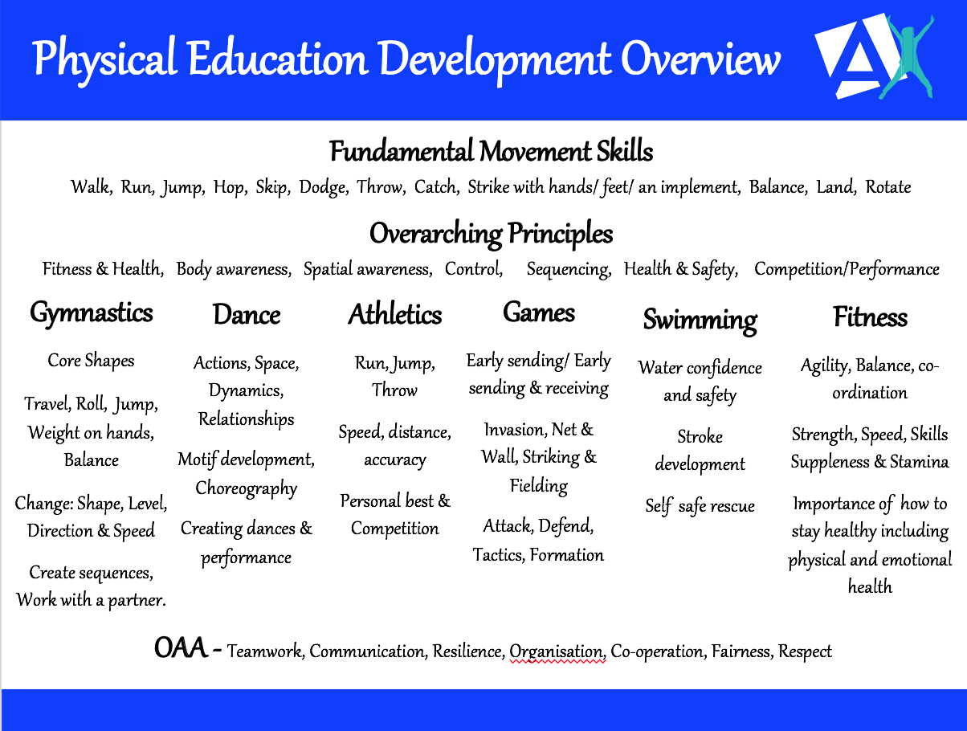

Subject Specific Vocabulary

Gymnastics

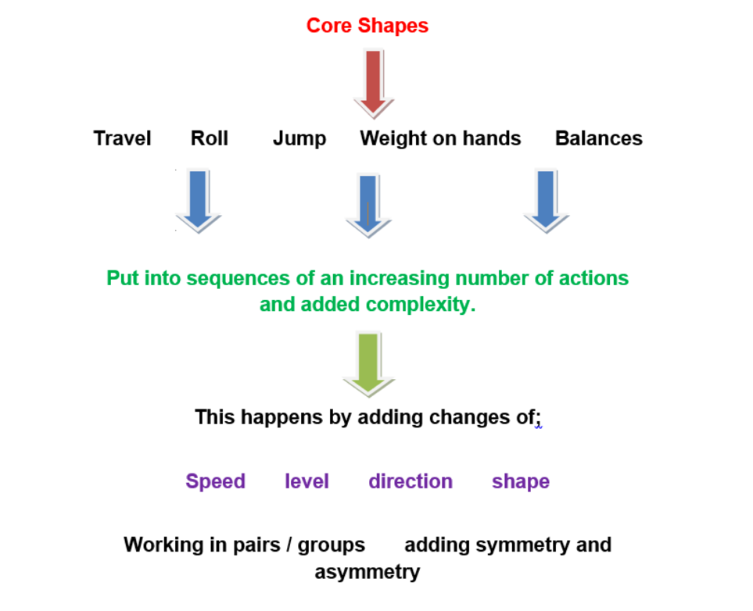

Dance
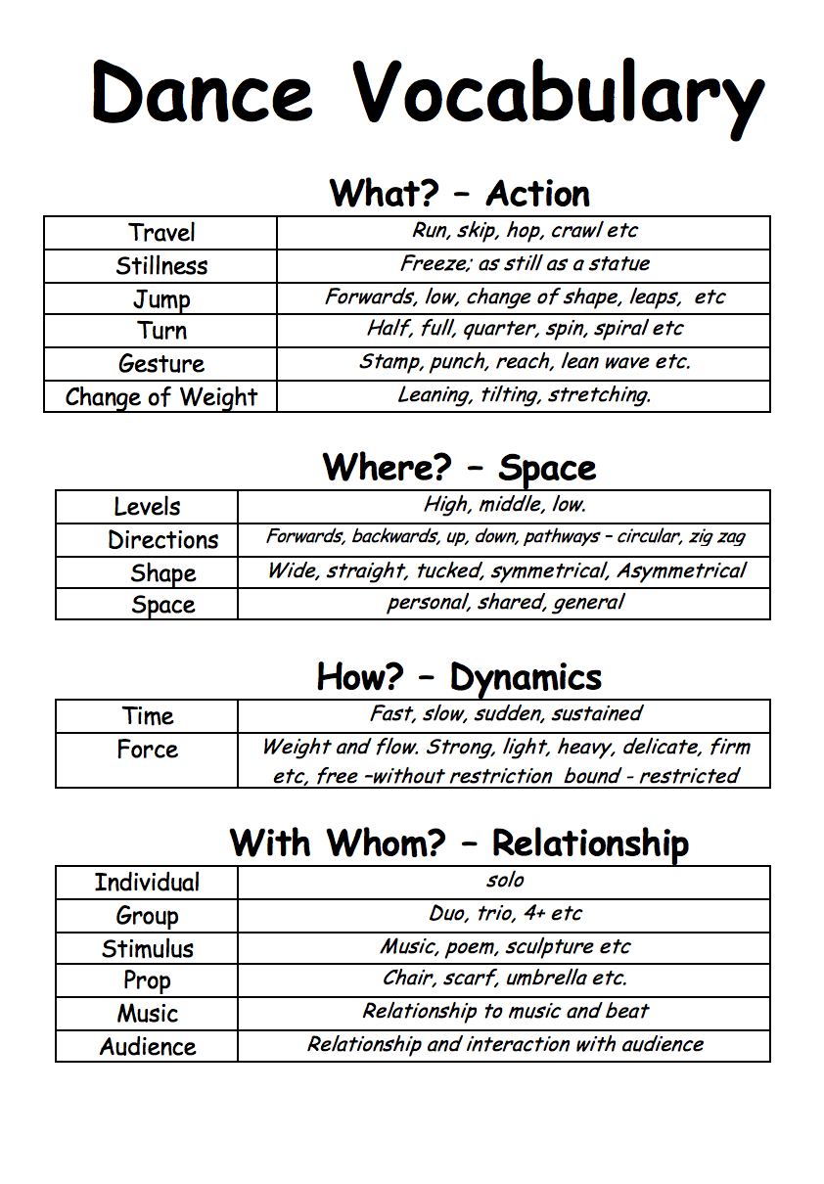

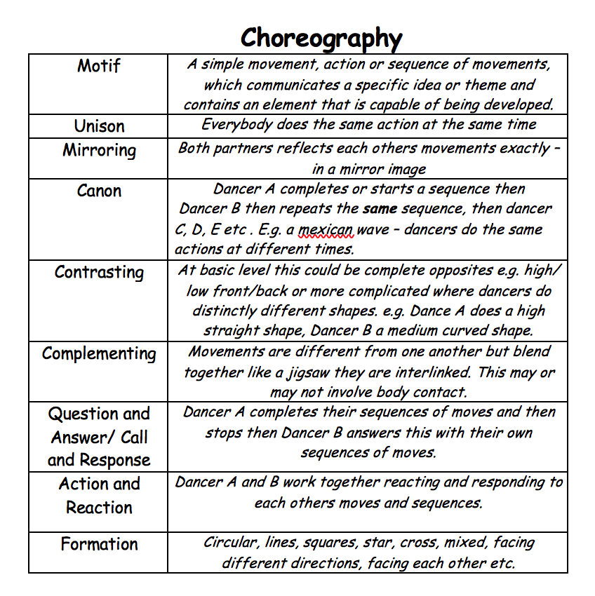

Useful Resources to Support Delivery

Subject Specific Vocabulary Posters, teaching cards and challenge cards:

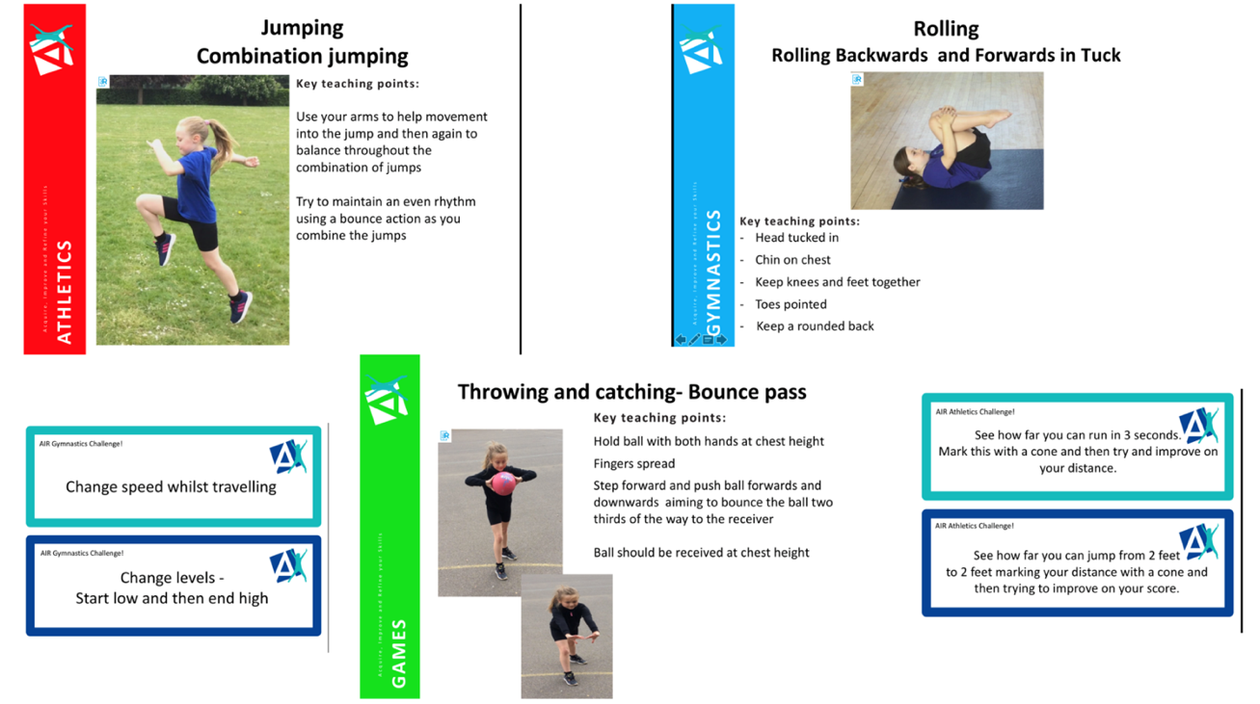

Resources that show games and activities you can use

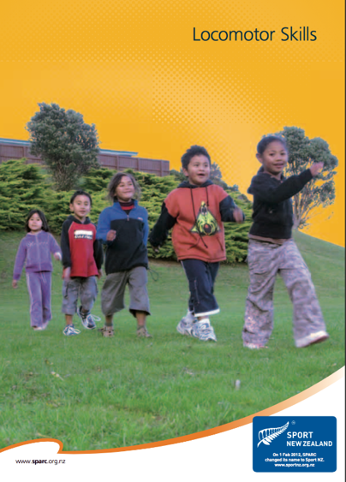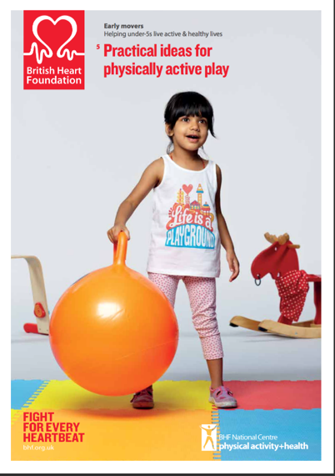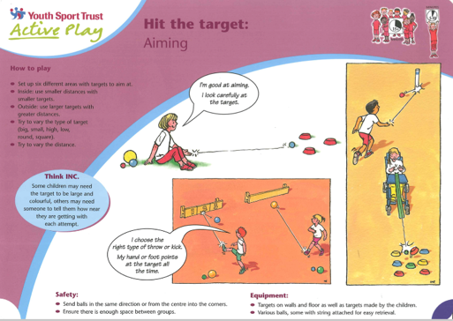

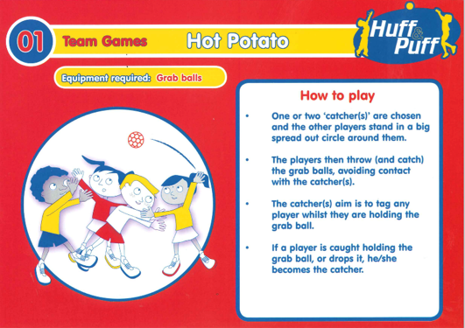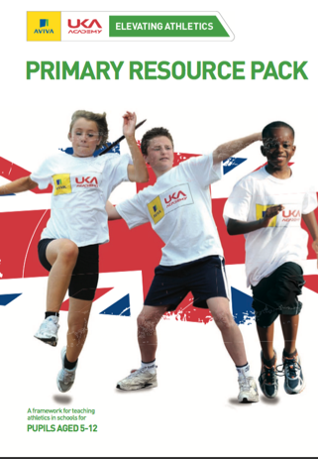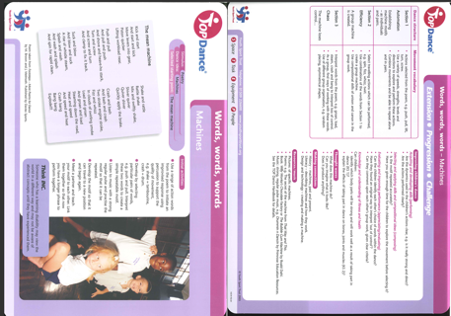

Resources to help with organisation

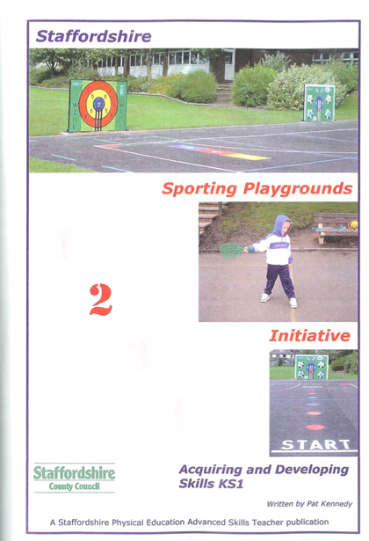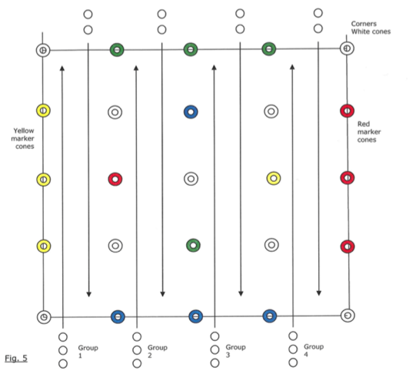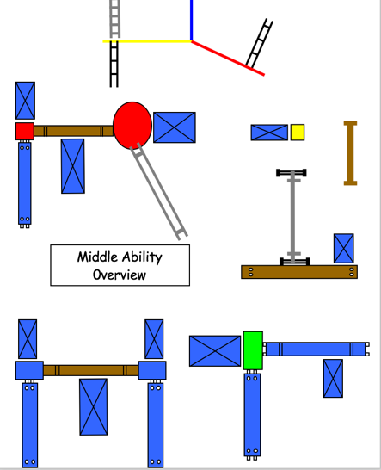

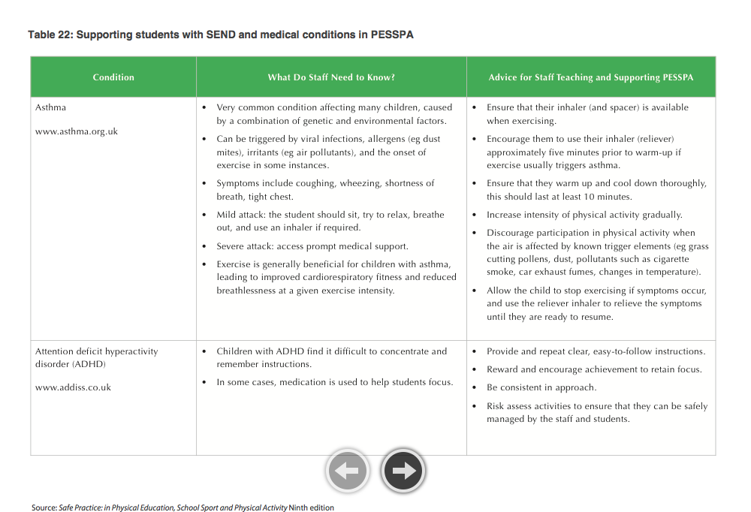
Resources for health and safety

