Reception
(Further detail on content can be found on termly plans)
 | Autumn One  (7 weeks) |  | Autumn Two  (7 weeks) |  | Spring One  (6 weeks) | Spring Two  (5 weeks 3 days) |  | Summer One  (6 weeks) | Summer Two  (6 weeks)
Topic Title / Information: | Settling in (2 weeks)  All About Me (2 weeks)  Autumn and Halloween (3 weeks) | Colours (2 weeks)  People who help Me (2 weeks)  Christmas / celebrations (3 weeks) |  |  | Winter Wonderland  (2 weeks)  Space (2 weeks)  Superheroes (2 weeks) | Fairy-tales  (4 weeks)  Easter/Spring  (1 week) |  | Farm (3 weeks)  Mini Beast topic (3 weeks) | Transport (2 weeks)  Seaside/Under the Sea  (3 weeks)  Transition
Book/text links | 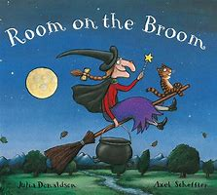  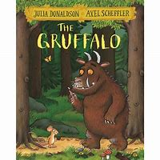 | 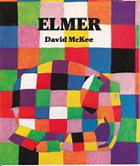  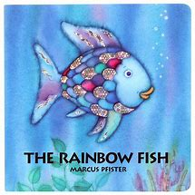 |  |  | 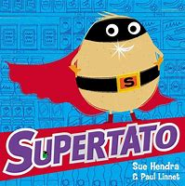  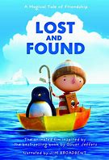 | 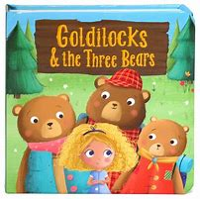  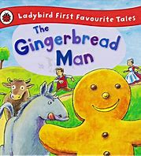 |  | 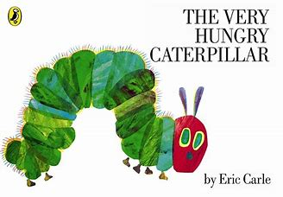  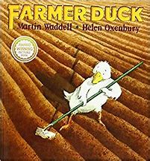 | 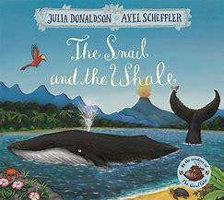  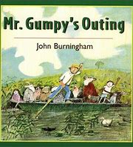
Literacy | As Writers, we will;  - Give meaning to the marks we make  - Write our own name and some captions  - Orally re-tell simple stories  - Sequence a story (through role play etc)  As Readers, we will;  - Hear and say the initial sound in words.  - Recognise familiar words including our own name.  - Begin to segment and blend the sounds in simple words. (In line with phonics knowledge) |  |  |  | As Writers, we will;  - Use story-telling vocabulary (once-upon a time..) when re-telling  - Begin to use simple connectives  - Explore rhyme and alliteration  - Use our phonics knowledge to write words which are spelt correctly or match our spoken sounds.  As Readers, we will;  - Understand that information can be retrieved from books and computers.  - Continue a rhyming string  - Use vocabulary and forms of speech that are increasingly by our experience of books.  - Segment and blend the sounds in simple words. (In line with phonics knowledge) |  |  | As Writers, we will;  - Use a capital letter at the start of sentences  - Finish a sentence with a full stop  - Use finger spaces between words.  As Readers, we will;  - Read some common irregular words.  - Use our phonic knowledge to decode regular words.  - Enjoy an increasing range of books  - Read and understand simple sentences  - Segment and blend the sounds in simple words. (In line with phonics knowledge)
Phonics | Phase 1 and Assessments  S a t p i n  m d g |  |  | B f ff  L ll ss  Reading CVC | J v x y  z zz qu  ch sh th  ng ai  ee igh |  | Oa oo  ar or  ur ow  oi ear air  ure er | Phase 4 clusters and blends  ay ou ie  oy ur ue
Communication and Language | Listening and attention  - Focuses attention  - Listens to others one to one or in small groups.  - Joins in with repeated refrains and anticipates key events and phrases in rhymes and stories.  Speaking  - Uses language to imagine in play situations.  - Includes a narrative during play.  Understanding  - Follows a story without pictures/prompts.  - Responds to instructions involving a 2-part sequence. |  |  |  | Listening and attention  - Two-channelled attention – can listen and do for short span.  - Maintains attention, concentrates and sits quietly during appropriate activity.  Speaking  - Uses talk to organise, sequence and clarify thinking, ideas, feelings and events.  - Extends vocabulary exploring the meaning and sounds of new words.  Understanding  - Understand humour eg nonsense verse  - Responds to ideas expressed by others. |  |  | Listening and attention  - Listen attentively in a range of situations.  - Listens to stories, accurately anticipating key events and respond.  - They give their attention to what others say and respond appropriately, while engaged in another activity.  Speaking  - Express themselves effectively, showing awareness of listeners’ needs.  - Use past, present and future forms accurately  - Connect ideas or events.  Understanding  - follow instructions involving several ideas or actions.  - Answer ‘how’ and ‘why’ questions about their experiences and in response to stories or events.

