Plants can grow from seeds or bulbs -
seeds  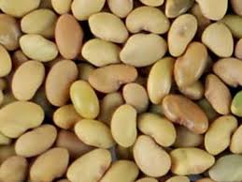 | bulbs  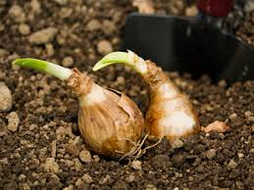
Seeds and bulbs germinate and grow into seedlings
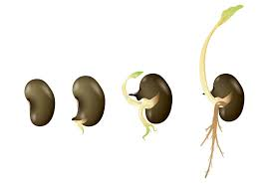
Seedlings then grow into mature plants

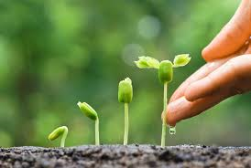
Seedling
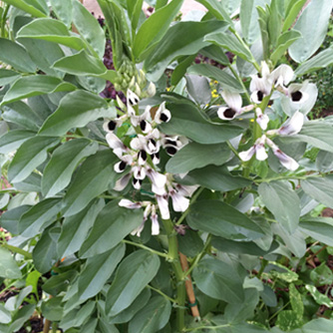
Mature plant

© ECM Education Consultants 2019
Plants – Year 2
Key vocabulary
seed | Part of a flowering plant that grows into a new plant.
bulb | A root shaped like an onion that grows into a new plant.
germinate | When a seed begins to grow its shoots. Seeds need warmth and water to germinate.
seedling | A young plant that has grown from a seed.
bud | Growth on a plant that develops into a stem, leaf or shoot.
flower | The part of a plant which is often brightly coloured and grows at the end of a stem.
fruit | Fleshy part of a plant that contains seeds or a stone.
berry | Small, juicy fruit without a stone.
root | The part of the plant that grows under the ground.
Significant scientist
David Douglas  (1799-1834)  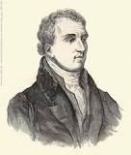 | David Douglas was a Scottish botanist, best known as the namesake of the Douglas-fir.  He worked as a gardener, and explored the Scottish Highlands, North America, and Hawaii.
Some plants grow best in full sun.  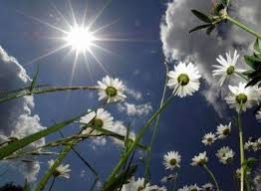 |  | Some plants grow best in the shade.  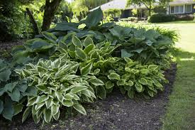
Some plants need lots of water.  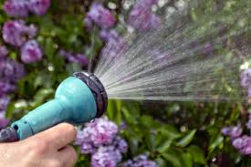 |  | Some plants don’t need much water.  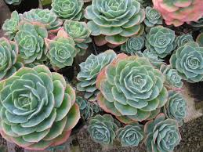
What does a plant need to grow and stay healthy?
light
water

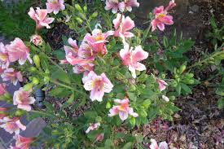
A suitable temperature
space

Some plants grow quickly and some grow more slowly.

