 |  | Autumn 1 |  | Autumn 2 |  | Spring 1 |  | Spring 2 |  | Summer 1 |  | Summer 2
 |  | Fiction | Non-Fiction | Fiction | Non-Fiction | Fiction | Non -Fiction | Fiction | Non-Fiction | Fiction | Non-Fiction | Fiction | Non-Fiction
Year 3 | GENRE | Quest | Non-chron report | Recount – the no post on Sundays scene | Persuasive advert | Discussion | Finding tale | Wishing tale | Suspense | Newspaper report | Explanation | Monster | Journey Arctic expedition
 | TEXT | The scarabs secret | Tutankhamun's Tomb (I Was There) | Harry potter and the philosophers stone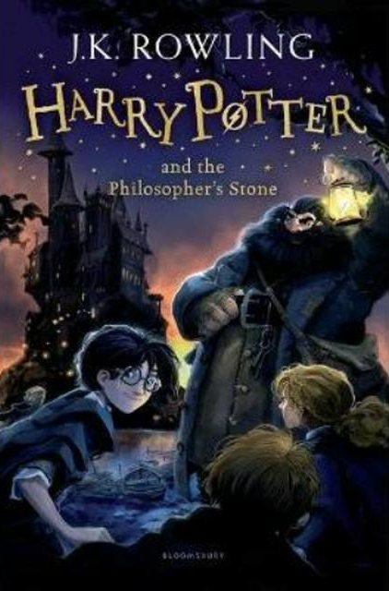 | Harry potter and the philosophers stone | The valley of lost secrets  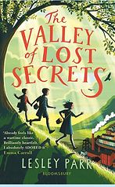 | The missing: the story of my family in World War 2  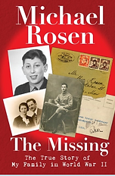 | The king of the fishes. | Max and the millions  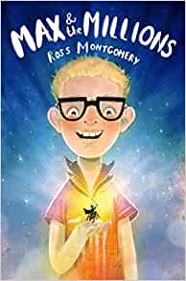 | The true story of the 3 little pigs  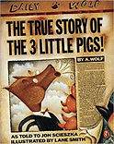 | Black powder  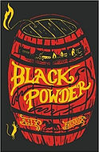 | Chalk  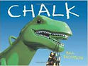 | Arctic star  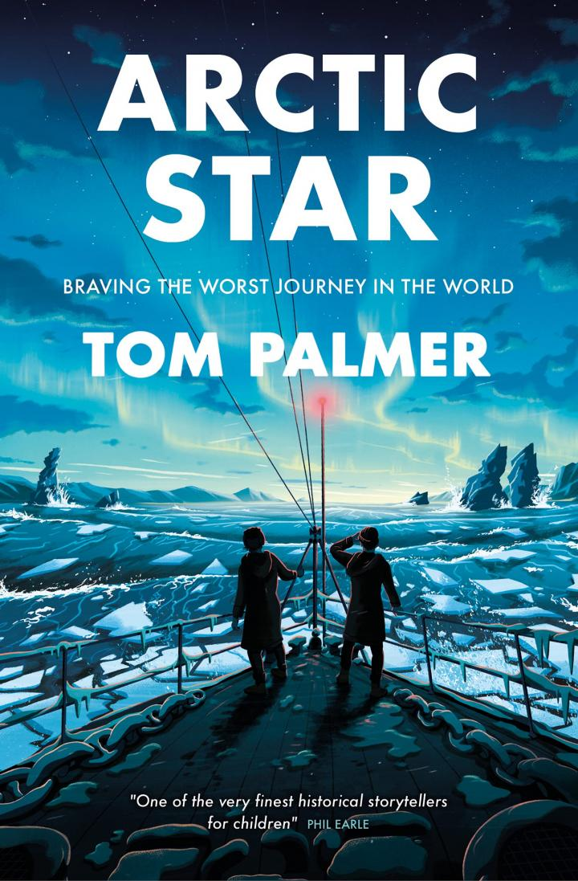
 | poetry | List and Alphabet poems |  |  |  | War time poetry |  |  |  | Haiku, kennings and caligrams

