Year 2 (Key Stage One)
 | Autumn One | Autumn Two | Spring One | Spring Two | Summer One | Summer Two
Topic Title / Information: | What a Wonderful World  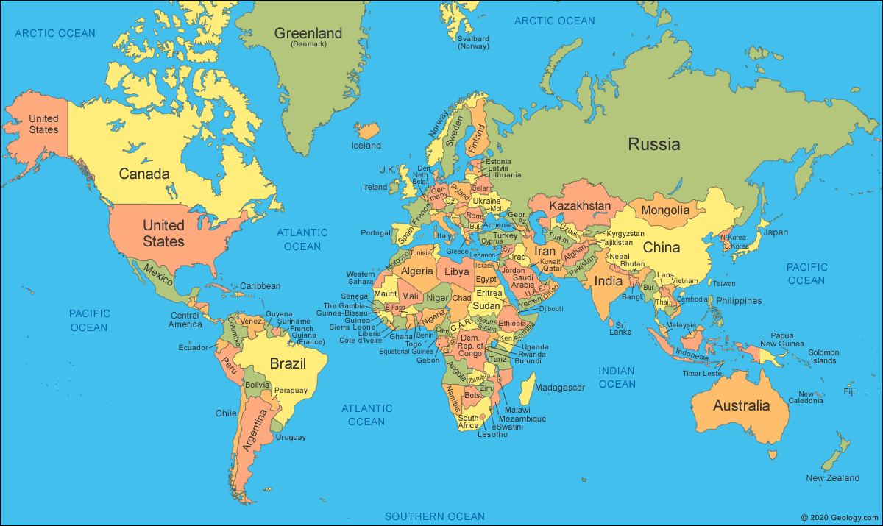  We will learn about the location of countries, continents and oceans of the world in relation to our own locality. | Nurturing Nurses  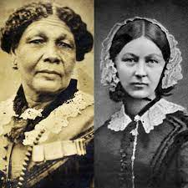  We will learn about influential nurses and consider how they have influenced nursing today. | Sensational Africa  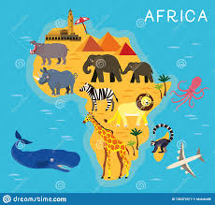  Off we go! We are travelling to Africa to learn all about African Culture including, food, lifestyle, sports, music and much more!! | 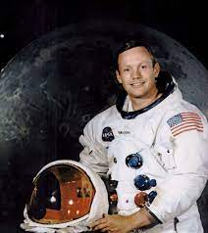  Significant Explorers  We will explore significant explorers and consider why they are considered significant. | Kings and Queens  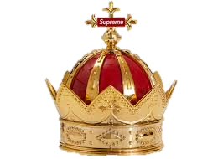  The crown jewels are sparkling as we learn about the Royal family as well as our own family trees! | 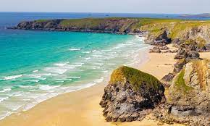  Beside the Seaside  We will learn about geographical features of the seaside, both human and physical.
Enquiry Question | What are the continents of the world and how can I describe their key features? | Who were Florence Nightingale, Mary Seacole and Edith Cavell?  Can I compare and contrast their lives? | How is Africa different to the United Kingdom? | Who was Ibn Battuta and Felicity Aston and where would I explore? | Can I investigate and create  my own family tree ? | Can I describe a local seaside location and use a map to plan where I would like to explore?
Enrichments including trips/visitors | Gymnastics | Christmas Performance | Residential trip to - Burwardsley | Forest School – map skills | A Medieval Banquet ! | Trip to the seaside -Prestatyn

