Autumn 1 |  | Autumn 2 |  | Spring 1 |  | Spring 2 |  | Summer 1 |  | Summer 2
ANCIENT EGYPTIANS |  | RAINFORESTS |  | WW2  Battle of Britain |  | LAND USE |  | CRIME & PUNISHMENT |  | EXTREME EARTH
Author Focus  Jeremy Strong  There’s a Pharaoh in our Bath  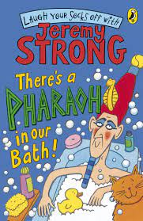  The Scarab’s Secret |  | Author Focus  JK Rowling  Harry Potter and the Philosopher’s Stone  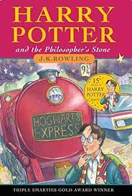 |  | Author Focus  Michael Morpurgo  Friend or Foe  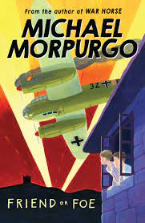 |  | Author Focus  Ted Hughes  The Iron Man   |  | Author Focus  Robert Swindells  The Ice Palace  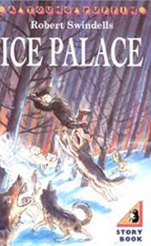 |  | Author Focus  Cressida Cowell  How to train your dragon  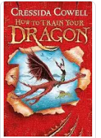
Fiction | Non-Fiction | Fiction | Non-Fiction | Fiction/  Non-Fiction | Non-Fiction | Fiction | Non-Fiction | Fiction | Non-Fiction | Fiction | Non-Fiction
Wishing  Tale | Instructions | Defeat the Monster /  Suspense | Persuasive  Writing  Adverts | Recount | Non Chron  Report | SUSPENSE | Newspaper Report | Quest/  Setting | Explanation Texts | Finding Tale | Discussion /Persuasive letter
ONE CHANCE  (T4W Y5 unit) | How to wrap a mummy | The Troll | Job Advert  DARK ARTS  teacher  Writing Models  Y 5  98 / 99 | First person account – soldier or boys  (Literacy Shed / BBC radio adaptation) | WW2 focus  Life on the Home Front  (set research as homework) | Staying Out  (T4W) | The Sun Bat Angel  (Grammasaurus model text) | Journey to Storvig to save brother. | How a Jelly fish stings  How a giant  spider traps its prey  Writing Model  Y4 | Finding a dragon’s egg | Letter about recycling  environmental issues or persuasion to keep dragon as pet
Poetry  Poems on a theme – wishing |  |  |  | Poetry  List poems / Alphabet poems /  Blackout poetry |  |  |  | Poetry  Haiku  Kennings Calligrams
AUTUMN SPAG |  |  |  | SPRING SPAG |  |  |  | SUMMER SPAG
Nouns and pronouns for clarity  Singular and Plural Nouns  Consonant and vowels  Suffixes – ly  Past tense  Subordinate clauses  Adjectives  A or an ?  Prefixes: super, anti, auto  Present Tense  Apostrophes  Possessive pronouns  Fronted adverbials |  |  |  | Verbs  Compound nouns  Prefixes: dis, mis, un  Subordinating conjunctions  Inverted commas – new line, new speaker  Adverbs – time and cause  Prefixes – in  Suffixes – ation  Coordinating conjunctions  Organisational devises  Commas after fronted adverbials  Expanded noun phrases  Determiners |  |  |  | Prepositions to express time and cause  Verb inflections  Possessive apostrophes  Subordinate clauses  Prefixes: re, sub, inter  Suffixes beginning with vowels  Time conjunctions  Paragraphs  Homophones  Suffixes – ous  Word families  Place and cause conjunction
FOCUS  Wishing Tale | FOCUS  Instructions | FOCUS  Beat the Monster | FOCUS  Persuasive Writing | FOCUS  Finding  Tale/History | FOCUS  Non-Chron  Report | FOCUS  SUSPENSE | FOCUS  Newspaper  Report | FOCUS  Quest | FOCUS  Explanation Text | FOCUS  Recount | FOCUS  Discussion/  Persuasive letter
Creating mood – sentences of 3  Outside / Inside opening to create atmosphere  Writing speech effectively  Dialogue  Showing character opposites through  dialogue/actions | Include introductions to interest or hook the reader e.g. These simple directions will help you to... Have you ever wondered how to...? Have you ever been bored by...Well this game will give you hours of fun...  And conclusions to wrap up and summarise e.g. Follow these directions carefully and you will never need to...; These simple instructions should enable anyone to...  Use appropriate punctuation: commas for lists, colons and bullets, for points and sub-points, new lines and paragraphs etc. to frame the sequence for readers.  Use a range of add-on and drop-in phrases/clauses to advise and warn e.g. Without spilling it, transfer the powder to...; the next player, who should have taken a card already... ; First climb up the beanstalk, taking care not to..., | Key features of suspense  -character in the dark/lonely place  -use of senses  -verb selection  -short sentences for pace and tension  -character’s reaction show/not tell | Shared reading a variety of persuasive texts –adverts and publicity - to understand how they are organised.  informal language  imperative direct language  boasting  short sentences Extend use of  3 part structure.  -general statement to intro topic  -series of logical steps  -steps continue until explanation complete  -summary  Use of descriptive language  invent similes to illustrate points | Showing character through  dialogue/actions  -Range of adverbial openers  -similes  -metaphors  -sentences x3  -change setting to change mood | Collect and organise ideas developing boxing-up.  Expanding range of connectives and generalisers  Use of technical language  Use of complex sentences to combine information  Write reports for different purpose | Describe Setting &  character  Effective story openers  -Showing character through  dialogue/actions  -Range of adverbial openers  -similes  -metaphors  -sentences x3  -change setting to change mood  Key features of suspense  -character in the dark/lonely place  -use of senses  -verb selection  -short sentences for pace and tension  -character’s reaction show/not tell | Journalistic writing  Opening paragraph – well- crafted using complex sentences to grab reader’s attention  Organise into paragraphs introduced with topic sentence  Range of connectives  direct and indirect speech  Y5  subordinating clauses | Settings  Show setting through main character’s eyes  Describe character’s reactions to show how setting is making them feel  Use unexpected detail to add hook  Use of figurative language to bring setting to life | Extend use of  3 part structure.  -general statement to intro topic  series of logical steps  -steps continue until explanation complete  -summary  Use of descriptive language  invent similes to illustrate | Use recounts to explore alternative points of view e.g. from stories or linked to other subjects of the curriculum, writing in role as a character | Opening paragraph to engage reader  -series of points in favour in connected paragraph  -series of points against in connected paragraph  -reasoned conclusion  Y5  address readers directly to hold attention and draw in

