Sound and District Primary School Year 1 English Genre and Text Plan
 | Autumn 1 |  | Autumn 2 |  | Spring 1 |  | Spring 2 |  | Summer 1 |  | Summer 2
T | Super Sound! |  | GUNPOWDER PLOT |  | Wonderful Weather |  | The Great Fire of London and Nantwich |  | OUR COUNTRY |  | TOYS
 | Fiction | Non-Fiction | Fiction | Non-Fiction | Fiction | Non-Fiction | Fiction | Non-Fiction | Fiction | Non-Fiction | Fiction | Non-Fiction
GENRE | Sentences  Postcard  Speech bubbles  Questions  Description | Map labelling  Labels  lists | Character descriptionsequence sentencesAdjectives  Story writing | Gather information Fact sheet  Positional language  Questions  Letter | Finding Tale  T4W  Sequence sentences  letter | Non-Chron report | Adjectives  Questions  Adjectives  Basic story plot | Instructions | Traditional Tales  Sequencing  Character  Story writing  Proper nouns  Retell events | Persuasive writing – advert | Setting  Similes  Story  Conjunctions  Question marks | Explanation
TEXT | 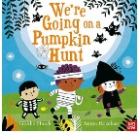 |   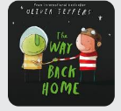 |  | 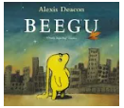  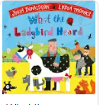 |  |   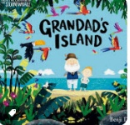  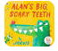 | 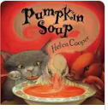  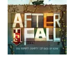 | 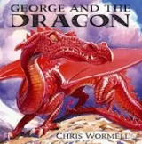 | 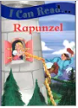 | 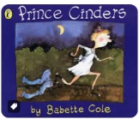  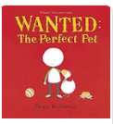 |  | 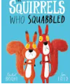  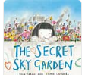
POETRY  FOCUS | Generate rhyming words |  | Poems about Bonfire Night  Acrostic poems |  | List poems about the weather |  | Free verse based on experience, objects and senses |  | Group performance poetry |  | Rhymes and repeated phrases
 | Autumn |  |  |  | Spring |  |  |  | Summer
SPAG | Capital letters and lower case  Verbs  Suffixes – ing  Finger spaces  Writing sentences  Personal pronouns  Noun suffixes – s  Prefixes – un  Capital letters and full stops  Writing sentences |  |  |  | Singular nouns  Past and present verbs  Suffixes -ed  Capital letters for the days of the week  Writing sentences  Plural nouns  Compound words  Question marks  Sequencing sentences |  |  |  | Punctuating sentences  Noun suffixes -es  Exclamation marks  Capital letters for people and places  Writing question sentences  Joining words using and  Suffixes – er  Punctuating sentences  Writing exclamation sentences
FOCUS | Including finger spaces, full stops and capital letters  Say a sentence, write and  read it back to check that it  makes sense. | Using:  Numbered instructions  Simple  Connectives  Finger spaces, full stops and capital letters | Begin to use run sentences  Finger spaces  Full stops  Capital letters | Heading  Introduction  Middle section(s)  Ending | Embellished simple sentences using adjectives  Compound sentences  Run sentences  Simple Connectives  Introduce speech | Bullet points  Simple Connectives  Heading  Introduction  Middle section(s)  Ending | Alliteration  Embellished simple sentences using adjectives  Compound sentences  Run sentences  Simple Connectives | Numbered  Simple Connectives  Heading  Introduction  Middle section(s)  Ending | Similes using as….as…  Alliteration Embellished simple sentences using adjectives  Compound sentences | Bullet points  Simple Connectives  Heading  Introduction  Middle section(s)  Ending | Alliteration  Embellished simple sentences using adjectives  Compound sentences  Run sentences  Simple Connectives | Simple Connectives  Heading  Introduction  Middle section(s)  Ending

We also have seasonal weeks where we will also be completing short burst writing, poetry and creative writing activities.

