 | Autumn 1 |  | Autumn 2 |  | Spring 1 |  | Spring 2 |  | Summer 1 |  | Summer 2
 | 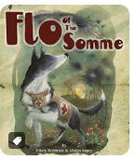  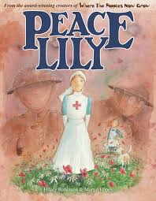  WAR AND REMEMBRANCE |  | WHAT A WONDERFUL WORLD |  | SENSATIONAL  AFRICA |  | 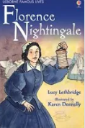  NUTURING NURSES |  | KINGS AND QUEENS |  | BESIDE THE SEASIDE
Books linked to topic | 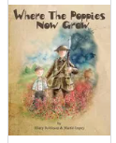 |  | 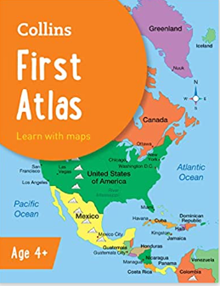 |  | 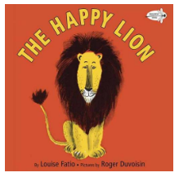  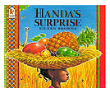   |  |  |  | 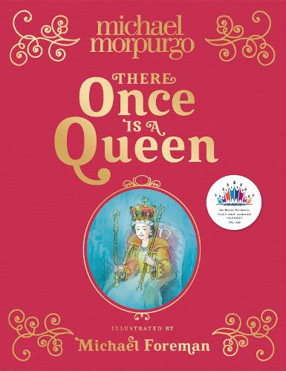 |  | 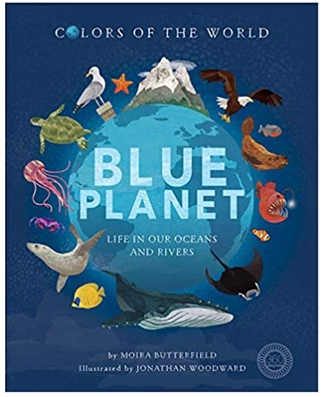  
 | Fiction | Non-Fiction | Fiction | Non-Fiction | Fiction | Non-Fiction | Non-Fiction | Non-Fiction | Fiction | Non-Fiction | Fiction |  | Non-Fiction
GENRE | Quest  Story | Instruction | Finding Story | Non-Chron  Report | Journey Story | Non-Chron  Report | Explanation | Tale of fear | Short units of writing covering a range of genres to collect evidence for end of Ks1 assessments.  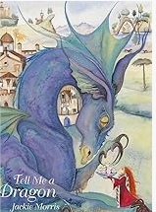  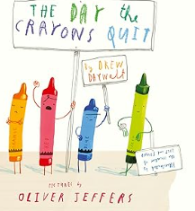 |  | Tale of defeating the monster |  | Discussion Text
TEXT | Little Red  BY  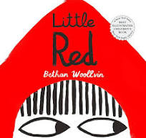 | How to TRAP A STONE GIANT  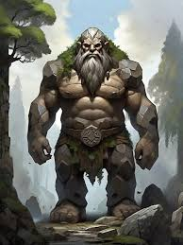 | Bog Baby  by Jeanne Willis  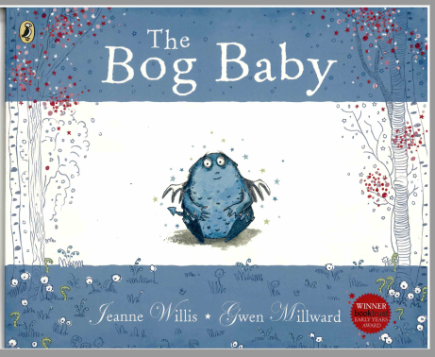 | Mary Seacole  Florence Nightingale | Meerkat Mail   | African Animal  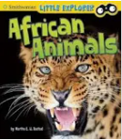  Painted Dogs | How are camels adapted to the desert?  How are polar bears adapted to the artic?  Science link | The Papaya that spoke  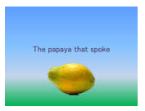  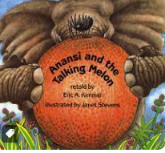 |  |  | The paper bag princess  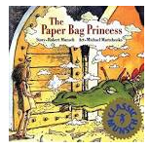 |  | Planet full of plastic  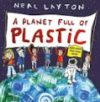
POETRY | We will innovate our own descriptive poems linked to Remembrance Day.  Tongue twisters – alliterative sentences |  |  |  | We will use all of our grammar knowledge to create our own grammar poems!  Shape Poems. |  |  |  | We will use our Scientific understanding of our senses to create our own sense poems.  Contemporary poems.
 | Autumn SPAG |  |  |  | Spring SPAG |  |  |  | Summer SPAG
SPAG | Nouns  Vowels and consonants  Demarcating sentences  Nouns – using ness  Adjectives  Compound words  Adjectives – er and est  Subordination  Statements and exclamations |  |  |  | Noun phrases  Homophones  Adjectives – ful and -less  Questions and Commands  Sentence writing  Verbs  Adverbs – ly  Commas in lists Changing adjectives to adverbs |  |  |  | Adverbs  Word classes  Coordination  Apostrophes for possession  Past and present tense  Forming nouns using -er  Progressive tense  Apostrophes for Contractions  Uplevelling Sentences
 | TEXT FOCUS |  | TEXT FOCUS |  | TEXT FOCUS |  | TEXT FOCUS |  | TEXT FOCUS
FOCUS | Consolidate Yr 1- Full stop, capital letter  Sentence  Structure  Embellished simple sentences using: adjectives e.g. The boys peeped inside the dark cave. adverbs e.g. Tom ran quickly down the hill  Tenses  Simple conjunctions for more embellished sentences  -and  -because | Titles  Sequential connectives  Imperative language  Tenses | Descriptive sentences- Expanded noun phrases  Conjunctions  Run sentences | Headings  Hook to engage reader  Factual statement / definition  Opening question  Varied openers  Generalisers | Setting  Adverbs for description  List of three for description  Dialogue | Powerful adjectives  Persuasive language  Range of sentences-long/short | Range of punctuation- sentence types- long and short sentences, exclamatory sentences.  Casual conjunctions (this causes, therefore, thus, consequently) | Additional subordinating conjunctions: what/while/when/where/ because/ then/so that/ if/to/until  Character actions  Dialogue  Commas  (commas after ly) | Powerful adjectives  Persuasive language  Range of sentences-long/short  Paragraphing  Consolidation |  |  | Consolidation on all of this.

