Autumn 1 |  | Autumn 2 |  | Spring 1 |  | Spring 2 |  | Summer 1 |  | Summer 2
WW2 |  | SOMEWHERE TO SETTLE |  | Indus Valley |  | WATER |  | BENIN |  | RAGING RIVERS
Author Focus  Author Focus  Michael Morpurgo  Friend or Foe  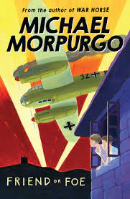 |  | Author Focus  JK Rowling  Harry Potter and the Philosopher’s Stone  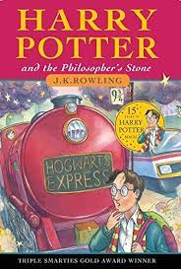 |  | Krindlekrax  Philip Ridley  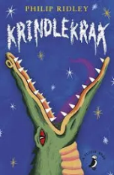 |  | Author Focus  Robert Swindells  The Ice Palace  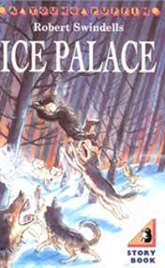 |  | Author Focus  Ted Hughes  The Iron Man  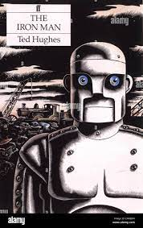 |  | Author Focus  Boy at the back of the class  Onjali Rauf  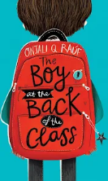
Fiction | Non-Fiction | Fiction | Non-Fiction | Fiction/  Non-Fiction | Non-Fiction | Fiction | Fiction | Non-Fiction | Non-Fiction | Fiction | Non-Fiction
Dilehma | Instructions | Defeat the Monster /  Suspense | Persuasive  Writing  Adverts | Persuasive / Discussion letter | Non-Chron report | SETTING | Quest / Suspense | Recount | Newspaper Report | Finding Tale/Wishing Tale | Explanation Text
To help the German soldier or not – story with a choice | WW2 focus  Anderson shelter  Gas Mask  Air raid  Black out | The Troll | Job Advert  DARK ARTS  teacher  Writing Models  Y 5  98 / 99 | Lead role in the play | Linked to topic – indus valley | Winter /  Caves/ tunnels | Journey to Storvig to save brother | The Iron Man  Hogarth’s diary | The Sun Bat Angel How a Jelly fish stings  How a giant  spider traps its prey  Writing Model  Y4 | Linked to the story | How a jelly fish stings  How a giant spider traps its prey  Writing Model Year 4
Poetry  Poems on a theme – wishing |  |  |  | Poetry  List poems / Alphabet poems /  Blackout poetry |  |  |  | Poetry  Haiku  Kennings Calligrams
AUTUMN SPAG |  |  |  | SPRING SPAG |  |  |  | SUMMER SPAG
Singular and plural nouns  Pronouns recap Proper Nouns  Adverbs to express time and cause  Compound words  Possessive pronouns  Fronted Adverbials - commas after fronted adverbials  Prepositions to express time and cause  Plural and possessive – s  Commas  Inverted commas  Paragraphs – linking with adverbials  Converting nouns and adjectives into verbs – suffixes – ate, ise and ify |  |  |  | Adjectives  Adverbs of possibility (perhaps, surely)  Modal verbs (NF reports – could, will)  Homophones  Expanded noun phrases  Determiners  Word families  Prepositional phrases - prepositions  Verbs – present  Subordinating conjunctions  Verb prefixes – dis,mis,over re  Verb prefixes – in, im, ir and il  Co-ordinating conjunctions  Direct and indirect speech ( newspaper report) |  |  |  | Verb inflections  Conjunctions to express time and cause  Suffixes  Possessive apostrophes  Paragraphs  Verbs – past  Prefixes  Plural possessive apostrophes  Subordinate clauses  Parenthesis – brackets, commas, dashes  Homophones  Relative clauses  Writing cohesive paragraphs
FOCUS  Wishing Tale | FOCUS  Instructions | FOCUS  Beat the Monster | FOCUS  Persuasive Writing | FOCUS  Finding  Tale/History | FOCUS  Non-Chron  Report | FOCUS  SUSPENSE | FOCUS  Newspaper  Report | FOCUS  Quest | FOCUS  Explanation Text | FOCUS  Recount | FOCUS  Discussion/  Persuasive letter
Creating mood – sentences of 3  Outside / Inside opening to create atmosphere  Writing speech effectively  Dialogue  Showing character opposites through  dialogue/actions | Include introductions to interest or hook the reader e.g. These simple directions will help you to... Have you ever wondered how to...? Have you ever been bored by...Well this game will give you hours of fun...  And conclusions to wrap up and summarise e.g. Follow these directions carefully and you will never need to...; These simple instructions should enable anyone to...  Use appropriate punctuation: commas for lists, colons and bullets, for points and sub-points, new lines and paragraphs etc. to frame the sequence for readers.  Use a range of add-on and drop-in phrases/clauses to advise and warn e.g. Without spilling it, transfer the powder to...; the next player, who should have taken a card already... ; First climb up the beanstalk, taking care not to..., | Key features of suspense  -character in the dark/lonely place  -use of senses  -verb selection  -short sentences for pace and tension  -character’s reaction show/not tell | Shared reading a variety of persuasive texts –adverts and publicity - to understand how they are organised.  informal language  imperative direct language  boasting  short sentences Extend use of  3 part structure.  -general statement to intro topic  -series of logical steps  -steps continue until explanation complete  -summary  Use of descriptive language  invent similes to illustrate points | Showing character through  dialogue/actions  -Range of adverbial openers  -similes  -metaphors  -sentences x3  -change setting to change mood | Collect and organise ideas developing boxing-up.  Expanding range of connectives and generalisers  Use of technical language  Use of complex sentences to combine information  Write reports for different purpose | Describe Setting &  character  Effective story openers  -Showing character through  dialogue/actions  -Range of adverbial openers  -similes  -metaphors  -sentences x3  -change setting to change mood  Key features of suspense  -character in the dark/lonely place  -use of senses  -verb selection  -short sentences for pace and tension  -character’s reaction show/not tell | Journalistic writing  Opening paragraph – well- crafted using complex sentences to grab reader’s attention  Organise into paragraphs introduced with topic sentence  Range of connectives  direct and indirect speech  Y5  subordinating clauses | Settings  Show setting through main character’s eyes  Describe character’s reactions to show how setting is making them feel  Use unexpected detail to add hook  Use of figurative language to bring setting to life | Extend use of  3 part structure.  -general statement to intro topic  series of logical steps  -steps continue until explanation complete  -summary  Use of descriptive language  invent similes to illustrate | Use recounts to explore alternative points of view e.g. from stories or linked to other subjects of the curriculum, writing in role as a character | Opening paragraph to engage reader  -series of points in favour in connected paragraph  -series of points against in connected paragraph  -reasoned conclusion  Y5  address readers directly to hold attention and draw in

