SOUND & DISTRICT PRIMARY SCHOOL

Whole School Maths Progression Map 2024-25

Scheme followed: White Rose (v3)



**Who is this document for?**

This progression has been made to help both Class Teachers and the Maths Subject Lead. For Class Teachers this progression document allows teachers to clearly see what has already been covered in the previous year, the areas which are to be covered in the current year but also where learning continues into the next year. This progression document allows us to see how topics are developed over time and built on.

It also allows the Maths Subject Lead to know when topics are being taught and which resources may be needed across the school at a particular time.

**Revision of Maths Topics at Sound School**

The White Rose Maths curriculum is a cumulative curriculum; so that once a topic is covered it is met many times again in other contexts. For example: place value is covered in Autumn 1 but it is then revisited within addition, subtraction, multiplication and division. The Flashback Four activities also aid in revisiting areas of learning.

As well as this, at Sound and District Primary School we have started Maths REVISIT sessions each half term. These are opportunities where teachers dedicate Maths sessions to recapping previous areas and skills taught. This ensures children are continually reviewing what they have learned and adding these to their long-term memory. However, teachers plan in dedicated time in most lessons to recap concepts and embed learning.

NB: In order for Year 6 and Year 2 to have fully covered the curriculum before SATs in May and before statutory Teacher Assessments are due, Sound & District Primary School have tweaked the White Rose plan and therefore do not follow the timescales in its entirety.

**Whole School Overview**

|  |  |  |  |  |  |  |
| --- | --- | --- | --- | --- | --- | --- |
|  | **Autumn 1** | **Autumn 2** | **Spring 1** | **Spring 2** | **Summer 1** | **Summer 2** |
| **EYFS** | **Getting to know you**  **Match, sort & compare**  **Talk about measure & patterns**  **It’s me 1,2,3**  **Circles & triangles**  **1,2,3,4,5**  **Shapes with 4 sides** | | **Alive in 5**  **Mass & capacity**  **Growing 6,7,8**  **Length, height & time**  **Building 9 & 10**  **Explore 3-D shapes** | | **To 20 and beyond**  **How many now?**  **Manipulate, compose & decompose**  **Sharing & grouping**  **Visualise, build & map**  **Make connections**  **Consolidation** | |
| **Year 1** | **Place Value**  **Addition and Subtraction** | **Addition and Subtraction**  **Shape**  **Consolidation** | **Place value (within 20)**  **Addition and Subtraction**  **(within 20)** | **Place Value (within 50)**  **Measurement-length, height, mass and volume** | **Multiplication and Division**  **Fractions**  **Position and Direction** | **Place Value (within 100)**  **Money**  **Time**  **Consolidation** |
| **Year 2** | **Place Value**  **Addition and Subtraction** | **Shape**  **Money** | **Multiplication and Division**  **Length & height** | **Mass, capacity & temperature Fractions** | **Time**  **Statistics**  **Position & direction** | **Consolidation** |
| **Year 3/4** | **Place Value**  **Addition & Subtraction** | **Area**  **Multiplication & Division** | **Multiplication & Division**  **Length & Perimeter**  **Mass & Capacity (Y3)** | **Fractions**  **Decimals** | **Money**  **Time**  **Shape** | **Statistics**  **Position & Direction** |
| **Year 4/5** | **Place Value**  **Addition and subtraction** | **Multiplication and division**  **Fractions**  **Consolidation** | **Multiplication and division**  **Fractions** | **Decimals & percentages**  **Perimeter & area**  **Statistics**  **Consolidation** | **Shape**  **Position and direction**  **Decimals** | **Negative numbers**  **Converting units (inc money & time Y4)**  **Volume** |
| **Year 6** | **Place Value**  **Four Operations-addition, subtraction, multiplication & division** | **Fractions**  **Decimals and percentages** | **Ratio**  **Converting units**  **Algebra** | **Perimeter**  **Area**  **Volume**  **Statistics** | **Properties of shape**  **Position and direction** | **Investigations and consolidation** |

**Mathematical Vocabulary Progression**

**EYFS- Year 6**

* Using correct mathematical language is crucial for thinking, learning, and communicating mathematically.
* At Sound and District Primary School we encourage children to explain what they are doing and why they are doing it.
* When children are first introduced to new vocabulary, it is not essential that children remember these words immediately. Rather this modelling will help them become familiar with the terms, gradually beginning to use them accurately and with greater understanding.

**EYFS- Reception- Diamond Class-Vocabulary**

|  |  |
| --- | --- |
| **Number** | number, zero 1-20 count on/back lots, more, few, fewer, compare, sort, order, before, after, less, many, most, the same as, ones, pair add, more, altogether, takeaway, number line, one more, one less, equals, equal to, double, half, how many? make, total times, counting in ones, twos, fives, tens, lots of, groups of, once, twice, five times sharing, share, set, group, left, left over |
| **Numerical Patterns** | listen, join in, say, think, imagine, remember, start from, start with, start at, look at, point to, put, place, fit, change, split, carry on, what comes next? find, choose, collect, use, make, build, tell me, pick out, talk about, explain, show me read, write, finish, copy, colour, tick, cross, draw, draw a line between, join (up), ring, arrow, cost, count, work out, answer, fill in, check, in order, every, each. |
| **Shape, space, and measure** | days of the week, week, month, year, weekend, birthday, holiday, morning, afternoon, evening, night, midnight, bedtime, dinnertime, playtime, today, yesterday, tomorrow, before, after, next, last, now, soon, early, late, quick, fast, slow, old, new, watch, clock, always, never, first, size, weight, capacity, time, money long, longer, longest, short, shorter, shortest, heavy, light, empty, full, tall, small, large, thick, thin, low, deep, ruler, far, near, holds, container, weigh, weighs coin, pound, pence, cost, money, penny, buy, sell, position, distance, after, before, in, on, inside, under, on top of, behind, next to, above, below, top, bottom, side, outside, around, underneath, in front, front, back, before, middle, up, down, forwards, backwards, across, close, far, along, to, from, slide, roll, turn, stretch, bend, move. shape, group, sort, round, flat, straight, make, build, draw. square, circle, triangle, cube, cuboid, sphere double/half/ whole |

**Year 1- Emerald Class-Vocabulary**

***(+ repetition of EYFS vocabulary)***

|  |  |
| --- | --- |
| **Number and Place Value** | 20-100 count (on/up/to/from/ down), least, fewest, smallest, greater, lesser, equal to, odd, even, units, tens, ten more/less, digit, numeral, figure(s), compare (In) order/a different order, size, value, between, halfway between above, below. |
| **Addition & Subtraction** | number bonds, addition, plus, sum, greater, near double, halve, is the same as, (including equals sign), how many more to make...? how, many more is…than...? how much more is..? subtract, minus, how many fewer is…than..? |
| **Multiplication & Division** | odd, even, count in twos, fives, tens, (forwards from/backwards from), how many times?, multiple of, multiply, multiply by repeated addition, array, row, column, halve, share equally, group in pairs, threes, etc. equal groups of, divide, divided by |
| **Measure (Time and Money)** | Seasons: Spring, Summer, Autumn, Winter, quicker, quickest, quickly, faster, fastest, slower, slowest, slowly, older, oldest, newer, newest, takes longer, takes less time, hour, o clock, half past, hands, how long ago? how long will it be to…? how long will it take to…? how often? often, sometimes, usually, once, twice, second, third etc, estimate, close to, about the same as, just over/under, too many/few, not enough, enough. spend, spent, change, dear(er), costs more, costs less, cheaper, costs the same as, how much? |
| **Measure (Length, Mass & Capacity)** | size, bigger, larger, length, width, height, depth, taller, tallest, high, higher, highest, wide, narrow, shallow, close, Metre, metre stick. half full, balances, heavier, heaviest, lighter, lightest, scales. |
| **Geometry** | over, beside, opposite, apart, between, edge, centre, corner, direction, journey, left, right, sideways, near, through, towards, away from, movement, whole turn, half turn. |
| **Fractions** | whole, equal parts, four equal parts, one half, two halves, a quarter, two quarters. |
| **General Problem Solving** | arrange, rearrange, change over, separate, continue, repeat, describe, explain, record, trace, complete, shade, same number(s)/different number(s)/missing number(s) number facts, same way, different way, best way, another way, in a different order, not all. |

**Year 2- Ruby Class-Vocabulary**

***(+ repetition of Year 1 vocabulary)***

|  |  |
| --- | --- |
| **Number and Place Value** | numbers to one hundred, hundreds, partition, recombine, hundred more/less, represents, exchange, |
| **Addition & Subtraction** | number bonds, addition, plus, sum, greater, inverse, near double, halve, is the same as, (including equals sign), difference between, how many more to make...? how, many more is…than...? how much more is..? subtract, minus, how many fewer is…than..? |
| **Multiplication & Division** | count in multiplies of 3, 4, 5 and 6, recall times table facts for 1-6 times tables.  sharing/groups of |
| **Measure** | quarter past/to, fortnight temperature (degrees) m/cm, g/kg, ml/l  *pounds/pence/change/card/notes/coins* |
| **Statistics** | count, tally, sort, vote, graph, block graph, pictogram, represent group, set, list, table label, title most popular, most common, least popular, least common. |
| **Geometry** | rotation, clockwise, anticlockwise, straight line, ninety-degree turn, right angle.  smaller, symmetrical, line of symmetry, fold, match, mirror line, reflection, pattern, repeating pattern, vertices, vertex. pentagon, hexagon, octagon, circular, triangular, right angle. |
| **Fractions** | three quarters, one third, a third, equivalence, equivalent. |
| **General Problem Solving** | predict, describe the pattern, describe the rule, find, find all, find different, investigate. |

**Year 3- Opal Class-Vocabulary**

***(+ repetition of Year 2 vocabulary)***

|  |  |
| --- | --- |
| **Number and Place Value** | numbers to 1,000 |
| **Addition & Subtraction** | column addition and subtraction- regrouping, borrowing, carrying, making another ten |
| **Multiplication & Division** | count in multiples of 4, 8, 7, 9 and 11 |
| **Measure** | leap year twelve-hour/24- hour clock, am/pm, century roman numerals I-XII mm |
| **Statistics** | chart, bar chart, frequency table, Carroll diagram, Venn diagram, Axis, Axes diagram |
| **Geometry** | greater/less than 90 degrees orientation (same orientation, different orientation), north, south, east, west  horizontal, vertical, perpendicular, and parallel lines. perimeter hemi-sphere, prism, semi-circle |
| **Fractions** | numerator, denominator. unit fraction, non-unit fraction. compare and order. Tenths |

**Year 4- Topaz Class- Vocabulary**

***(+ repetition of Year 3 vocabulary)***

|  |  |
| --- | --- |
| **Number and Place Value** | tenths, hundredths, numeral decimal places round (to nearest) thousand more/less negative integers count through zero roman numerals I to C |
| **Multiplication & Division** | count in multiples of 6, 7, 9, 12. inverse derive division facts |
| **Measure** | convert, noon |
| **Statistics** | continuous data line graphs |
| **Geometry** | co-ordinates translation, translate, quadrant x-axis, y-axis.  area, net rectilinear adjacent quadrilaterals: (rhombus, parallelogram, trapezium, trapezoid, kite). heptagon, polygon, tetrahedron, polyhedron, cylindrical triangles (isosceles, scalene) right angle, acute angle, obtuse angles |
| **Fractions** | equivalent fractions and decimals, decimal point, decimal fraction hundredths |

**Year 5- Topaz Class- Vocabulary**

***(+ repetition of Year 4 vocabulary)***

|  |  |
| --- | --- |
| **Number and Place Value** | powers of 10 numbers to 1,000,000 roman numerals I to M |
| **Multiplication & Division** | count in multiples for all tables up to 12x12 factor pairs composite numbers, prime numbers, prime factors, square number, cubed number |
| **Measure** | volume, concave, convex breadth imperial units/metric units inches, pounds, pints, currency, ounce, tonne etc |
| **Statistics** | average |
| **Geometry** | reflex angles dimensions regular/irregular polygons, octahedron |
| **Fractions** | proper fractions, improper fractions, mixed numbers percentage |

**Year 6- Onyx Class- Vocabulary**

***(+ repetition of Year 5 vocabulary)***

|  |  |
| --- | --- |
| **Number and Place Value** | numbers to 10,000,000 |
| **Addition & Subtraction/ Multiplication & Division** | order of operations  order of operations common factors, common multiples, factorise |
| **Algebra, Ratio & Proportion** | algebra, algebraically express ratio proportion linear number of sequence substitute, variables, symbol, known values |
| **Statistics** | mean, median, range pie chart construct |
| **Geometry** | four quadrants  circumference, radius, diameter, arc, congruent, dodecahedron |
| **Fractions** | degree of accuracy  simplify |

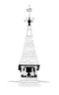

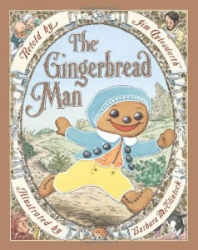

**EYFS**

**Reception Class Maths Progression Information**

**EYFS**

* 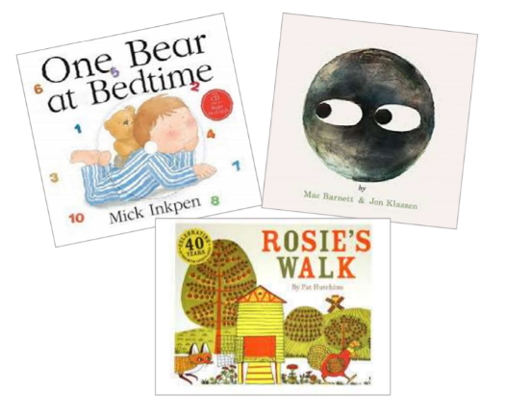Reading to children is an essential part of their development. Below is a selection of the books used to develop Maths understanding in our reception class.

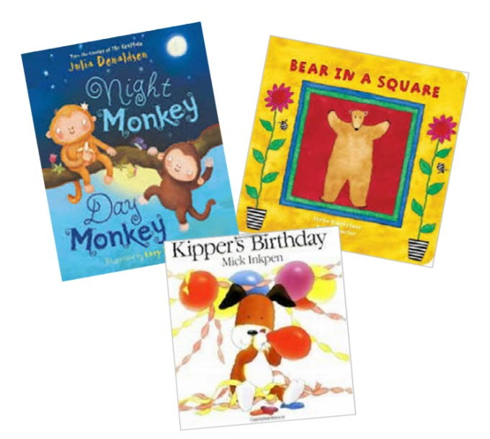

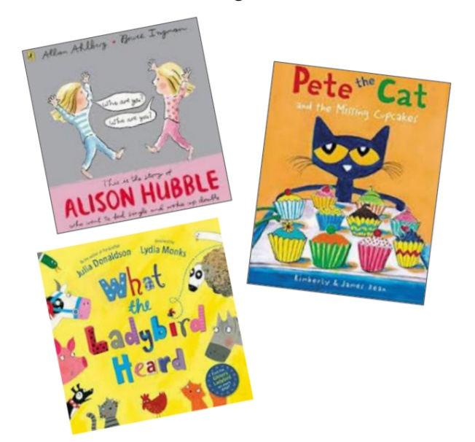

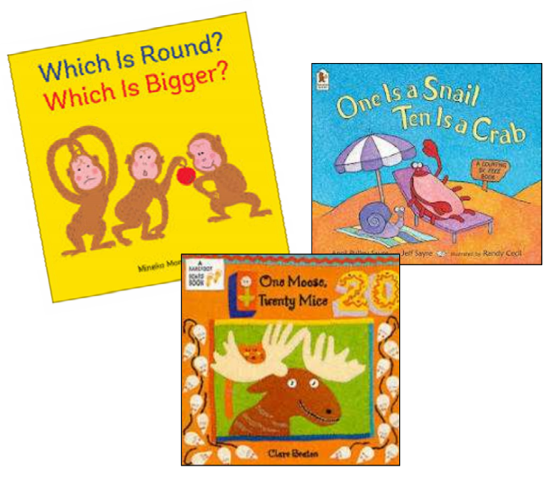

**Reception Progression of Knowledge**

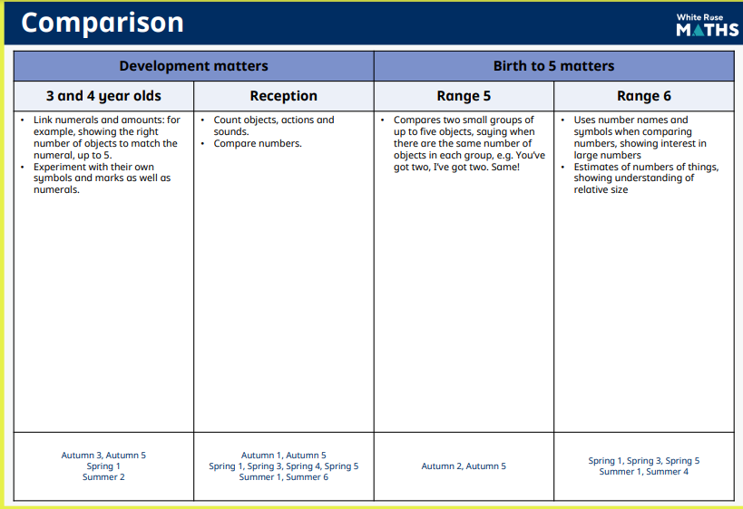

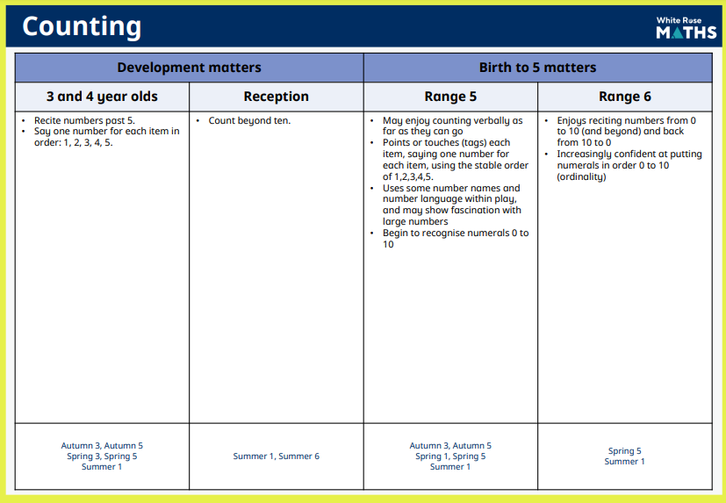

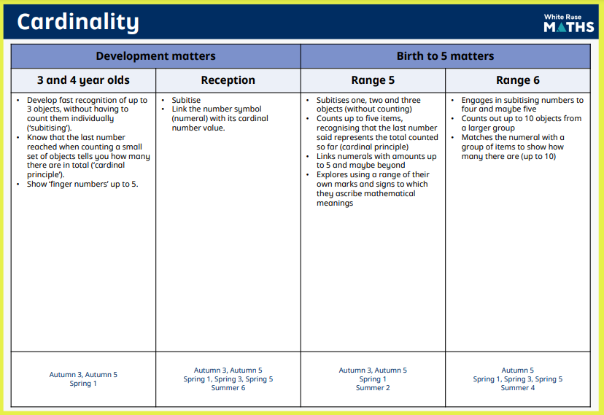

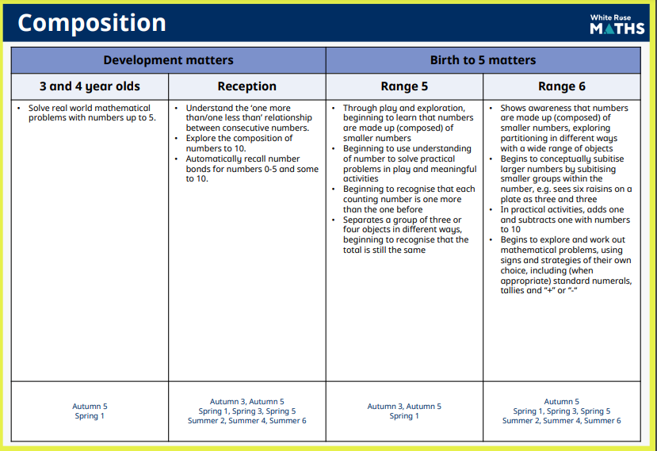

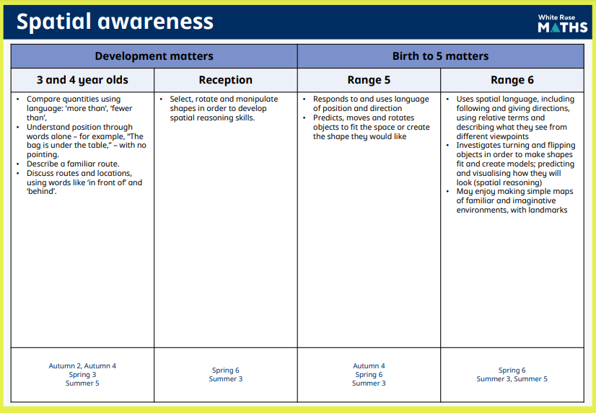

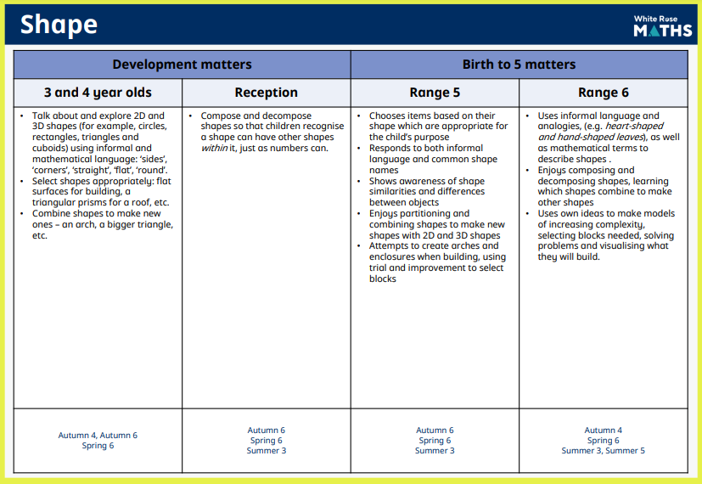

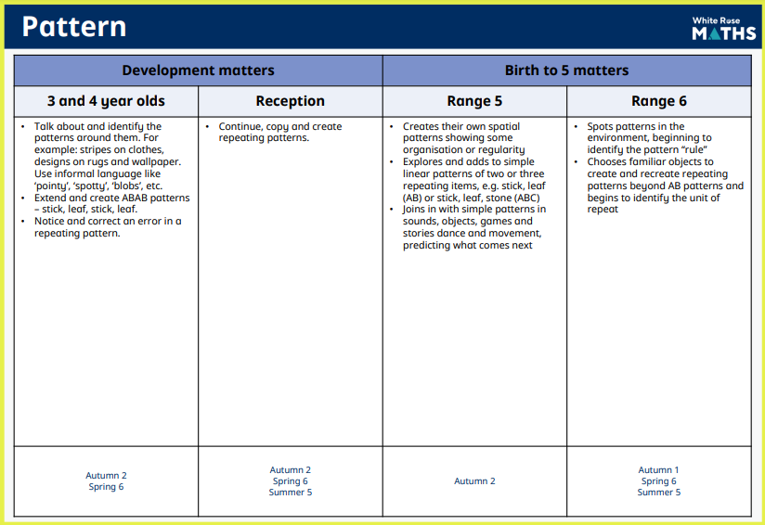 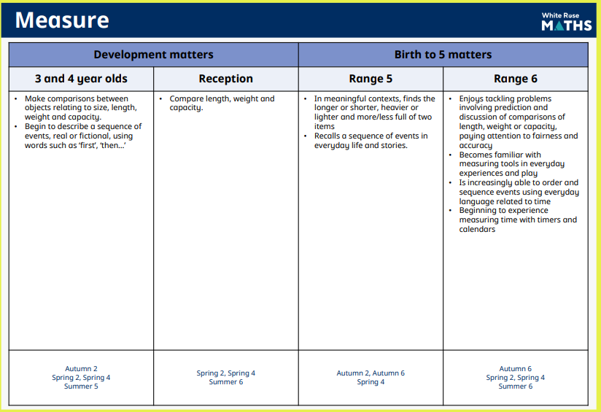



**Progression of Knowledge**

**Years 1-6**

**Place Value**

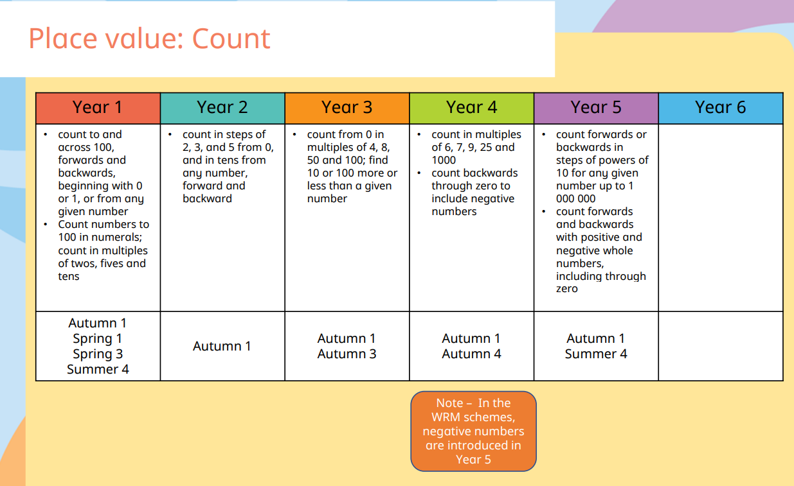

**Place Value**

**Place Value**

**Place Value**

**Addition and Subtraction**

**

**Multiplication and Division**

**Multiplication and Division**

**Multiplication and Division**

**Fractions, Decimals and Percentages**

**Fractions, Decimals and Percentages**

**Fractions, Decimals and Percentages**

**Fractions, Decimals and Percentages**

**

**Ratio and Proportion**

**Algebra**

**Measurement**

**Measurement**

**Measurement**

**Measurement**

**Geometry**

**Geometry**

**Geometry**

**Geometry**

**Statistics**

**Statistics**



**Times Table Progression**

**EYFS- Year 6**

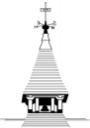

**Sound and District Primary School**

Times Tables Progression

|  |
| --- |
| EYFS-Reception |
| Throughout the year children will count reliably with numbers 1-20.  Children will begin to count in 2’s, 5’s and 10’s. |

|  |
| --- |
| Year 1 |
| **Autumn 1**- 1 x table (no division facts)  **Autumn 2**- 10 x table to 6 (no division facts)  **Spring 1**- 10 x table to 12 (include simple division facts)  **Spring 2**- 2 x tables to 6 (include simple division facts)  **Summer 1**- 2 x tables to 12 (include simple division facts)  **Summer 2**- Recap all previously taught tables rules and apply these to problem solving contexts. |

|  |
| --- |
| Year 2 |
| **Autumn 1**- Recap previously taught tables-x10 & x2 (include division facts).  **Autumn 2**- 5x table to 12 (include division facts)  **Spring 1- (SATS)** Recap all previously taught tables and apply these to problem solving contexts.  **Spring 2-** **(SATS)** Recap all previously taught tables and apply these to problem solving contexts.  **Summer 1- (SATS)** Recap all previously taught tables and apply these to problem solving contexts.  **Summer 2-** 3x and 4x tables to 12 (include division facts) |

|  |
| --- |
| Year 3 |
| **Autumn 1-** Recap all previously taught tables and apply to problem solving contexts (include division facts)-x2, 5, 10, 3 & 4.  **Autumn 2-** Consolidate above.  **Spring 1-** Begin x6 and x8 times tables.  **Spring 2-** Consolidate above including division facts.  **Summer 1-** 11 x tables to 12 (include division facts)  **Summer 2-** Recap all previously taught tables rules and apply these to problem solving contexts. |

|  |
| --- |
| Year 4 |
| **Autumn 1–** Recap Year 3  **Autumn 2-** x7, x9 &12 x table to 12(include division facts)  Use place value, known and derived facts to multiply and divide mentally, including: multiplying by 0 and 1; dividing by 1; multiplying together 3 numbers.  **Spring 1-** Revisit ALL times tables  Recognise and use factor pairs and commutativity in mental calculations. Multiply two-digit and three-digit numbers by a one-digit number using formal written layout.  **Spring 2-** Recall multiplication and division facts for all multiplication tables up to 12x12.  **Summer term-**  Revisit division facts.  Solve problems involving multiplying and adding, including using the distributive law to multiply two-digit numbers by 1 digit, integer scaling problems and harder correspondence problems such as n objects are connected to m objects. |

|  |
| --- |
| Year 5 |
| **Recall multiplication and division facts for multiplication tables up to 12x12**  **Autumn 1-** Identify multiples and factors, including finding all factor pairs of a number, and common factors of 2 numbers.  **Autumn 2-** Know and use the vocabulary of prime numbers, prime factors, and composite (non-prime) numbers.  Establish whether a number up to 100 is prime and recall prime numbers up to 19.  **Spring 1-** Multiply numbers up to 4 digits by a one- or two-digit number using a formal written method, including long multiplication for two-digit numbers.  Multiply and divide numbers mentally, drawing upon known facts.  Divide numbers up to 4 digits by a one-digit number using the formal written method of short division and interpret remainders appropriately for the context.  **Spring 2-** Multiply and divide whole numbers and those involving decimals by 10, 100 and 1,000.  Recognise and use square numbers and cube numbers, and the notation for squared (²) and cubed (³)  **Summer term-** Solve problems involving multiplication and division, including using their knowledge of factors and multiples, squares, and cubes, scaling by simple fractions and problems involving simple rate. |

|  |
| --- |
| Year 6 |
| **Recall multiplication and division facts for multiplication tables up to 12x12**  **Autumn 1 –** Multiply multi-digit numbers up to 4 digits by a two-digit whole number using the formal written method of long multiplication.  **Autumn 2 –** Divide numbers up to 4 digits by a two-digit whole number using the formal written method of long division, and interpret remainders as whole number remainders, fractions, or by rounding, as appropriate for the context.  **Spring 1 –** Perform mental calculations, including with mixed operations and large numbers.  **Spring 2 –** Identify common factors, common multiples, and prime numbers.  **Summer 1 –** Solve problems involving addition, subtraction, multiplication, and division.  **Summer 2 –** Use estimation to check answers to calculations and determine, in the context of a problem, an appropriate degree of accuracy. |