**SOUND & DISTRICT PRIMARY SCHOOL**

Whole School Science Progression Map 2024-2025

Scheme: ECM (Knowledge Organisers)



**Who is this document for?**

This progression has been made to help both Class Teachers and the Science Subject Lead.

For Class Teachers this progression document allows teachers to clearly see what has already been covered in the previous year, the areas which are to be covered in the current year but also where learning continues into the next year. This progression document allows us to see how topics are developed over time and built on, as well as exact key knowledge that children must know in each unit and each class.

In addition to the above, it also allows the Science Subject Lead to know when topics are being taught, which resources may be needed across the school at a particular time and also help with monitoring of key knowledge and coverage for triangulation.

Note: In mixed year groups, the rotation of topics is based on a 2 year rolling programme. This ensures that pupils gain the coverage of each topic area building on as they move through school and gain the key knowledge associated. The progression of Scientific Knowledge is specific to each year group NOT class e.g. 3/4, 4/5 (see progression detailed below) so the end points in mixed classes will be different depending on age group.

**Whole School Overview**

|  |  |  |  |  |  |  |  |
| --- | --- | --- | --- | --- | --- | --- | --- |
|  | **Autumn 1** | **Autumn 2** | **Spring 1** | **Spring 2** | | **Summer 1** | **Summer 2** |
| **Diamond Class (R)** | **Understanding the World**  Explore the natural world around them  Describe what they see, hear and feel whilst outside.  Recognise some environments that are different from the one in which they live.  Understand the effect of changing seasons on the natural world around them.  **Personal Social and Emotional Development**  Observe effects on own bodies, hunger, tiredness, safety and tools, toileting, washing and drying of hands, dressing. | | **Understanding the World**  Explore the natural world around them  Describe what they see, hear and feel whilst outside.  Recognise some environments that are different from the one in which they live.  Understand the effect of changing seasons on the natural world around them.  **Personal, Social and Emotional Development**  Eats healthily, understanding of safety, good practice with exercise, eating, sleeping and hygiene. | | | **Understanding the World**  Explore the natural world around them  Describe what they see, hear and feel whilst outside.  Recognise some environments that are different from the one in which they live.  Understand the effect of changing seasons on the natural world around them.  **Personal, Social and Emotional Development**  Children know the importance for good health of physical exercise, and a healthy diet, and talk about ways to keep healthy and safe. They manage their own basic hygiene and personal needs successfully, including dressing and going to the toilet independently. | |
| **Emerald Class (Y1)** | Animals Including Humans | Seasonal Changes (Autumn-Winter) | Everyday Materials | | | Plants  Seasonal Changes (Spring-Summer) | |
| **Ruby Class (Y2)** | Animals Including Humans | Use of Everyday Materials | Living things and their habitats | | | Plants | |
| **Opal Class (Y3/4)**  **Year B 2023- 24** | Forces & Magnetism | | Animals including humans | | Light | Rocks | Plants |
| **Opal Class (Y3/4)**  **Year C**  **2024- 25** | States of Matter  (Year 4 NC) | | Sound  (Year 4 NC) | | Animals including humans  (Year 4 NC) | Living Things and their Habitats  (Year 4 NC) | Electricity  (Year 4 NC) |
| **Topaz Class (Y4/5)**  **Year B**  **2023- 24** | Earth & Space | Forces | Properties of Materials | | | Animals including humans | Living things and their habitats |
| **Topaz Class (Y4/5)**  **Year C**  **2024- 25** | Animals including humans  (Year 4 NC) | Electricity  (Year 4 NC) | States of Matter  (Year 4 NC) | | | Sound  (Year 4 NC) | Living Things and their Habitats  (Year 4 NC) |
| **Onyx Class (Y6)** | Living things and their habitats | Animals including humans | Electricity | | | Evolution and Inheritance | Light |

**Key Scientists and Linked Text**

|  |  |  |  |  |  |  |  |
| --- | --- | --- | --- | --- | --- | --- | --- |
|  | **Autumn 1** | **Autumn 2** | **Spring 1** | | **Spring 2** | **Summer 1** | **Summer 2** |
| **Diamond Class (R)** | **Key Scientists**  **Marie Curie, Stephen Hawking**  Linked Texts: Otto Blotter, Bird Spotter (Graham Carter), The Extraordinary Gardener (Sam Bughton), Bug Hotel (Libby Walden), Dear Earth (Isabel Otter), Seasons (Hannah Pang) | | | | | | |
| **Emerald Class (Y1)** | Animals Including Humans  **Key Scientists**  **Jane Goodhall (Primatologist)**  **Joan Beauchamp Proctor (Zoologist)**  Linked Texts  One Year with Kipper (Mick Inkpen) Snail Trail (Ruth Brown) Superworm (Julia Donaldson & Axel Scheffler) | Seasonal Changes (Autumn-Winter)  **Key Scientists**  **George James Symons (Meteorologist)**  **Anders Celsius (Astronomer, Physicist & Mathematician)**  Linked Texts  Tree: Seasons Come, Seasons Go (Patricia Hegarty and Britta Teckentrup) One Year with Kipper (Mick Inkpen) After the Storm (Nick Butterworth) | Everyday Materials  **Key Scientists**  **Charles Mackintosh (Chemist & inventor)**  **Ole Kirk Christiansen (Inventor)**  **Martin Brock (Engineer)**  Linked Texts  The Great Paper Caper (Oliver Jeffers) Who Sank the Boat (Pamela Allen) The Story of Cinderella (Walt Disney) | | | Plants  **Key Scientists**  **Beatrix Potter (Botanist & Natural Scientist)**  **John Ray (Naturalist)**  **Wangari Maathai**  Linked Texts  Tree: Seasons Come, Seasons Go (Patricia Hegarty and Britta Teckentrup) A Little Guide to Wild Flowers (Charlotte Voake) The Things That I LOVE about TREES (Chris Butterworth) Harry’s Hazelnut (Ruth Parsons)  Seasonal Changes (Spring-Summer)  **Key Scientists**  **Dr Steve Lyons (Extreme Weather) Holly Green (Meteorologist)**  Linked Texts  Tree: Seasons Come, Seasons Go (Patricia Hegarty and Britta Teckentrup) One Year with Kipper (Mick Inkpen) After the Storm (Nick Butterworth) | |
| **Ruby Class (Y2)** | Animals Including Humans  **Key Scientists**  **Dr Ernest Madu (Cardiologist), Maria Sibylla Merian (Scientific illustrator & Entomologist)**  **Louis Pasteur (Biologist & Chemist)**  Linked Texts  The Gruffalo (Julia Donaldson)  Meerkat Mail (Emily Gravett)  Tadpole's Promise (Jeanne Willis and Tony Ross) | Use of Everyday Materials **Key Scientists**  **Jon Dunlop (Inventor)**  **Robert Gair (Inventor)**  **John Loudon McAdam (Engineer)**  **Julie Brusaw**  **(Inventor)**  Linked Texts  The Tin Forest (Helen Ward) Traction Man (Mini Grey) Three Little Pigs (Lesley Sims) | Living things and their habitats  **Key Scientists**  **Sylvia Earle (Marine Biologist & explorer)**  **Sir Ernest Shackleton (Antartic Explorer)**  Linked Texts  The Gruffalo (Julia Donaldson) Meerkat Mail (Emily Gravett)  No Place Like Home (Jonathon Emmett) | | | Plants  **Key Scientists**  **David Douglas (Botonist)**  **Agnes Arber (Botanist)**  **Jane Colden (Botanist)**  Linked Texts  The Tin Forest (Helen Ward)  Jack and the Beanstalk (Richard Walker)  Ten Seeds (Ruth Brown)  A Seed Is Sleepy (Dianna Aston) | |
| **Opal Class (Y3/4) 2023-24 Year B** | Forces & Magnets  **Key Scientists**  **John McAdam (Civil Engineer & Road Builder)**  **Isaac Newton (Physicist)**  **Michael Faraday (Scientist)**  Linked Texts  Float (Daniel Miyares),  Magnetic Max (Monica Lozano Hughes),  The Iron Man (Ted Hughes) | | Animals including humans  **Key Scientists**  **Wilhelm Rontgen (Mechanical engineer & physicist)**  **Ibn Sina “Avicenna” (Physician)**  Linked Texts  Life on Earth: Human Body (Heather Alexander), Book of Bones (Gabrielle Balkan), Can I build another me? (Shinsuke Yoshitake) | Light  **Key Scientists**  **Ibn al-Haytham “Alhazen” (Inventor)**  **Lewis Latimer (Inventor)**  **Justus von Liebig (Chemist)**  Linked Texts  My Shadow (Robert Louis Stevenson), The Night Box (Louise Greig), You are Light (Aaron Becker) | | Rocks  **Key Scientists**  **Mary Anning (Paleontologist)**  **Florence Bascom (Geologist)**  **Holly Betts (palaeobiologist)**  Linked Texts  The Pebble in My Pocket: A History of Our Earth (Meredith Hooper), A Rock is Lively (Dianna Hutts Aston), The Street Beneath My Feet (Charlotte Guiillian) | Plants  **Key Scientists**  **Stephen Hales (Botonist)**  **Anna Atkins (Botonist & Photographer)**  **Joseph Dalton Hooker (Doctor) Professor Monique Simmonds (Director of Science)**  Linked Texts  The Night Flower (Lara Hawthorne), The Big Book of Blooms (Yuval Zommer), I am a Seed that grew the tree (Fiona Waters) |
| **Opal Class (Y3/4) 2024-25 Year C** | States of Matter  **Key Scientists**  **Anders Celcius (Celcius Temperature Scale) Daniel Fahrenheit (Fahrenheit Temperature Scale / Invention of the Thermometer)**  Linked Texts  Once Upon a Raindrop: The Story of Water (James Carter) Sticks (Diane Alber) | | Sound  **Key Scientists**  **Aristotle (Sound Waves) Gailileo Galilei (Frequency and Pitch of Sound Waves) Alexander Graham Bell (Invented the Telephone)**  Linked Texts  Horrid Henry Rocks (Francesca Simon) Moonbird (Joyce Dunbar) The Pied Piper of Hamelin (Natalia Vasquez) | Animals including humans (digestive system)  **Key Scientists**  **Ivan Pavlov (Digestive System Mechanisms) Joseph Lister (Discovered Antiseptics)**  Linked Texts  Human Body Odyssey (Werner Holzwarth) Crocodiles Don't Brush Their Teeth (Colin Fancy) Wolves (Emily Gravett) | | Living things and their habitats  **Key Scientists**  **Carl Linnaeus**  **(Identifying, Naming**  **and Classifying**  **Organisms)**  Linked Texts  Beetle Boy  (M G Leonard)  Insect Soup  (Barry Louis Polisar)  Fur and Feathers  (Janet Halfmann | Electricity  **Key Scientists**  **Thomas Edison (First Working Lightbulb) Joseph Swan (Incadesecant Light Bulb)**  Linked Texts  Until I Met Dudley (Roger McGough) Oscar and the Bird: A Book about Electricity (Geoff Waring) Electrical Wizard: How Nikola Tesla Lit Up the World (Elizabeth Rusch) |
| **Topaz Class (Y4/5) 2023-24 Year B** | Earth & Space  **Key Scientists**  **Galileo Galilei (Astronomer, Physicist & Engineer)**  **Mae Jemison (Astronaut)**  **Nicolaus Copernicus (Astronomer) Maggie Aderin-Pocock (Space Scientist)**  Linked Texts  Cosmic (Frank Cottrell Boyce), Curisity: The Story of the Mars Rover (Markus Motum), Armstrong:The Adventurous Story of a Mouse on The Moon (Torben Kuhlmann) | Forces  **Key Scientists**  **Albert Einstein (Theoretical Physicist)**  **Archimedes (Mathematician, Engineer & Inventor)**  **Emma England – (Aeronautical engineer)**  Linked Texts  On a Beam of Light: A Story Of Albert Einstein (Jennifer Berne & Vladimer Radunsky), Aerodynamics of Biscuits (Clare Helen Walsh), Newton’s Rainbow (Kathryn Lasky) | Properties of Materials  **Key Scientists**  **Spencer Silver & Arthur Fry (Chemist & Inventor)**  **Stephanie Kwolek (Chemist)**  **Joe Keddie (Prof of Physics)**  Linked Texts  Make it Change (Anna Claybourne), Itch (Simon Mayo), Kensuke’s Kingdom (Michael Morpurgo) | | | Animals including humans  **Key Scientists**  **Elizabeth Blackwell (Doctor)**  **Patrick Steptoe, Robert Edwards & Jean Purdy (Obstetrician, Physiologist & Embryologist)**  **Sarah Fowler (Marine Biologist)**  Linked Texts  Home in the Woods (Eliza Wheeler), Nine Months (Miranda Paul), The Borrowers (Mary Norton) | Living things and their habitats  **Key Scientists**  **Mary Agnes Chase (Botonist)**  **David Attenborough (Broadcaster & Natural Historian)**  **Lucy Evelyn Cheesman (Entomologist)**  Linked Texts  Beetle Boy (M.G.Leonard), The Butterfuly is Parient (Dianna Aston), Where the World turns Wild (Nicola Penfold) |
| **Topaz Class (Y4/5) 2024-25 Year C** | Animals including humans (digestive system)  **Key Scientists**  **Ivan Pavlov (Digestive System Mechanisms) Joseph Lister (Discovered Antiseptics)**  Linked Texts  Human Body Odyssey (Werner Holzwarth) Crocodiles Don't Brush Their Teeth (Colin Fancy) Wolves (Emily Gravett) | Electricity  **Key Scientists**  **Thomas Edison (First Working Lightbulb) Joseph Swan (Incadesecant Light Bulb)**  Linked Texts  Until I Met Dudley (Roger McGough) Oscar and the Bird: A Book about Electricity (Geoff Waring) Electrical Wizard: How Nikola Tesla Lit Up the World (Elizabeth Rusch) | States of Matter  **Key Scientists**  **Anders Celcius (Celcius Temperature Scale) Daniel Fahrenheit (Fahrenheit Temperature Scale / Invention of the Thermometer)**  Linked Texts  Once Upon a Raindrop: The Story of Water (James Carter) Sticks (Diane Alber) | | | Sound  **Key Scientists**  **Aristotle (Sound Waves) Gailileo Galilei (Frequency and Pitch of Sound Waves) Alexander Graham Bell (Invented the Telephone)**  Linked Texts  Horrid Henry Rocks (Francesca Simon) Moonbird (Joyce Dunbar) The Pied Piper of Hamelin (Natalia Vasquez) | Living things and their habitats  **Key Scientists**  **Carl Linnaeus**  **(Identifying, Naming**  **and Classifying**  **Organisms)**  Linked Texts  Beetle Boy  (M G Leonard)  Insect Soup  (Barry Louis Polisar)  Fur and Feathers  (Janet Halfmann) |
| **Onyx Class (Y6)** | Living things and their habitats  **Key Scientists**  **Carl Linnaeus (Botonist & Zoologist)**  **Marjory Stoneman Douglas (Writer & Conservation)**  **Chris Nelson (Horticulturalist)**  Linked Texts  Beetle Boy (M G Leonard) Insect Soup (Barry Louis Polisar) Fur and Feathers (Janet Halfmann) | Animals including humans **Key Scientists**  **Marie Curie (Physicist & Chemist)**  **Alexander Fleming (Physician & Microbiologist), William Harvey (Physician)**  Linked Texts  Pig-Heart Boy (Malorie Blackman) Skellig (David Almond) A Heart Pumping Adventure (Heather Manley) | Electricity  **Key Scientists**  **Michael Faraday (Physicist)**  **William Kamkwamba (Inventor)**  **Nicholas Tesla (Engineer & Physicist), Peter Rawlinson (Engineer)**  Linked Texts  Goodnight Mister Tom (Michelle Magorian) Blackout (John Rocco) Hitler's Canary (Sandi Toksvig) | | | Evolution and Inheritance **Key Scientists**  **Charles Darwin (Naturalist)**  **Gregor Mendel (Botanist & Biologist)**  **Alfred Wallace (explorer, naturalist and anthropologist).**  Linked Texts  One Smart Fish (Christopher Wormell) The Molliebird (Jules Pottle)  Our Family Tree (Lisa Westberg Peters) | Light  **Key Scientists**  **Thomas Edison (Inventor)**  **Edith Clarke (Electrical Engineer)**  **Abu Ali al-Hasan (Alhazen) (Mathematician) Ben Jensen (Inventor)**  Linked Texts  Letters from the Lighthouse (Emma Carroll) The Gruffalo’s Child (Julia Donaldson) The King Who Banned the Dark (Emily Haworth-Booth) |

**NB: See separate document for more texts linked to each year group & Science.**

**Progression of Learning for Units**

|  |  |  |  |  |  |  |  |  |  |
| --- | --- | --- | --- | --- | --- | --- | --- | --- | --- |
|  | **Reception** | **Year One** | **Year Two** | **Year Three** | **Year Four** | **Year Five** | | **Year Six** | |
| **Animals Including Humans** | **Pupils should be taught to:**   * be able to identify different parts of their body. * Have some understanding of healthy food and the need for variety in their diets. * Be able to show care and concern for living things. * Know the effects exercise has on their bodies. * Have some understanding of growth and change.   • Can talk about things they have observed including animals | **Pupils should be taught to:**   * identify and name a variety of common animals including fish, amphibians, reptiles, birds and mammals; * identify and name a variety of common animals that are carnivores, herbivores and omnivores; * describe and compare the structure of a variety of common animals (fish, amphibians, reptiles, birds and mammals including pets); * identify, name, draw and label the basic parts of the human body and say which part of the body is associated with each sense. | **Pupils should be taught to:**   * notice that animals, including humans, have offspring which grow into adults; * find out about and describe the basic needs of animals,  including humans, for survival (water, food and air); * describe the importance for  humans of exercise, eating the right amounts of different types of food, and hygiene. | **Pupils should be taught to:**   * identify that animals, including humans, need the right types and amount of nutrition, and that they cannot make their own food; they get nutrition from what they eat; * identify that humans and some other animals have skeletons and muscles for support, protection and movement. | **Pupils should be taught to:**   * describe the simple functions of the basic parts of the digestive system in humans; * identify the different types of teeth in humans and their simple functions; * construct and interpret a variety of food chains, identifying producers, predators and prey. | **Pupils should be taught to:**   * describe the changes as humans develop to old age. | | **Pupils should be taught to:**   * identify and name the main parts of the human circulatory system, and describe the functions of the heart, blood vessels and blood; * recognise the impact of diet,  exercise, drugs and lifestyle on the way their bodies function; * describe the ways in which nutrients and water are transported within animals, including humans. | |
| **Vocabulary** |  | * Names of animal groups: **fish, amphibians, reptiles, birds, mammals.** * Animal diets: **carnivore, herbivore, omnivore.** * Human and animal body parts: e.g. body, head, neck, arms, elbows, legs, knees, face, ears, eyes, nose, hair, mouth, teeth, hands, feet, tail, wings, feathers, fur, beak, fins, gills. * Human senses: **sight, hearing, touch, smell, taste.** * Exploring senses: loud, quiet, soft, rough. * Other: human, animal, pet. | * Being born and growing: **Young, offspring, live young**, grow, **develop**, change, hatch, lay, fly, crawl, talk. * Young and adult names: e.g. lamb and sheep, kitten and cat, duckling and duck. * **Life cycle** stages: e.g. baby, toddler, child, teenager, **adult;** frogspawn, tadpole, froglet, frog. * Survival and staying healthy: basic needs, survive, food, air, **exercise, diet,** **nutrition**, healthy, balanced diet, **hygiene, germs.** * Food groups: fruit and vegetables, proteins, dairy and alternatives, carbohydrates, oil and spreads, fat, salt, sugar.   Previously introduced vocabulary: **water**. | * Food groups and **nutrients**: fibre, fats **(saturated and unsaturated**), vitamins, minerals. * Skeletons and muscles: skeleton, **muscles, tendons, joints,** protection, support, organs, voluntary muscles, involuntary muscles, biceps, triceps, contract, relax, bone, cartilage, shell, **vertebrate, invertebrate,** endoskeleton, exoskeleton, hydrostatic skeleton. * Names of human bones: e.g. skull, spine, backbone, vertebral column, ribcage, pelvis, clavicle, scapula, humerus, ulna, pelvis, radius, femur, tibia, fibula. * Other: **energy**.   Previously introduced vocabulary: movement. | * Digestive system: **digest**, digestion, tongue, teeth, saliva, salivary glands, **oesophagus, stomach,** liver, pancreas,gall bladder, **small intestine,** duodenum**, large intestine, rectum,** anus, faeces, organ. * Types of teeth and dental care: **molar**, **premolar**, **incisor**, **canine**, wisdom teeth, tooth decay, plaque, enamel, baby (milk) teeth. * Food chains and animal diets: decomposer, food web.   Previously introduced vocabulary: **producer,** consumer**, prey, predator,** excretion**,** habitat. | | * Process of reproduction: **gestation, asexual reproduction, sexual reproduction,** sperm, egg, cells, clone. * Changes and **life cycle:** embryo, foetus, uterus, **prenatal, adolescence, puberty, menstruation, adulthood,** menopause, **life expectancy,** old age, hormones, sweat. * Changing body parts: e.g. breasts, penis, larynx, ovaries, genitalia, pubic hair.   Previously introduced vocabulary: reproduction, **reproduce,** types of animals and animal groups, **fertilisation.** | | * **Circulatory system**: circulation, **heart**, pulse, heartbeat, heart rate, lungs, breathing, **blood vessels**, blood, pump, transported, **oxygenated blood, deoxygenated blood,** oxygen, arteries, veins, capillaries, chambers, plasma, platelets, white blood cells, red blood cells. * Lifestyle: **drug, alcohol,** smoking, disease, calorie, energy input, energy output. * Other: water transportation, nutrient transportation, waste products.   Previously introduced vocabulary: carbon dioxide. |
| **Plants** | **Pupils should be taught to:**   * Make observations of plants * Know some names of plants, trees and flowers   May be able to name and describe different plants, trees and flowers | **Pupils should be taught to:**   * identify and name a variety of common wild and garden  plants, including deciduous and evergreen trees; * identify and describe the basic structure of a variety of common flowering plants, including trees. | **Pupils should be taught to:**   * observe and describe how seeds and bulbs grow into mature plants; * find out and describe how plants need water, light and a suitable temperature to grow and stay healthy. | **Pupils should be taught to:**   * identify and describe the functions of different parts of flowering plants: roots, stem/trunk, leaves and flowers; * explore the requirements of  plants for life and growth (air, light, water, nutrients from soil, and room to grow) and how they vary from plant to plant; * investigate the way in which water is transported within plants; * explore the part that flowers play in the life cycle of flowering plants, including pollination, seed formation and seed dispersal. |  |  | |  | |
| **Vocabulary** |  | * Names of common plants: **wild plant, garden plant, evergreen** tree, **deciduous** tree, common flowering plant, **weed,** grass. * Name some features of plants: e.g. **flower**, vegetable, **fruit**, berry, **leaf/leaves**, blossom, **petal**, **stem**, trunk, branch, **root**, **seed, bulb,** soil. * Name some common types of plant e.g. sunflower, daffodil. | * Growth of plants: **germination**, **shoot, seed dispersal,** grow, food store, life cycle, die, wilt, seedling, sapling. * Needs of plants: **sunlight, nutrition,** light, healthy,space, air. * Name different types of plant: e.g. bean plant, cactus. * Names of different habitats: e.g. rainforest, desert.   Previously introduced vocabulary: **water**, **temperature**, warm, hot, cold, habitat. | * Water transportation: transport, **evaporation, evaporate, nutrients,** absorb, anchor. * Life cycle of flowering plants: **pollination** (insect/wind), pollen, nectar, pollinator, seed formation, **seed dispersal** (animal/wind/water), reproduce, **fertilisation,** fertilise, **stamen,** anther, filament, **carpel (pistil),** stigma, style, ovary, ovule, **sepal**, carbon dioxide.   Previously introduced vocabulary: life cycle**.** |  | |  | |  |
| **Living Things Including Habitats** | **Pupils should be taught to:**  In Early Years children should:  •Comments and questions about the place they live or the natural world.  • Shows care and concern for living things and the environment.  • Can talk about things they have observed such as plants and animals.  • Notices features of objects in their environment.  • Comments and asks questions about their familiar world. |  | **Pupils should be taught to:**   * explore and compare the differences between things that are living, dead, and things that have never been alive; * identify that most living things live in habitats to which they are suited and describe how different habitats provide for the basic needs of different kinds of animals and plants, and how they depend on each other; * identify and name a variety of plants and animals in their habitats, including microhabitats; * describe how animals obtain their food from plants and other animals, using the idea of a simple food chain, and identify and name different sources of food. |  | **Pupils should be taught to:**   * recognise that living things can be grouped in a variety of ways; * explore and use classification keys to help group, identify and name a variety of living things in their local and wider environment; * recognise that environments can change and that this can sometimes pose dangers to living things. | **Pupils should be taught to:**   * describe the differences in the life cycles of a mammal, an amphibian, an insect and a bird; * describe the life process of reproduction in some plants and animals. | | **Pupils should be taught to:**   * describe how living things are classified into broad groups according to common observable characteristics and based on similarities and differences, including  micro-organisms, plants and animals; * give reasons for classifying plants and animals based on specific characteristics. | |
| **Vocabulary** |  |  | * Living or dead**: living, dead, never living,** not living, alive, never been alive, healthy. * **Habitats** including **microhabitats**: **depend,** shelter, safety, **survive**, suited, space, minibeast, air. * **Life processes:** movement, sensitivity, growth, reproduction, nutrition, excretion, respiration. * **Food chains: food sources,** food, producer, consumer, predator, prey. * Names of habitats and microhabitats: e.g. under leaves, woodland, rainforest, sea shore, ocean, urban, local habitat.   Previously introduced vocabulary: senses, **carnivore**, **herbivore**, **omnivore**, **seed**, **water**, names of materials. |  | * Living things: **organisms, specimen,** species. * Grouping living things: **classification,** classification keys, classify, **characteristics**. * Names of invertebrate animals: snails and slugs, worms, spiders, insects. * Invertebrate body parts: e.g. wing case, abdomen, thorax, antenna, segments, mandible, proboscis, prolegs. * Environmental changes: **environment,** environmental dangers, adapt, natural changes, climate change, deforestation, pollution, urbanisation, invasive species, **endangered species, extinct.**   Previously introduced vocabulary: carbon dioxide, **fish, bird, mammal, amphibian, reptile**, skeleton, bone, **vertebrate, invertebrate,** backbone, names for animal body parts, names of common plants, photosynthesis. | | * **Reproduction**: **asexual reproduction, sexual reproduction**, **gestation, metamorphosis,** gametes, tuber, runners/side branches, plantlet, cuttings, embryo, adolescent, penis, vagina, egg, pregnancy, gestation.   Previously introduced vocabulary: **life cycle, pollination,** offspring, **fertilise,** fertilisation, sepal, filament, anther, stamen, pollen, petal, stigma, style, ovary, carpel, ovule, stem, bulb, roots, mammal, adult, baby, sperm, cells, live young. | | * Classifying: Carl Linnaeus, Linnaean system, flowering and non-flowering plants, variation. * **Microorganisms**: **bacteria,** single-celled, microbes, microscopic, virus, fungi, fungus, mould, antibiotic, yeast, ferment, **microscope**, decompose. |
| **Evolution and Inheritance** |  |  |  |  |  |  | | **Pupils should be taught to:**   * recognise that living things have changed over time and that fossils provide information about living things that inhabited the Earth millions of years ago; * recognise that living things produce offspring of the same kind, but normally offspring vary and are not identical to their parents; * identify how animals and plants are adapted to suit their environment in different ways and that adaptation may lead to evolution. | |
| **Vocabulary** |  |  |  |  |  |  | | * **Evolution** and **inheritance:** evolve, **adaptation,** inherit, **natural selection, adaptive traits, inherited traits,** mutations, theory of evolution, ancestors, biological parent, chromosomes, genes, Charles Darwin. * Other: selective breeding, artificial selection, breed, cross breeding, genetically modified food, cloning, DNA.   Previously introduced vocabulary: classification, **offspring, characteristics, habitat, environment,** adapt, **variations**, human, **fossil,** suited, cells, names of different habitats, names of animals and their body parts, species, **sedimentary rock**, lava, **igneous rock**, **metamorphic rock**, **magma**, heat, **fossilisation**. | |
| **Seasonal Changes** | **Pupils should be taught to:**  • Developing an understanding of change.  • Observe and explain why certain things may occur (e.g. leaves falling off trees, weather changes).  • Look closely at similarities, differences, patterns and change. | **Pupils should be taught to:**   * observe changes across the 4 seasons; * observe and describe weather associated with the seasons and how day length varies. |  |  |  |  | |  | |
| **Vocabulary** |  | * **Seasons**: **spring, summer, autumn, winter**, seasonal change. * **Weather**: e.g. sun, rain, snow, sleet, frost, ice, fog, cloud, hot/warm, cold, storm, wind, thunder, weather forecast. * Measuring weather: temperature, rainfall, wind direction, thermometer, rain gauge. * Day length: night, day, **daylight.** |  |  |  |  | |  | |
| **Forces** | **Pupils should be taught to:**   * know about similarities and differences in relation to places, objects, materials and living things. * talk about the features of their own immediate environment and how environments might vary from one another.   make observations of animals and plants and explain why some things occur, and talk about changes. |  |  | Forces and Magnets  **Pupils should be taught to:**   * compare how things move on  different surfaces; * notice that some forces need contact between 2 objects, but magnetic forces can act at a distance; * observe how magnets attract or repel each other and attract some materials and not others; * compare and group together  a variety of everyday materials on the basis of whether they are attracted to a magnet, and identify some magnetic materials; * describe magnets as having 2 poles; * predict whether 2 magnets will attract or repel each other, depending on which poles are facing. |  | Forces  **Pupils should be taught to:**   * explain that unsupported objects fall towards the Earth because of the force of gravity acting between the Earth and the falling object; * identify the effects of air  resistance, water resistance  and friction, that act between moving surfaces; * recognise that some mechanisms including levers, pulleys and gears allow a smaller force to have a greater effect. | |  | |
| **Vocabulary** |  |  |  | * How things move: move, movement, **surface**, distance, strength. * Types of **forces**:push, pull, contact force, non-contact force, **friction**. * **Magnets: magnetic, magnetic field,** magnetic force, bar magnet, horseshoe magnet, ring magnet, magnetic **poles** (north pole, south pole), **attract, repel,** compass. * Magnetic and non-magnetic materials: e.g. iron, nickel, cobalt.   Previously introduced vocabulary: metal, names of materials. |  | * Types of forces: **air resistance, water resistance, buoyancy, upthrust,** Earth’s **gravitational pull, gravity**,opposing forces, driving force. * **Mechanisms:** levers, pulleys, gears/cogs. * Measurements: **weight, mass,** kilograms (kg), Newtons (N), scales, speed, fast, slow. * Other: **streamlined**, Earth.   Previously introduced vocabulary:air, heat, moon. | |  | |
| **Light** | * **Pupils should be taught to:**  Developing an understanding of change. * Observe and explain why certain things may occur (e.g leaves falling off trees, weather changes). * Look closely at similarities, differences, patterns and change. |  |  | **Pupils should be taught to:**   * recognise that they need light  in order to see things and that dark is the absence of light; * notice that light is reflected  from surfaces; * recognise that light from the sun can be dangerous and that there are ways to protect their eyes; * recognise that shadows are formed when the light from a light source is blocked by an opaque object; * find patterns in the way that the size of shadows change. |  |  | | **Pupils should be taught to:**   * recognise that light appears to travel in straight lines; * use the idea that light travels in straight lines to explain that objects are seen because they give out or reflect light into the eye; * explain that we see things because light travels from light sources to our eyes or from light sources to objects and then to our eyes; * use the idea that light travels in straight lines to explain why shadows have the same shape as the objects that cast them. | |
| **Vocabulary** |  |  |  | * **Light** and seeing: **dark,** absence of light, **light source,** illuminate, visible, **shadow, translucent,** energy, block. * **Light sources:** e.g. candle, torch, fire, lantern, lightning. * **Reflective light: reflect, reflection,** surface, **ray**, scatter, reverse, beam, angle, mirror, moon. * Sun safety:dangerous, glare, damage, UV light, UV rating, sunglasses, direct.   Previously introduced vocabulary: **opaque, transparent,** sunlight, sun. |  |  | | * Reflection: periscope. * Seeing light: **visible spectrum, prism.** * How light travels: light waves, wavelength, straight line, **refraction.**   Previously introduced vocabulary: names and properties of materials, absorb. | |
| **Sound** | **Pupils should be taught to:**   * May have some understanding that objects make different sounds. * Some understanding that they use their ears to hear sounds. * Know about their different senses. |  |  |  | **Pupils should be taught to:**   * identify how sounds are made, associating some of them with something vibrating; * recognise that vibrations from sounds travel through a medium to the ear; * find patterns between the pitch of a sound and features of the object that produced it; * find patterns between the volume of a sound and the strength of the vibrations that produced it;   recognise that sounds get fainter as the distance from the sound source increases |  | |  | |
| **Vocabulary** |  |  |  |  | * Parts of the **ear**: **eardrum.** * Making sound: **vibration,** vocal cords, **particles.** * Measuring sound: **pitch**, **volume, amplitude, sound wave,** quiet, loud, high, low, travel**, distance.** * Other: **soundproof, absorb sound.** |  | |  | |
| **Earth and Space** | * **Pupils should be taught to:**  Understand changes in weather patterns and seasons. * Compare how things move on different surfaces. |  |  |  |  | **Pupils should be taught to:**   * describe the movement of the Earth and other planets relative to the Sun in the solar system; * describe the movement of the Moon relative to the Earth; * describe the Sun, Earth and Moon as approximately spherical bodies; * use the idea of the Earth’s rotation to explain day and night and the apparent movement of the sun across the sky. | |  | |
| **Vocabulary** |  |  |  |  |  | * Solar system: **star, planet.** * Names of planets: Mercury, Venus, Earth, Mars, Jupiter, Saturn, Neptune, Uranus. * Shape: **spherical bodies, sphere.** * Movement: **rotate, axis,** **orbit, satellite.** * Theories: **geocentric model, heliocentric model, astronomer.** * Day length: sunrise, sunset, midday, time zone.   Previously introduced vocabulary: **Sun, moon,** **shadow**, day, night, heat, **light**, **reflect**. | |  | |
| **Electricity** | **Pupils should be taught to:**  • May have some understanding that objects need electricity to work.  • May understand that a switch will turn something on or off |  |  |  | **Pupils should be taught to:**   * identify common appliances that run on electricity; * construct a simple series electrical circuit, identifying and naming its basic parts, including cells, wires, bulbs, switches and buzzers; * identify whether or not a lamp will light in a simple series circuit, based on whether or not the lamp is part of a complete loop with a battery; * recognise that a switch opens and closes a circuit and associate this with whether or not a lamp lights in a simple series circuit; * recognise some common conductors and insulators, and associate metals with being good conductors. |  | | **Pupils should be taught to:**   * associate the brightness of a lamp or the volume of a buzzer with the number and voltage of cells used in the circuit; * compare and give reasons for variations in how components function, including the brightness of bulbs, the loudness of buzzers and the on/off position of switches; * use recognised symbols when representing a simple circuit in a diagram. | |
| **Vocabulary** |  |  |  |  | * **Electricity:** mains-powered, battery-powered, **mains electricity,** plug, **appliances**, devices. * Circuits: **circuit,** simple series circuit, complete circuit, incomplete circuit. * Circuit parts: bulb, cell, wire, buzzer, switch, motor, **battery.** * Materials: **electrical conductor, electrical insulator.** * Other: safety.   Previously introduced vocabulary: names of materials. |  | | * Flow and measure of electricity: **voltage, amps, resistance, electrons**, volts (V), **current.** * Circuits**: symbol,** circuit diagram, component, function, filament. * Variations: dimmer, brighter, louder, quieter. * Types of electricity: natural electricity, human-made electricity, solar panels, power station. * Other: positive, negative. | |
| **Materials** | **Pupils should be taught to:** • be able to ask questions about the place they live.  • Talk about why things happen and how things work.  • Discuss the things they have observed such as natural and found objects.  • Manipulates materials to achieve a planned effect. | Everyday Materials  **Pupils should be taught to:**   * distinguish between an object and the material from which it is made; * identify and name a variety of everyday materials, including wood, plastic, glass, metal, water, and rock; * describe the simple physical properties of a variety of everyday materials; * compare and group together a variety of everyday materials on the basis of their simple physical properties. | Use of Everyday Materials  **Pupils should be taught to:**   * identify and compare the suitability of a variety of everyday materials, including wood, metal, plastic, glass, brick, rock, paper and cardboard for particular uses; * find out how the shapes of solid objects made from some materials can be changed by squashing, bending, twisting and stretching. | Rocks  **Pupils should be taught to:**   * compare and group together different kinds of rocks on the basis of their appearance and simple physical properties; * describe in simple terms how fossils are formed when things that have lived are trapped within rock;   recognise that soils are made from rocks and organic matter | States of Matter  **Pupils should be taught to:**   * compare and group materials together, according to whether they are solids, liquids or gases; * observe that some materials change state when they are heated or cooled, and measure or research the temperature at which this happens in degrees Celsius (°C); * identify the part played by evaporation and condensation in the water cycle and associate the rate of evaporation with temperature. | Properties and Changes of Materials  **Pupils should be taught to:**   * compare and group together everyday materials on the basis of their properties, including their hardness, solubility, transparency, conductivity (electrical and thermal), and response to magnets; * know that some materials will dissolve in liquid to form a solution, and describe how to recover a substance from a solution; * use knowledge of solids, liquids and gases to decide how mixtures might be separated, including through filtering, sieving and evaporating; * give reasons, based on evidence from comparative and fair tests, for the particular uses of everyday materials, including metals, wood and plastic; * demonstrate that dissolving, mixing and changes of state are reversible changes; * explain that some changes result in the formation of new materials, and that this kind of change is not usually reversible, including changes associated with burning and the action of acid on bicarbonate of soda. | |  | |
| **Vocabulary** |  | * Names of **materials**: wood, plastic, glass, metal, water, rock, paper, cardboard, rubber, fabric. * Properties of materials: **hard, soft, shiny, dull, stretchy**, **rough**, **smooth, bendy, not bendy, transparent, opaque, waterproof, not waterproof**, **absorbent, not absorbent,** sharp, stiff. * Other: **object.** | * Changing shape: squash, bend, twist, stretch. * **Properties** of **materials:** e.g.strong, flexible, light, hard-wearing, elastic. * Other: **suitability**, recycle, pollution. | * Types of rock**: sedimentary rock, igneous rock, metamorphic rock.** * **Properties of rocks: permeable,** semi-permeable, **impermeable,** durable. * Names of rocks: e.g. marble, chalk, granite, sandstone, slate. * Formation of rocks and fossils: natural, human-made, **magma, lava,** molten rock, **sediment, erosion, fossilisation,** layers, bone, fossil. * Soil: sandy, chalky, clay, peaty, loamy, topsoil, subsoil, bedrock, mineral, organic matter, compost. * Other: **palaeontology.**   Previously introduced vocabulary: soil, **water**, air. | * **States of matter: solids, liquids, gases,** particles. * State change: **evaporate,** **condense,** **melt, freeze**, heat, cool, melting point, freezing point, boiling point, **water vapour**. * Water cycle: **precipitation**, evaporation, condensation, ground run-off, collection, underground water, bodies of water (sea, river, stream), water droplets, hail. * Other: atmosphere.   Previously introduced vocabulary: temperature, rain, cloud, snow, wind, sun, hot, cold, absorb, carbon dioxide | * Properties of **materials**: thermal **conductor/insulator,** magnetism, electrical resistance, **transparency**. * Mixtures and solutions: dissolving, substance, soluble, insoluble. * Changes of materials: reversible change, physical change, irreversible change, chemical change, burning, new material, product. * Separating: sieving, filtering, magnetic attraction.   Previously introduced vocabulary: electrical **conductor/insulator,** bulb, **translucent**. | |  | |

**Vocabulary for EYFS**

|  |
| --- |
| family, baby, toddler, child, teenager, adult, elderly person, classroom, playground, dining hall, office  names of senses, names of body parts  weather, seasons, investigate, magnifying glass  igloo, iceberg, snowflake, glacier, snow, ice, freezing, melting, water, cold, arctic  polar bear, penguin, seal, walrus, arctic hare, husky  light, dark, sun, planet, rays, night and day, reflection, electricity, fire  nocturnal, owl, bat, fox, badger, mole, cats, hedgehogs, hamsters, desert, rainforest, city, town, savannah, arctic, farmland, woodland, marine, environment, trees, grass, sand, mountains, ocean  pollution, damage, rubbish, care, citizenship, nature, oil slicks, cars and gases, deforestation  recycling, litter, plastic bags, reusing, paper, saving electricity, turning off taps  trains, aeroplanes, ships, cars, buses, bikes, motorbikes, barges, hot air balloon, hovercraft, wheels, rotor blades, helicopter, sea, canal, rail tracks, roads, airport, port, dock  butterflies, caterpillars, cocoons, hatch, wings, antennae, chicks, chickens, eggs, shells, peck, beak, life cycles, growth and change, incubator, map, globe, atlas, flags, country, city  sheep, lamb, cow, calf, horse, foal, goat, kid, pig, piglet, dog, puppy, cat, kitten, duck, duckling, chicken, chick |

**Progression of Key Knowledge by class & unit**

|  |  |
| --- | --- |
|  | **Diamond Class (Reception)** |
| **Autumn** | **Understanding the World**   * Provide children with have frequent opportunities for outdoor play and exploration. * Offer opportunities to sing songs and join in with rhymes and poems about the natural world. * Observe and interact with natural processes, such as ice melting, a sound causing a vibration, light travelling through transparent material, an object casting a shadow, a magnet attracting an object and a boat floating on water. * Listen to children describing and commenting on things they have seen whilst outside, including plants and animals. * Model the vocabulary needed to name specific features of the world, both natural and made by people. * Share non-fiction texts that offer an insight into contrasting environments. * Listen to how children communicate their understanding of their own environment and contrasting environments through conversation and in play. * Guide children’s understanding by drawing children’s attention to the weather and seasonal features. * Throughout the year, take children outside to observe the natural world and encourage children to observe how animals behave differently as the seasons change. * Look for children incorporating their understanding of the seasons and weather in their play.   **Personal Social and Emotional Development**   * Model practices that support good hygiene, such as insisting on washing hands before snack time. * Help individual children to develop good personal hygiene. Acknowledge and praise their efforts. Provide regular reminders about thorough handwashing and toileting.   **Communication and Language**   * Learn new vocabulary * Ask questions to find out more and to check what has been said to them * Articulate their ideas and thoughts into well-thought sentences * Describe events in some detail * Use talk to help work out problems and organize thinking and activities to explain how things work and why they might happen, * Use new vocabulary in different contexts |
| **Spring 1** | **Understanding the World**   * Throughout the year, take children outside to observe the natural world and encourage children to observe how animals behave differently as the seasons change. * Provide opportunities for children to note and record the weather. Select texts to share with the children about the changing seasons. * After close observation, draw pictures of the natural world, including animals and plants. * Name and describe some plants and animals children are likely to see, encouraging children to recognise familiar plants and animals whilst outside. * Teach children about a range of contrasting environments within both their local and national region. * Model the vocabulary needed to name specific features of the world, both natural and made by people. * Guide children’s understanding by drawing children’s attention to the weather and seasonal features. * Provide opportunities for children to note and record the weather. Select texts to share with the children about the changing seasons. * Throughout the year, take children outside to observe the natural world and encourage children to observe how animals behave differently as the seasons change.   **Personal Social and Emotional Development**   * Narrate your own decisions about healthy foods, highlighting the importance of eating plenty of fruits and vegetables. * Use picture books and other resources to explain the importance of the different aspects of a healthy lifestyle. Explain to children and model how to travel safely in their local environment, including: staying on the pavement, holding hands and crossing the road when walking, stopping quickly when scootering and cycling, and being sensitive to other pedestrians. * Talk with children about exercise, healthy eating and the importance of sleep.   **Communication and Language**   * Learn new vocabulary * Ask questions to find out more and to check what has been said to them * Articulate their ideas and thoughts into well-thought sentences * Describe events in some detail * Use talk to help work out problems and organize thinking and activities to explain how things work and why they might happen, * Use new vocabulary in different contexts |
| **Summer** | **Understanding the World**   * Encourage interactions with the outdoors to foster curiosity and give children freedom to touch, smell and hear the natural world around them during hands-on experiences. * Create opportunities to discuss how we care for the natural world around us. * Throughout the year, take children outside to observe the natural world and encourage children to observe how animals behave differently as the seasons change. * Provide opportunities for children to note and record the weather. Select texts to share with the children about the changing seasons. * Encourage focused observation of the natural world. * Encourage positive interaction with the outside world, offering children a chance to take supported risks, appropriate to themselves and the environment within which they are in. * Model the vocabulary needed to name specific features of the world, both natural and made by people. * Guide children’s understanding by drawing children’s attention to the weather and seasonal features. * Throughout the year, take children outside to observe the natural world and encourage children to observe how animals behave differently as the seasons change.   **Personal Social and Emotional Development**   * Know and talk about the different factors that support their overall health and wellbeing:   + Regular physical activity   + Healthy eating   + Tooth brushing   + Sensible amounts of ‘screen time’   + Having a good sleep routine   + Being a safe pedestrian   **Communication and Language**   * Learn new vocabulary * Ask questions to find out more and to check what has been said to them * Articulate their ideas and thoughts into well-thought sentences * Describe events in some detail * Use talk to help work out problems and organize thinking and activities to explain how things work and why they might happen, * Use new vocabulary in different contexts |
| **By the End of Reception (ELG)** | **Understanding the World**   * Explore the natural world around them, making observations and drawing pictures of animals and plants. * Know some similarities and differences between the natural world around them and contrasting environments, drawing on their experiences and what has been read in class. * Understand some important processes and changes in the natural world around them, including the seasons and changing states of matter.   **Personal Social and Emotional Development**   * Manage their own basic hygiene and personal needs, including dressing, going to the toilet and understanding the importance of healthy food choices.   **Communication and Language**   * Make comments about what they have heard and ask questions to clarify their understanding. |

|  |  |  |
| --- | --- | --- |
|  | | **Emerald Class (Year One)** |
| **Autumn 1** | | **Animals Including Humans**  Key Knowledge   * Identify and name a variety of common animals including fish, amphibians, reptiles,   birds and mammals.   * Identify and name a variety of common animals that are carnivores, herbivores and omnivores. * Describe and compare the structure of a variety of common animals (fish, amphibians, reptiles, birds and * mammals including pets). * Identify, name, draw and label the basic parts of the human body and say which part of the body is * associated with each sense. |
| **Autumn 2** | | **Seasonal Changes (Autumn to Winter)**  Key Knowledge   * Observe changes across the 4 seasons; * Observe and describe weather associated with the seasons and how day length varies. |
| **Spring** | | **Everyday Materials**  Key Knowledge   * Distinguish between an object and the material from which it is made; * Identify and name a variety of everyday materials, including wood, plastic, glass, metal, water, and rock; * Describe the simple physical properties of a variety of everyday materials; * Compare and group together a variety of everyday materials on the basis of their simple physical properties. |
| **Summer** | | **Plants and Seasonal Changes (Spring to Summer)**  Key Knowledge   * Observe changes across the 4 seasons; * Observe and describe weather associated with the seasons and how day length varies. * Identify and name a variety of common wild and garden  plants, including deciduous and evergreen trees; * Identify and describe the basic structure of a variety of common flowering plants, including trees. |
|  | **Ruby Class (Year Two)** | | |
| **Autumn 1** | **Animals Including Humans**  Key Knowledge:   * Notice that animals, including humans, have offspring which grow into adults; * Find out about and describe the basic needs of animals, including humans, for survival (water, food and air); * Describe the importance for humans of exercise, eating the right amounts of different types of food, and hygiene | | |
| **Autumn 2** | **Use of Everyday Materials**  Key Knowledge   * Identify and compare the suitability of a variety of everyday materials, including wood, metal, plastic,   glass, brick, rock, paper and cardboard for particular uses;   * Find out how the shapes of solid objects made from some materials can be changed by squashing, bending, twisting and stretching. | | |
| **Spring** | **Living Things and Their Habitats**  Key Knowledge   * Explore and compare the differences between things that are living, dead, and things   that have never been alive;   * Identify that most living things live in habitats to which they are suited and describe how different habitats provide for the basic needs of different kinds of animals and plants, and how they depend on each other; * Identify and name a variety of plants and animals in their habitats, including microhabitats; * Describe how animals obtain their food from plants and other animals, using the idea of a simple food chain, and identify and name different sources of food. | | |
| **Summer** | **Plants**  Key Knowledge   * Observe and describe how seeds and bulbs grow into mature plants; * Find out and describe how plants need water, light and a suitable temperature to grow and stay healthy. | | |

|  |  |
| --- | --- |
|  | **Opal Class Years Three and Four (NC Y3)** |
| **Autumn** | **Forces and Magnets**  Key Knowledge   * compare how things move on  different surfaces; * notice that some forces need contact between 2 objects, but magnetic forces can act at a distance; * observe how magnets attract or repel each other and attract some materials and not others; * compare and group together  a variety of everyday materials on the basis of whether they are attracted to a magnet, and identify some magnetic materials; * describe magnets as having 2 poles; * predict whether 2 magnets will attract or repel each other, depending on which poles are facing. |
| **Spring 1** | **Animals Including Humans**  Key Knowledge   * Identify that animals, including humans, need the right types and amount of nutrition, and that they   cannot make their own food; they get nutrition from what they eat;   * Identify that humans and some other animals have skeletons and muscles for support, protection and movement. |
| **Spring 2** | **Light**  Key Knowledge   * recognise that they need light in order to see things and that dark is the absence of light; * notice that light is reflected from surfaces; * recognise that light from the sun can be dangerous and that there are ways to protect their eyes; * recognise that shadows are formed when the light from a light source is blocked by an opaque object; * find patterns in the way that the size of shadows change. |
| **Summer 1** | **Rocks**  Key Knowledge   * compare and group together different kinds of rocks on the basis of their appearance and   simple physical properties;   * describe in simple terms how fossils are formed when things that have lived are trapped within rock; recognise that soils are made from rocks and organic matter |
| **Summer 2** | **Plants**  Key Knowledge   * identify and describe the functions of different parts of flowering plants: roots, stem/trunk, leaves   and flowers;   * explore the requirements of  plants for life and growth (air, light, water, nutrients from soil, and room to grow) and how they vary from plant to plant; * investigate the way in which water is transported within plants; * explore the part that flowers play in the life cycle of flowering plants, including pollination, seed formation and seed dispersal. |

|  |  |
| --- | --- |
|  | **Opal Class Years Three and Four (NC Y4 ) YEAR C 2024-25** |
| **Autumn** | **States of Matter**  Key Knowledge   * Compare and group materials together, according to whether they are solids, liquids or * gases; * Observe that some materials change state when they are heated or cooled, and measure or research the temperature at which this happens in degrees Celsius (°C); * Identify the part played by evaporation and condensation in the water cycle and associate the rate of evaporation with temperature. |
| **Spring 1** | **Sound**  Key Knowledge   * Identify how sounds are made, associating some of them with something vibrating; * Recognise that vibrations from sounds travel through a medium to the ear; * Find patterns between the pitch of a sound and features of the object that produced it; * Find patterns between the volume of a sound and the strength of the vibrations that produced it; * Recognise that sounds get fainter as the distance from the sound source increases. * Frequencies of sound waves, measured in hertz (Hz); echoes, reflection and absorption of sound * Sound needs a medium to travel, the speed of sound in air, in water, in solids * Sound produced by vibrations of objects, in loud speakers, detected by their effects on microphone diaphragm and the ear drum; * Sound waves are longitudinal * Auditory range of humans and animals. |
| **Spring 2** | **Animals Including Humans**  Key Knowledge   * Describe the simple functions of the basic parts of the digestive system in humans; * Identify the different types of teeth in humans and their simple functions; * Construct and interpret a variety of food chains, identifying producers, predators and prey. |
| **Summer 1** | **Living Things and Their Habitats**  Key Knowledge   * Recognise that living things can be grouped in a variety of ways; * Explore and use classification keys to help group, identify and name a variety of living things in their local and wider environment; * Recognise that environments can change and that this can sometimes pose dangers to living things. * Describe the differences in the life cycles of a mammal, an amphibian, an insect and a bird. |
| **Summer 2** | **Electricity**  Key Knowledge   * Identify common appliances that run on electricity; * Construct a simple series electrical circuit, identifying and naming its basic parts, including cells, wires, bulbs, switches and buzzers; * Identify whether or not a lamp will light in a simple series circuit, based on whether or not the lamp is part of a complete loop with a battery; * Recognise that a switch opens and closes a circuit and associate this with whether or not a lamp lights in a simple series circuit; * Recognise some common conductors and insulators, and associate metals with being good conductors. |

|  |  |
| --- | --- |
|  | **Topaz Class Year Four and Five (NC Y5)** |
| **Autumn 1** | **Earth & Space**   * Key Knowledgedescribe the movement of the Earth and other planets relative to the Sun in the solar   system;   * describe the movement of the Moon relative to the Earth; * describe the Sun, Earth and Moon as approximately spherical bodies; * use the idea of the Earth’s rotation to explain day and night and the apparent movement of the sun across the sky. |
| **Autumn 2** | **Forces**  Key Knowledge   * explain that unsupported objects fall towards the Earth because of the force of gravity acting   between the Earth and the falling object;   * identify the effects of air  resistance, water resistance  and friction, that act between moving surfaces; * recognise that some mechanisms including levers, pulleys and gears allow a smaller force to have a greater effect. |
| **Spring** | **Properties of Materials**  Key Knowledge   * compare and group materials together, according to whether they are solids, liquids or gases; * observe that some materials change state when they are heated or cooled, and measure or research the temperature at which this happens in degrees Celsius (°C); * identify the part played by evaporation and condensation in the water cycle and associate the rate of evaporation with temperature. |
| **Summer 1** | **Animals Including Humans**  Key Knowledge   * describe the changes as humans develop to old age. |
| **Summer 2** | **Living things & their habitats**  Key Knowledge   * describe the differences in the life cycles of a mammal, an amphibian, an insect and a   bird;   * describe the life process of reproduction in some plants and animals. |

|  |  |
| --- | --- |
|  | **Topaz Class Year Four and Five (NC Y4) Year C 2024-25** |
| **Autumn 1** | **Animals Including Humans**   * Describe the simple functions of the basic parts of the digestive system in humans; * Identify the different types of teeth in humans and their simple functions; * Construct and interpret a variety of food chains, identifying producers, predators and prey. |
| **Autumn 2** | **Electricity**  Key Knowledge   * Identify common appliances that run on electricity; * Construct a simple series electrical circuit, identifying and naming its basic parts, including cells, wires, bulbs, switches and buzzers; * Identify whether or not a lamp will light in a simple series circuit, based on whether or not the lamp is part of a complete loop with a battery; * Recognise that a switch opens and closes a circuit and associate this with whether or not a lamp lights in a simple series circuit; * Recognise some common conductors and insulators, and associate metals with being good conductors. |
| **Spring** | **States of Matter**  Key Knowledge   * Compare and group materials together, according to whether they are solids, liquids or gases; * Observe that some materials change state when they are heated or cooled, and measure or research the temperature at which this happens in degrees Celsius (°C); * Identify the part played by evaporation and condensation in the water cycle and associate the rate of evaporation with temperature. |
| **Summer 1** | **Sound**  Key Knowledge   * Identify how sounds are made, associating some of them with something vibrating; * Recognise that vibrations from sounds travel through a medium to the ear; * Find patterns between the pitch of a sound and features of the object that produced it; * Find patterns between the volume of a sound and the strength of the vibrations that produced it; * Recognise that sounds get fainter as the distance from the sound source increases. * Frequencies of sound waves, measured in hertz (Hz); echoes, reflection and absorption of sound * Sound needs a medium to travel, the speed of sound in air, in water, in solids * Sound produced by vibrations of objects, in loud speakers, detected by their effects on microphone diaphragm and the ear drum; * Sound waves are longitudinal * Auditory range of humans and animals. |
| **Summer 2** | **Living Things and Their Habitats**  Key Knowledge   * Recognise that living things can be grouped in a variety of ways; * Explore and use classification keys to help group, identify and name a variety of living things in their local and wider environment; * Recognise that environments can change and that this can sometimes pose dangers to living things. * Describe the differences in the life cycles of a mammal, an amphibian, an insect and a bird. |

|  |  |
| --- | --- |
|  | **Onyx Class (Year Six)** |
| **Autumn 1** | **Living Things and Their Habitats**  Key Knowledge   * Describe how living things are classified into broad groups according to common   observable characteristics and based on similarities and differences, including   micro-organisms, plants and animals;   * Give reasons for classifying plants and animals based on specific characteristics. |
| **Autumn 2** | **Animals Including Humans**  Key Knowledge   * Identify and name the main parts of the human circulatory system, and describe the functions of the heart, blood vessels and blood; * Recognise the impact of diet,  exercise, drugs and lifestyle on the way their bodies function; * Describe the ways in which nutrients and water are transported within animals, including humans. |
| **Spring** | **Electricity**  Key Knowledge   * Associate the brightness of a lamp or the volume of a buzzer with the number and voltage of cells used in the   circuit;   * Compare and give reasons for variations in how components function, including the brightness of bulbs, the loudness of buzzers and the on/off position of switches; * Use recognised symbols when representing a simple circuit in a diagram. |
| **Summer 1** | **Evolution & Inheritance**  Key Knowledge   * recognise that living things have changed over time and that fossils provide information   about living things that inhabited the Earth millions of years ago;   * recognise that living things produce offspring of the same kind, but normally offspring vary and are not identical to their parents; * identify how animals and plants are adapted to suit their environment in different ways and that adaptation may lead to evolution. |
| **Summer 2** | **Light**  Key Knowledge   * Recognise that light appears to travel in straight lines; * Use the idea that light travels in straight lines to explain that objects are seen because they give out   or reflect light into the eye;   * Explain that we see things because light travels from light sources to our eyes or from light sources to objects and then to our eyes; * Use the idea that light travels in straight lines to explain why shadows have the same shape as the objects that cast them. |

**Progression of Scientific Enquiry Skills (Year 1- Year 6)**

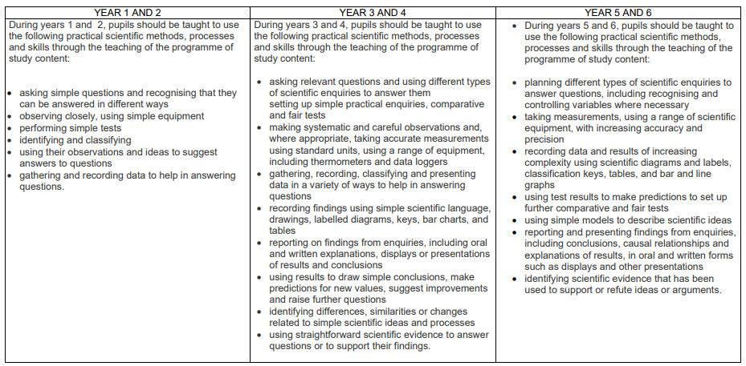

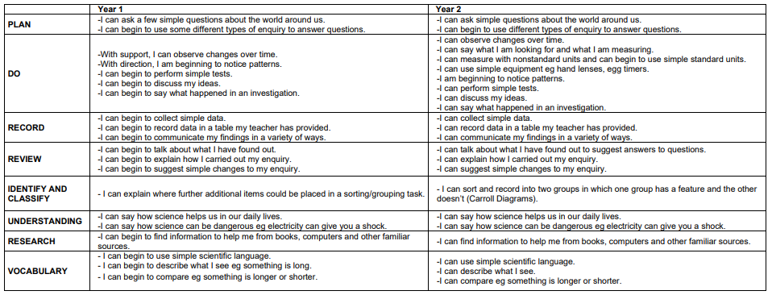

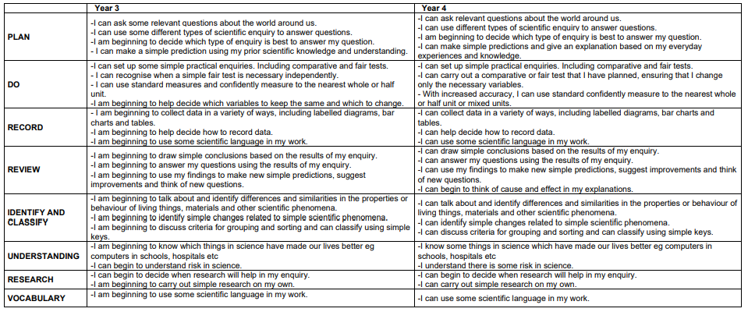

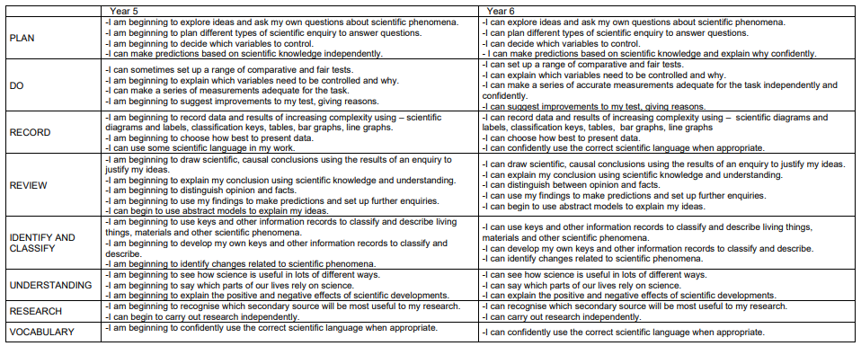

**Examples of recording (pictograms, bar charts, line graphs and tally charts)**

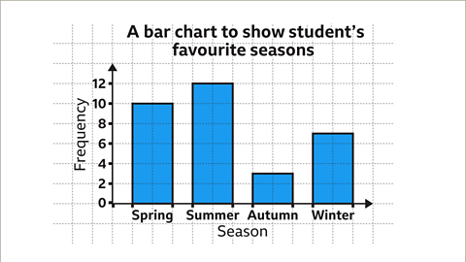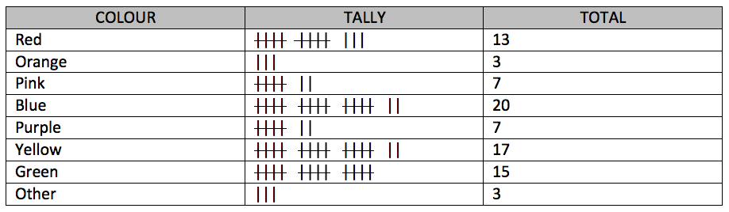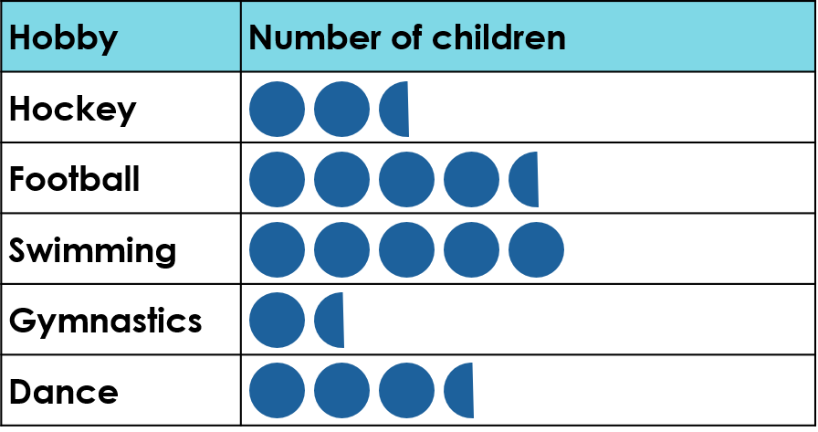 **KS1-Tally**

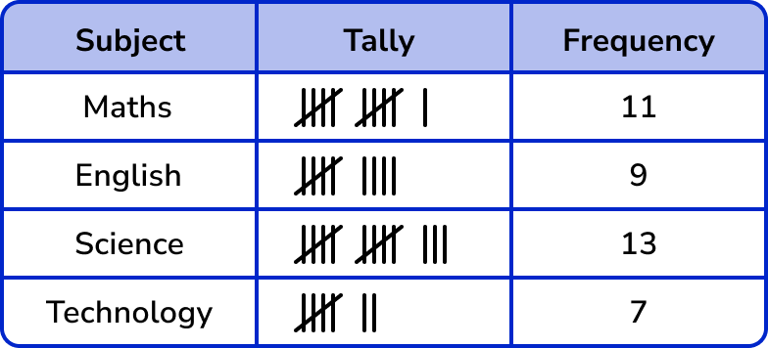**KS2-Tally**

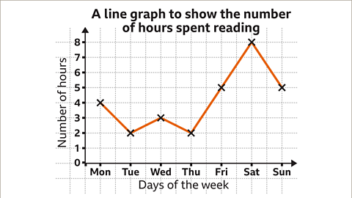

|  |  |  |  |  |  |
| --- | --- | --- | --- | --- | --- |
| **Headings for Science Investigations**  **Refer to Progression of Scientific Enquiry Skills document for breakdown of skills to cover within each heading** | | | | | |
| **Year 1** | **Year 2** | **Year 3** | **Year 4** | **Year 5** | **Year 6** |
| Question  Results  Conclusion | Question  Results  Conclusion | Question  Prediction  Fair Test   * Variables to change * Variables to measure * Variable to keep the same   Results  Conclusion | Question  Prediction  Fair Test   * Variables to change * Variables to measure * Variable to keep the same   Results  Conclusion | Question  Prediction  Fair Test   * Control Variables * Dependent Variables * Independent Variable   Results  Conclusion  Evaluation | Question  Prediction  Fair Test   * Control Variable * Dependent Variable * Independent Variable   Results  Conclusion  Evaluation |