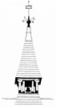

Sound and District Primary School
KS2 FRENCH PROGRESSION MAP
SUBSTANTIVE KNOWLEDGE END POINTS
2024-25

Scheme followed: Kapow

The French scheme of work aims to instil a love of language learning and an awareness of other cultures. We want pupils to develop the confidence to communicate in French for practical purposes, using both written and spoken French.

Through our scheme of work, we aim to give pupils a foundation for language learning that encourages and enables them to apply their skills to learning further languages, developing a strong understanding of the English language, facilitating future study and opening opportunities to study and work in other countries in the future.

The French scheme of work supports pupils to meet the National Curriculum end of Key stage 2 attainment targets (there are no Key stage 1 attainment targets for Languages).

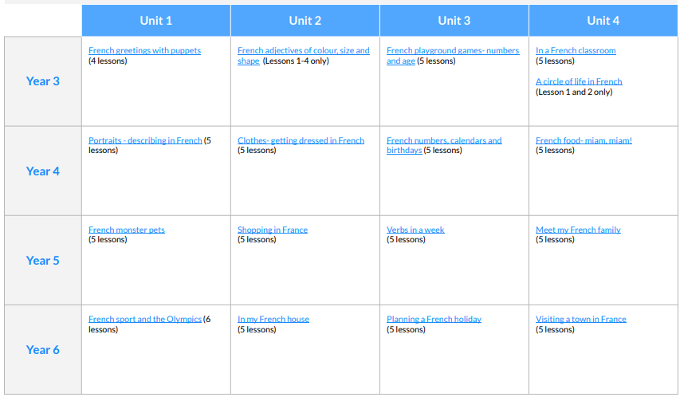
1
4
11
10
6
2
3
9
5
7
8
12
13
14
15
16
2024/25 – Y3/4 teach Units 2, 3, 4; Y4/5 teach Units 10, 11 & 12; Year 6 teach Units 6, 7, 8, 9, 10, 11, 12 & 16.
2025/26 – Year 3/4 & 4/5 teach Units 6, 7, 8; Year 6 teach Units 13, 14, 15, 16.

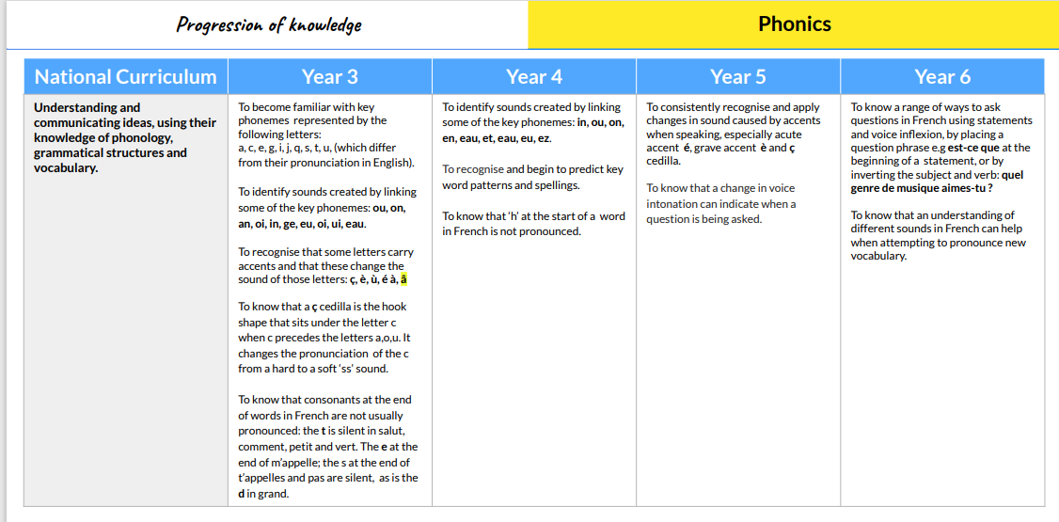
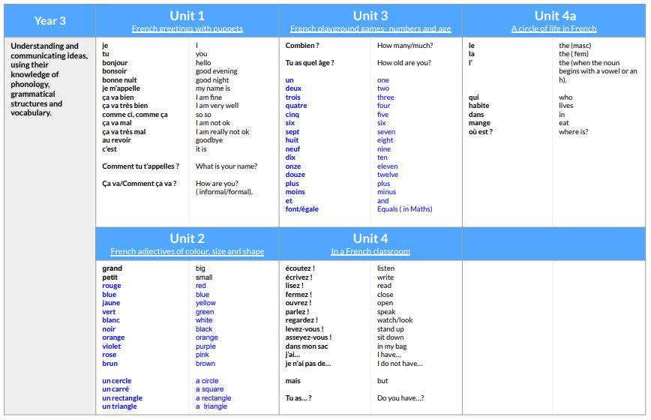
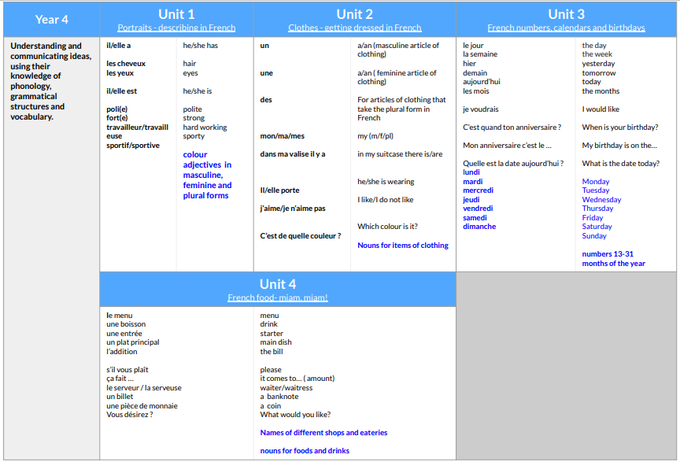
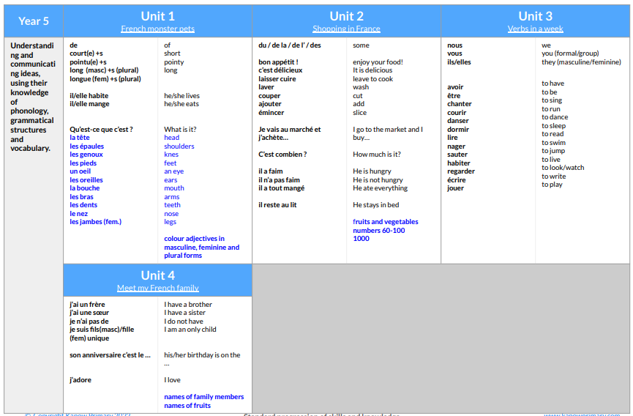
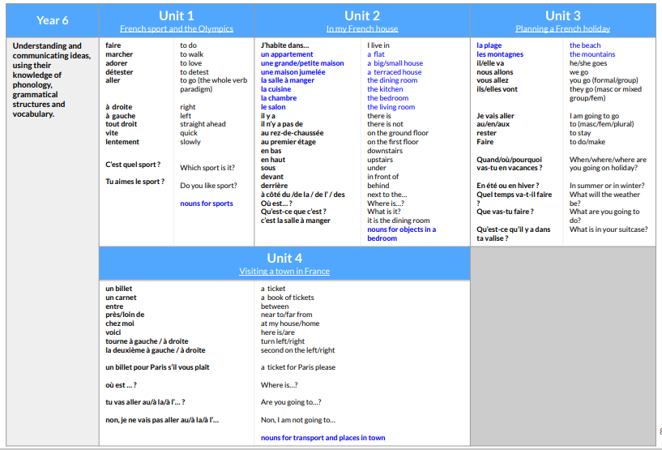
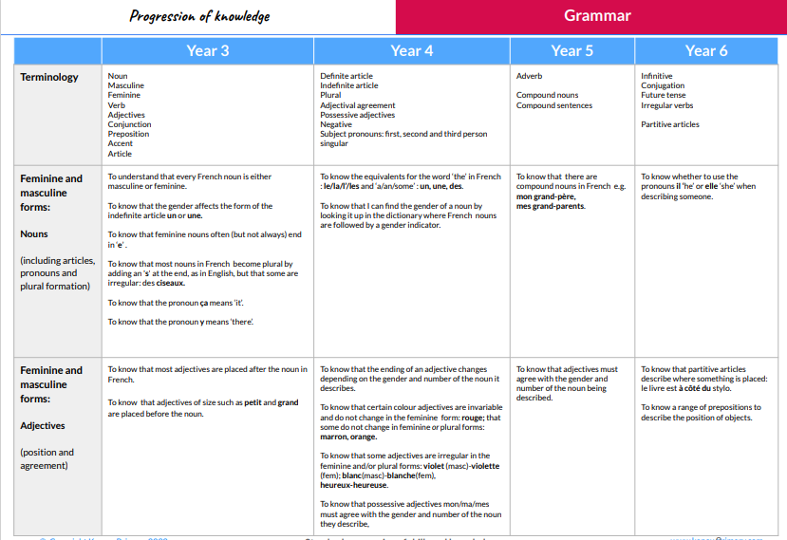
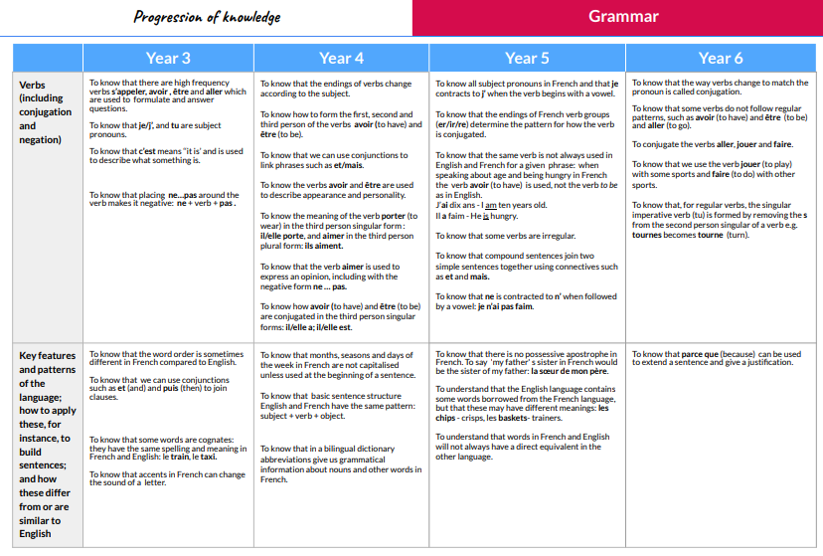
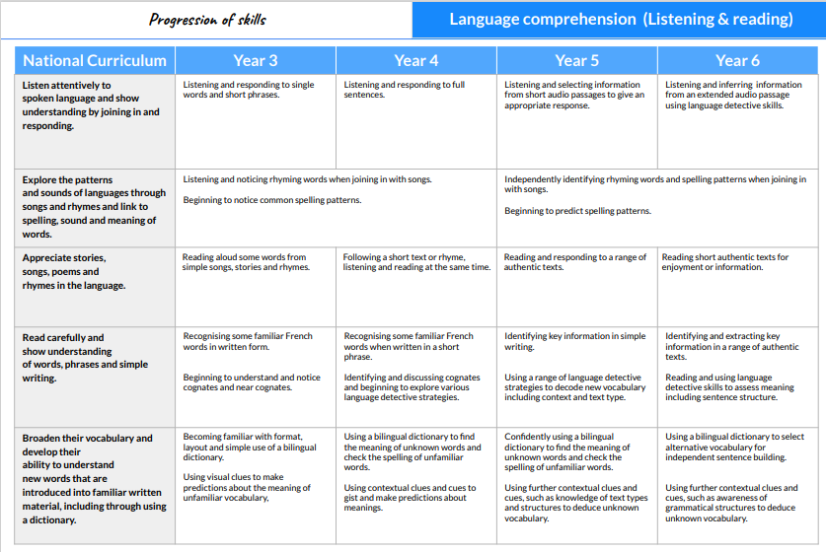
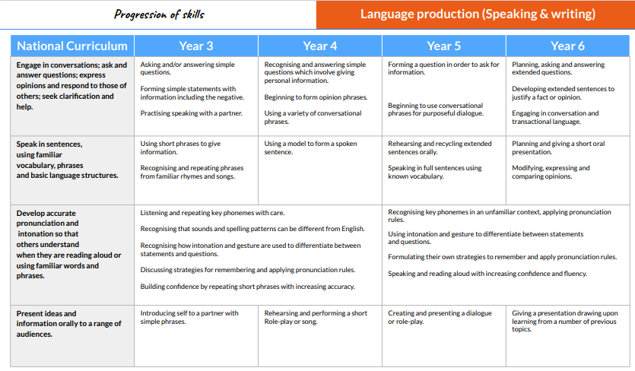
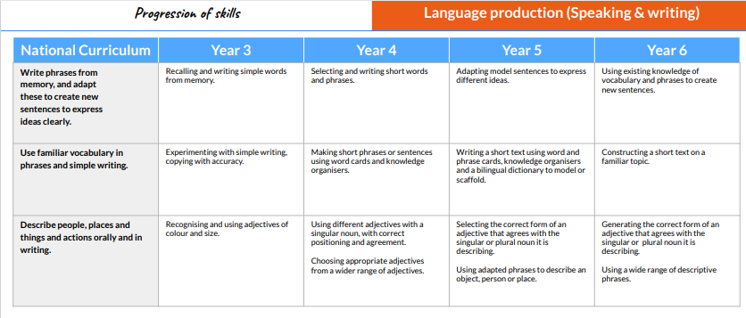
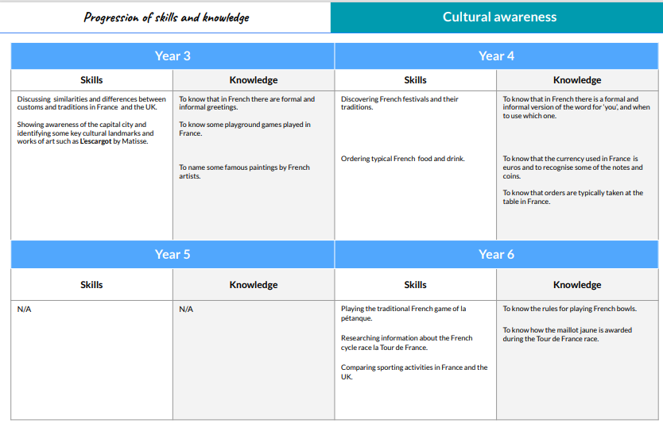See Key Skills and Knowledge document saved separately.

